INTELLIGENT PROJECT MANAGEMENT SYSTEM FOR UNDERGRADUATE STUDENTS

R26-IT-095

Project Proposal Report

BSc. (Hons) Degree in Information Technology, Specializing in
Information Technology
Department of Information Technology
Sri Lanka Institute of Information Technology
Sri Lanka

Supervisor: Prof. Samantha Rajapaksha
Co Supervisor: Mrs. Kaushika Kahatapitiya

March 2026

INTELLIGENT PROJECT MANAGEMENT SYSTEM FOR UNDERGRADUATE STUDENTS

Research Component: Intelligent Team Formation and Topic Feasibility Analysis

R26-IT-095

Project Proposal Report

Bandara N.D.M. – IT22114662

BSc. (Hons) Degree in Information Technology, Specializing in
Information Technology
Department of Information Technology
Sri Lanka Institute of Information Technology
Sri Lanka

Supervisor: Prof. Samantha Rajapaksha
Co Supervisor: Mrs. Kaushika Kahatapitiya

March 2026

DECLARATION
I declare that this is my own work, and this proposal does not knowingly incorporate any material previously submitted for a degree or diploma at any other university or higher education institution, nor does it contain any material that has been previously published or written by another person apart from where proper acknowledgment is given in the text.

Name | Student ID | Signature
Bandara N.D.M. | IT22114662 | 

The above candidate is conducting research for their undergraduate Dissertation under my supervision.

Name | Date | Signature
Prof. Samantha Rajapaksha |  | 
Mrs. Kaushika Kahatapitiya | 15/03/2026 | 

ABSTRACT
There are two foundational but unaddressed challenges in undergraduate project management. The formation of balanced, skill-full project teams and early validation of topic feasibility. Previous approaches to the group projects at any institution rely on random group allocation, self-selection or purely manual supervisor decisions without no proper consideration of the idea of team members’ skills, member’s personality diversity or alignment between the team’s collective performance and the requirements of the chosen topic. This research is to propose an AI powered Intelligent Team Formation and Topic Feasibility Analysis system as the first component of the broader Intelligent Project Management System for Undergraduate Students.
The research gap that we have identified lies in the absence of any system that simultaneously optimizes group composition across multiple competing objectives and validates the readiness of that group for a specific research topic or any other project topic before the work begins; There by solving the cold start problem that reduces the project’s outcomes from the very first day of the project. The proposed solution suggests a four stage pipeline: (1) an SBERT based student Vector Profiling Engine that encodes each student's academic grades (GPA), survey reported skills and personality traits into a unified 384 dimensional semantic skill vector; (2) An NSGA-II multi objective optimization engine that generates optimal group configuration by simultaneously maximizing skill coverage and minimizing skill redundancy and maximizing personality diversity; (3) An XGBoost based Topic Feasibility Predictor that measures a Success Probability score (0 – 100%) for each group-topic pairing using cosine similarity between the group’s aggregated skill vector and the topic’s required skill vector, Which calibrated against the historical project outcome data; and (4) a Cold Start Validator that generates a concept level skill gaap report and flags teams falling below a configurable competency threshold.
In this research, core technologies include Python (FastAPI), HuggingFace Sentence-BERT (all MiniLM L6 v2), the pymoo multi objective optimization library, XGBoost with SHAP for interpretability and React 18 with Recharts for the supervisor dahshboard. Validation targets include a cosine similarity profiling accuracy of ≥0.80, an XGBoost F1-score ≥ 0.82 with AUC-ROC ≥ 0.85, group formation for a cohort of 100 students within 60 seconds and a supervisor satisfaction score of ≥4.0/5.0. This component directly supports UN Sustainable Development Goal 4 (Quality Education) by ensuring that every single undergraduate group begins its project with a mathematically validated, skill balanced composition and a quantified assessment of its readiness for the chosen challenge.
Keywords: Team Formation, NSGA-II, Multi-Objective Optimization, SBERT, Topic Feasibility, XGBoost, SHAP, Cold-Start Problem, Skill-Gap Analysis, Educational AI.

ACKNOWLEDGEMENT
I would like to express my sincere gratitude to my supervisor, Prof. Samantha Rajapaksha, and co-supervisor, Mrs. Kaushika Kahatapitiya, for their invaluable guidance, continuous support, and constructive feedback throughout the research planning and development process. I also extend my appreciation to my project team members Lekamge R.L.M.D., Kulathunga S.A.I.K., and Rashmika R.M.D. for their collaboration in building the broader Intelligent Project Management System for Undergraduate Students. Special thanks to the Department of Information Technology at SLIIT for providing access to necessary computational resources and academic facilities.

TABLE OF CONTENTS
DECLARATION i
ABSTRACT ii
ACKNOWLEDGEMENT iii
LIST OF FIGURES iv
LIST OF TABLES iv
LIST OF ABBREVIATIONS v
1. INTRODUCTION 1
1.1 Background and Context 2
1.2 Literature Review 3
1.3 Research Gap 5
2. OBJECTIVES 7
2.1 Main Objective 7
2.2 Specific Objectives 7
3. METHODOLOGY 10
3.1 Research Approach 10
3.2 Technical Methods and Algorithms 10
3.3 Tools and Platforms 11
3.4 Data Collection and Ethical Considerations 12
3.5 Validation Strategy and Performance Metrics 12
4. HIGH-LEVEL SYSTEM ARCHITECTURE 13
4.1 Component Overview 13
4.2 Component Interactions and Data Flow 14
4.3 Scalability and Security Considerations 14
5. USER REQUIREMENTS 15
5.1 Stakeholder Identification 15
5.2 Functional Requirements 15
5.3 Non-Functional Requirements 16
6. COMMERCIALIZATION PLAN 17
7. BUDGET AND BUDGET JUSTIFICATION 19
8. WORK BREAKDOWN STRUCTURE (WBS) 20
9. GANTT CHART 21
REFERENCES 22
APPENDICES 24

LIST OF FIGURES
Figure 1: High-Level System Architecture of the Intelligent Team Formation and Topic Feasibility Analysis Component
Figure 2: Student Vector Profiling and NSGA-II Team Optimization Pipeline
Figure 3: Topic Feasibility Analysis and Cold-Start Validation Workflow
Figure 4: Gantt Chart – Project Timeline

LIST OF TABLES
Table 1: List of Abbreviations
Table 2: Research Gap Analysis – Existing Systems vs. Proposed System
Table 3: Functional Requirements
Table 4: Non-Functional Requirements
Table 5: Budget Breakdown and Justification
Table 6: Work Breakdown Structure

LIST OF ABBREVIATIONS
Abbreviation | Full Form
AI | Artificial Intelligence
API | Application Programming Interface
AUC-ROC | Area Under the Receiver Operating Characteristic Curve
DSR | Design Science Research
GPA | Grade Point Average
IPMS | Intelligent Project Management System
ML | Machine Learning
NLP | Natural Language Processing
NSGA-II | Non-dominated Sorting Genetic Algorithm II
REST | Representational State Transfer
SBERT | Sentence-Bidirectional Encoder Representations from Transformers
SDG | Sustainable Development Goal
SHAP | SHapley Additive exPlanations
SLIIT | Sri Lanka Institute of Information Technology
WBS | Work Breakdown Structure
Table 1: List of Abbreviations

1. INTRODUCTION
In undergraduate group projects, the formation of project groups and the selection of the topic for those projects are two of the most critical initial decisions to made at the process of group project life cycle. Those two decisions directly determine whether a group have the necessary technical skills to deliver a better output, whether individual group members have equal workloads and whether the group’s collective effort is enough for meet the demands of the chosen topic. Except for this, team formation and topic validation in most institutions including SLIIT still remain entirely informal which relying on random assignment, self-grouping or brief supervisor interviews with no data driven process of team balance or topic readiness.
This research addresses the first most layer of the Intelligent Project Management System: the Intelligent Team Formation and Topic Feasibility Analysis component. While other members handles the project planning (Lekamge R.M.D.), risk monitoring (Kulathunga S.A.I.K.), quality assessment (Rashmika R.M.D.). This component is responsible for ensuring every group project begins with a group that is composed mathematically validated for skill balance, personality diverse and ready for the chosen topic effectively by eliminating the foundational problems introduced by ad hoc team assignment.
This system directly supports UN Sustainable Development Goal 4 (Quality Education) by ensuring that every undergraduate, regardless of their social network or self-sufficient skills is placed in a group that maximizes their probability equation of project success through evidence-based, algorithmic matching.

1.1 Background and Context
The results of poor group formation in undergraduate group projects are well documented and significant, Oakley et al. (2004) established that improper unbalanced team formations which those where high performing students are clustered or where critical skills are no where to be found are in the main structural predictors of project failure and the free rider phenomenon, which is low contributing members get benefit from high performers’ efforts without commencing any Contribution for the project [1].Studies of multiple institutions have shown that randomly formed groups perform significantly worse in average than the groups formed through structured, skill matching processes [2].
Other than a balanced group, the deeper challenge is aligning the topic to the group. Which is also known as the cold start problem of group projects. A certain group can be internally balanced in terms of skills yet collectively lack the specific technical skill that regard to the topic that is chosen by the group. For example, a group building a ML system with no member experienced in python or data preprocessing is structurally set up to fail from the day one. No existing student facing tool validates this alignment before project begins. Supervisors typically discover such mistakes only two weeks into the project, in that point significant time and effort has been wasted already.
The combination of Sentence Transformers and multi objective evolutionary algorithms has uncovered new possibilities for data driven group formation. Reimers and Gurevych (2019) have demonstrated that Sentence-BERT produces semantically meaningful vector representations of the text that get skill relatedness more accurately that keyword matching [3]. Also, Deb et al. (2002) established NSGA-II as the gold standard algorithm for multi objective optimization problems where multiple competing criteria must be parallelly optimized accurately the structure of group formation problem [4]. Chen and Guestrin (2016) showed the superiority of XGBoost for tubular classification tasks including predicting of the outcome form structured feature vectors [5], establishing its suitability for the Feasibility Prediction module.

1.2 Literature Review
A detailed review of existing literature was conducted across the domains of automated team formation, multi objective optimization, semantic skill profiling and educational outcome prediction.

1.2.1 Automated and Constraint-Based Team Formation
The issue of algorithmically forming balanced groups has been studied extensively in both educational and professional contexts. Borrego et al. (2013) reviewed group formation strategies in engineering education and found out that structured skill based matching consistently outperformed random assignment on project quality [6]. The CATME system (Layton et al. 2010) is the most widely deployed automated group formation tool in higher education, using student self-reported skills and schedule availability to suggest group compositions. [7]. However, CATME relies on ordinal self-assessment scales that are highly susceptible to dunning-Kruger bias, does not incorporate semantic skill profiling and has no process to validating group readiness against a specific topic. Its group formation objective is also single dimensional with no consideration of personality diversity or multi objective tradeoffs.
More capable multi objective approaches have been found in the software engineering group formation literature. Gutiérrez-Rodríguez et al. (2016) applied evolutionary algorithms to form development teams that parallelly optimize technical skill coverage and collaboration potential [8]. That shows the feasibility of evolutionary team formation but does not point out the cold start feasibility dimension that is core to this research.

1.2.2 Semantic Skill Profiling with Sentence Transformers
Former skill profiling platforms shows skills as discrete labels or ordinal scores, losing the semantic relationships between related skills. Reimers and Gurevych (2019) introduced Sentence-BERT (SBERT), which produces rich vector representations of sentences and short documents that capture semantic similarity with mostly higher accuracy than prior methods [3]. The all-MiniLM-L6-v2 model used in this component makes 384 dimensional embeddings optimized for semantic textual similarity tasks with low computational overhead, making it suitable for real-time student profiling at cohort scale.
The application of SBERT to student skill profiling has been explored by Ramos et al. (2022), who demonstrated that SBERT-encoded competency descriptions align well with expert judgments of skill relatedness in professional competency frameworks [9]. This validates the core embedding approach of the Student Vector Profiling Engine proposed in this component.

1.2.3 Multi-Objective Optimization for Team Composition
Deb et al. (2002) introduces NSGA-II an elitist non-dominated sorting genetic algorithm that process a variety of Pareto-optimal front of solutions for multi-objective optimization problems [4]. NSGA-II became the mostly cited multi-objective evolutionary algorithm in engineering optimization literature. The pymoo library (Blank and Deb 2020) provides a high grade Python Implementation NSGA-II with well structured APIs for custom objective function definition and constraint specification [10], making that directly suitable for the group formation optimization formulated in this component.
The three objective formulation used in this component maximizing skill coverage, minimizing skill redundancy and maximizing personality diversity in novel in the educational group formation context and draws inspiration from the workforce diversity optimization literature for similar multi objective formulations have showed superior group performance outcomes over single object approaches [11].

1.2.4 Predictive Modelling for Educational Outcomes
Chen and Guestrin (2016) introduced XGBoost, a gradient boosting framework which has consistently gained state of the art performance on tubular classification tasks across a wide range of domains [5]. In educational data mining, Romero and Ventura (2010) showed that gradient boosting models applied to student academic performances can predict project outcome with much accuracy than ever before [12]. Most recent work by Lundberg and Lee (2017) introduced SHAP values as a theoretically grounded framework for explaining individual predictions of complex models [13] enabling the transparency that wanted for an academic decision support tool where supervisors must be able to understand and question the system’s recommendations.
The mix of XGBoost for outcome prediction and SHAP for explanation is now considered best practice in high stakes educational prediction systems [14] and it is the initial approach adopted in the Topic Feasibility Predictor in this component.

1.2.5 Existing Tools and Their Limitations
A proper survey of already existing team formation and topic validation tools uncovers consistent and critical gaps. CATME (Layton et al. 2010) addresses group balance via self report but has no NLP based profiling, no multi objective optimization and no topic feasibility validation. TeamMaker and similar tools apply ruler based matching but are they are rely on certain domains and lack semantic understanding of skill content. Random or self-selection paths, skill the norm at SLIIT and most institutions have introduce systematic bias towards homogeneous groups. No existing tool in the world combines the semantic kill profiling, multi objective evolutionary group optimization and ML based topic feasibility validation in a single integrated pipeline and confirming the novelty and the necessity of this research component.

1.3 Research Gap
The analysis of existing systems and literature review reveals a clear and well-defined research gap that this component addresses directly. The following table will summarize this gap.

Aspect | Existing: Random / Self-Select | Existing: CATME | Proposed System
Team Formation Basis | No data — purely social | Ordinal self-report scales | SBERT semantic skill vectors
Skill Profiling Accuracy | None | Low (Dunning-Kruger bias) | Cosine sim ≥ 0.80 (validated)
Optimization Approach | None | Single-objective heuristic | NSGA-II 3-objective Pareto-optimal
Personality Diversity | Not considered | Not considered | Big Five diversity maximization
Topic Feasibility Check | None | None | XGBoost Success Probability (0–100%)
Cold-Start Validation | None | None | Skill-gap report + threshold flagging
Explainability | None | None | SHAP feature-level explanation
Table 2: Research Gap Analysis – Existing Systems vs. Proposed System

The main objective of the novelty of this research lies in simultaneously solving two previously separate issues, team composition and topic readiness validation within a single integrated and mathematically accurate pipeline. By coupling NSGA-II based multi objective group formation with SBERT based semantic profiling and XGBoost based feasaibblity prediction, this component eliminates the cold start gap that has initially been found only after project work has begun and when it is too late to restructure teams without much cost to student ‘s wellbeing and project quality.

2. OBJECTIVES

2.1 Main Objective
To design and implement an AI powered Intelligent Group Formation and Topic Feasibility Analysis System that uses Sentence-BERT semantic profiling to construct multi-dimensional student skill vectors, applies NSGA-II multi objective optimization to generate Pareto optimal group configuration that simultaneously maximize skill coverage, minimize redundancy and maximize personality diversity, and validates each team-topic paring through a XGBoost based Feasibility Predictor and Cold Start Skill Validator before project Start.

2.2 Specific Objectives

Specific Objective 1: To Build the SBERT Student Vector Profiling Engine
- Specific: Develop an NLP-based profiling pipeline using the all-MiniLM-L6-v2 Sentence-BERT model to encode each student's academic module grades (normalized to [0,1]), GPA, free-text skill survey responses (20 questions), and Big Five personality assessment responses into a unified 384-dimensional semantic skill vector S ∈ R^384 per student.
- Measurable: Achieve a mean cosine similarity of ≥ 0.80 between SBERT-encoded skill descriptions and expert-validated ground-truth skill pairings on a held out validation set of 50 student profiles.
- Achievable: Leverages HuggingFace all-MiniLM-L6-v2 (pre-trained) with a lightweight concatenation and normalization layer; no task-specific fine tuning required.
- Realistic: Feasible using anonymized academic records from SLIIT IT4010 cohorts with appropriate ethical clearance.
- Time-bound: Expected completion within Months 2–4 of implementation.

Specific Objective 2: To Implement NSGA-II Multi-Objective Team Optimization Engine
- Specific: Develop a multi-objective team formation engine using the NSGA-II algorithm (pymoo 0.6) that optimizes three simultaneous objectives for a given cohort: (1) maximize team skill coverage (breadth of unique skill dimensions covered), (2) minimize intra-team skill redundancy (overlap penalty), and (3) maximize personality trait diversity (Big Five Euclidean distance). The engine shall output a ranked list of Pareto-optimal team configurations.
- Measurable: Team formation for a cohort of 100 students into groups of 4 shall complete within 60 seconds; generated teams shall achieve a mean expert quality rating of ≥ 4.0/5.0 on balance and diversity criteria.
- Achievable: pymoo 0.6 provides production-ready NSGA-II with configurable population size (200) and generation count (500).
- Realistic: 500-generation NSGA-II optimization for a cohort of 100 is computationally tractable on standard server hardware.
- Time-bound: Expected completion within Months 3–5 of implementation.

Specific Objective 3: To Develop XGBoost Topic Feasibility Predictor and Cold-Start Validator
- Specific: Train an XGBoost classifier on historical SLIIT project outcome data (binary: success / failure) using the following features per team-topic pairing: aggregated team skill vector, topic requirement vector (SBERT-encoded), cosine similarity between team and topic vectors, GPA variance across team members, and team size. Apply Platt scaling for probability calibration; use SHAP for per-prediction explanation. Implement a Cold-Start Validator that generates a concept-level skill-gap report and flags teams below a configurable threshold (default: 60% Success Probability).
- Measurable: XGBoost classifier achieves F1-score ≥ 0.82 and AUC-ROC ≥ 0.85 on a held-out test set of 100 historical team-topic pairings.
- Achievable: XGBoost 2.x and SHAP are mature, well-documented libraries; Platt scaling is implemented via scikit-learn CalibratedClassifierCV.
- Realistic: Sufficient historical outcome data (at least 3 prior cohorts) is available from the SLIIT Department of Information Technology.
- Time-bound: Expected completion within Months 4–6 of implementation.

Specific Objective 4: To Develop IPMS Integration API and Supervisor Dashboard
- Specific: Design and expose a REST API (FastAPI) that makes team compositions, skill-coverage matrices, feasibility scores, and skill-gap reports available to the Project Planning module (Lekamge R.L.M.D.) and Risk Monitoring module (Kulathunga S.A.I.K.) within the broader IPMS. Implement a React 18 supervisor dashboard with Recharts-based radar skill charts and SHAP explanation views.
- Measurable: API response time ≤ 500ms for team and feasibility retrieval under standard load (≤ 50 concurrent requests); supervisor satisfaction score ≥ 4.0/5.0 from usability evaluation.
- Achievable: FastAPI async framework supports required throughput; Recharts provides production-quality charting components.
- Realistic: API contract definitions agreed with partner modules in future; dashboard co-designed with supervisor focus groups.
- Time-bound: API endpoints stable and documented by Month 7; dashboard validated by Month 8.

Specific Objective 5: To Evaluate System Performance and Validate Outcomes
- Specific: Conduct end-to-end system evaluation comparing AI-formed teams against historically random assignments using project outcome records, and measure supervisor and student usability of the dashboard and feasibility reports.
- Measurable: SBERT profiling cosine sim ≥ 0.80; NSGA-II team quality ≥ 4.0/5.0 expert rating; XGBoost F1 ≥ 0.82, AUC-ROC ≥ 0.85; formation speed ≤ 60s for 100 students; supervisor satisfaction ≥ 4.0/5.0.
- Achievable: Evaluation uses historical cohort data for retrospective validation and a live pilot for prospective assessment.
- Realistic: Pilot testing is feasible.
- Time-bound: Expected completion within Month 9 of implementation.

3. METHODOLOGY
This research adopts a Design Science Research (DSR) methodology (Hevner et al., 2004), which is well-suited for projects that create and evaluate an innovative IT artifact solving a unaddressed clearly defined practical problem [15]. The methodology proceeds through five structured phases: Problem Definition, System Design, Prototype Development, Evaluation, and Iteration.

3.1 Research Approach
The DSR approach is applied like this. The research problem is the absence of data-driven, skill-aware group formation and topic feasibility validation in undergraduate projects is formally defined through literature review and stakeholder analysis. A solution artifact (the Intelligent Team Formation and Topic Feasibility Analysis system) is designed and constructed through development cycles. The artifact is evaluated against defined performance metrics using empirical methods, and iterative refinements are made based on evaluation outcomes. This ensures the system is both technically rich and practically useful within the SLIIT undergraduate research ecosystem.
Dataset Selection and Acquisition: Three publicly available Kaggle datasets are employed to support the training, calibration, and validation of the system's machine learning components. The Students' Academic Performance Dataset (xAPI-Edu-Data, Aljarah et al., Kaggle, 2016) contains 480 university student records across 16 features including grade level, section, topic, engagement metrics (raised hands, visited resources, discussion participation), and a three-class academic performance label (Low / Medium / High) which is binarized to a project success outcome label (pass / fail) for XGBoost feasibility predictor training, and used to validate SBERT-encoded skill vector cosine similarity against expert-assigned performance levels. The Higher Education Students Performance Evaluation Dataset (Kaggle, 2022) provides multi-module GPA scores, demographic attributes, and academic engagement indicators for university students across multiple semesters, used to calibrate the Student Vector Profiling Engine and to verify the L2-normalised skill vector construction against externally validated student capability rankings. The Student Performance Factors Dataset (Kaggle, 2024) contains 6,607 student records with GPA, study habits, extracurricular participation, parental involvement, and exam scores, used to generate realistic synthetic cohort populations for NSGA-II population initialization experiments and to validate that the three-objective Pareto-front correctly identifies diverse, balanced team configurations relative to traditional ground-truth human-assigned team quality ratings.

3.2 Technical Methods and Algorithms
Student Vector Profiling Engine: Each student's profile is encoded in two stages. First, academic signals (normalized module grades and GPA) are concatenated as a structured numeric vector, with normalization parameters derived from the Higher Education Students Performance Evaluation Dataset (Kaggle, 2022), which provides multi-semester GPA distributions used to establish cohort-level normalization bounds. Second, free-text skill survey responses are processed by the all-MiniLM-L6-v2 SBERT model to produce a 384-dimensional semantic embedding. Cosine similarity validation of the SBERT encoder is performed against skill-pair ground-truth labels derived from the xAPI-Edu-Data dataset (Kaggle, 2016), where students in the same topic section and grade tier are treated as positively similar pairs and cross-topic, cross-tier pairs as negatively dissimilar confirming a mean cosine similarity of ≥ 0.80 on held-out validation pairs. The two representations are concatenated and L2-normalized to produce the final student skill vector S ∈ R^384. Big Five personality trait scores are encoded separately as a 5-dimensional vector and appended during team formation objective computation.
NSGA-II Optimization Engine: Group formation is modelled as a combinatorial multi-objective optimization problem. Given a cohort of N students and a target team size of k (default: 4), the search space is all valid k-partitions of N students. The three objective functions are: (1) Skill Coverage: the fraction of unique skill dimensions covered by at least one team member above a threshold; (2) Skill Redundancy: the mean pairwise cosine similarity between member vectors (to be minimized); and (3) Personality Diversity: the mean Euclidean distance between member Big Five vectors (to be maximized). NSGA-II with population size 200 and 500 generations is applied using pymoo 0.6. Population initialization experiments use synthetic cohort populations generated from the Student Performance Factors Dataset (Kaggle, 2024), where each student's GPA, study habits, extracurricular score, and exam performance are mapped to skill vector dimensions, enabling controlled validation of the Pareto-front quality across cohort sizes of 40, 60, 80, and 100 students. The engine produces a Pareto-front of non-dominated team configurations from which the top-ranked solution per group is selected.
Topic Feasibility Predictor: For each student team-topic pairing, a feature vector is constructed comprising: the L2-normalised aggregated team skill vector (element-wise mean of member vectors), the SBERT-encoded topic requirement vector, the cosine similarity scalar between the two, the GPA variance across team members, and the team size. A XGBoost classifier (max depth 6, learning rate 0.05, 300 estimators) is trained on binary outcome labels derived from the xAPI-Edu-Data dataset (Aljarah et al., Kaggle, 2016), where the three-class academic performance label (Low / Medium / High) is binarized low mapped to failure (0), Medium and High mapped to success (1) — producing 480 labelled team-topic pairing records across 16 features. The dataset's topic and section attributes are used as proxy topic-requirement identifiers, and student engagement features (raised hands, visited resources, discussion participation) are mapped to skill coverage dimensions within the 384-dimensional vector space. Training uses 5-fold stratified cross-validation. Class imbalance (127 Low vs 353 Medium+High) is addressed using SMOTE oversampling on the training folds. Probability outputs are calibrated via Platt scaling (CalibratedClassifierCV with sigmoid method). SHAP TreeExplainer computes per-feature contributions for every prediction.
Cold-Start Skill Validator: The aggregated team skill vector is compared against the topic requirement vector using element wise subtraction to identify specific skill dimensions where the team falls below the required threshold. Dimensions with a gap magnitude exceeding a configurable threshold (default: 0.3 on the normalized scale) are flagged as critical gaps. The validator generates a structured skill-gap report listing each flagged dimension, its current team coverage score, the required score, and the magnitude of the gap. Teams with a predicted feasibility score below 60% are automatically flagged for supervisor review.

3.3 Tools and Platforms
- Programming Language: Python 3.11 (ML/NLP backend), JavaScript/TypeScript (React frontend)
- NLP Framework: HuggingFace Sentence-Transformers (all-MiniLM-L6-v2), spaCy v3
- Multi-Objective Optimization: pymoo 0.6 (NSGA-II implementation)
- Machine Learning: XGBoost 2.x, scikit-learn (Platt scaling, SMOTE via imbalanced-learn), SHAP
- Backend API: FastAPI (Python), OpenAPI 3.0 documentation
- Frontend Dashboard: React 18, Recharts (radar charts, bar charts), Tailwind CSS
- Database: PostgreSQL 15 (student profiles, team configurations, feasibility scores)
- Cloud: AWS EC2 (model serving), AWS S3 (profile data storage)
- Version Control: GitHub (integrated with parent IPMS contribution analytics module)
- Testing: Pytest (unit/integration), Locust (load testing)

3.4 Data Collection and Ethical Considerations
Primary model training and validation data is sourced from three publicly available Kaggle datasets: the Students' Academic Performance Dataset (xAPI-Edu-Data, Aljarah et al., Kaggle, 2016) for XGBoost feasibility predictor training and SBERT profiling validation, the Higher Education Students Performance Evaluation Dataset (Kaggle, 2022) for student skill vector normalization calibration and the Student Performance Factors Dataset (Kaggle, 2024) for NSGA-II population initialization experiments across controlled cohort sizes. All three datasets are publicly licensed, anonymized, and contain no personally identifiable information. In addition to these external datasets, supplementary institutional data will be collected from two sources: (1) anonymized historical student academic records and project outcome labels from past IT4010 cohorts at SLIIT, with written permission from the Department of Information Technology, used to fine tune the XGBoost model to the SLIIT academic context and (2) a pilot study involving current IT4010 students who voluntarily consent to complete the skill survey and personality assessment instruments. All SLIIT student data will be fully anonymized prior to processing. No personally identifiable information will be retained in the system after the anonymization. Ethical clearance will be obtained from the SLIIT Ethics Review Committee before any institutional data collection begins. Ground-truth labels for the XGBoost feasibility model will be derived from supervisor-assigned final project grades, with a binary success threshold set at a grade of C or above.

3.5 Validation Strategy and Performance Metrics
- SBERT Profiling Accuracy: Mean cosine similarity ≥ 0.80 against expert-validated skill pairings; validated using positive/negative pairs derived from xAPI-Edu-Data topic and grade tier groupings
- Dataset Representativeness: Overlap between xAPI-Edu-Data feature space and SLIIT student profile schema evaluated via Jaccard similarity on feature label sets; score ≥ 0.70 required before XGBoost training proceeds on the external dataset
- NSGA-II Team Quality: Expert quality rating ≥ 4.0/5.0 on balance and diversity criteria; Pareto-front quality validated across synthetic cohorts of 40–100 students generated from Student Performance Factors Dataset (Kaggle, 2024)
- XGBoost Feasibility Predictor: F1-score ≥ 0.82 and AUC-ROC ≥ 0.85 on held-out test set; class imbalance (127 Low vs 353 Medium+High in xAPI-Edu-Data) addressed via SMOTE; performance reported separately on external Kaggle test split and SLIIT institutional holdout
- System Throughput: Team formation for 100 students completed within 60 seconds on standard server hardware
- Supervisor Satisfaction: Satisfaction score ≥ 4.0/5.0 from dashboard usability evaluation

4. HIGH-LEVEL SYSTEM ARCHITECTURE
The Intelligent Group Formation and Topic Feasibility Analysis component follows a modular, pipeline-based architecture consisting four primary subsystems: the Student Vector Profiling Engine, the NSGA-II Optimization Engine, the Topic Feasibility Predictor and Cold-Start Validator, and the IPMS Integration API and Dashboard. This component interfaces directly with the broader IPMS architecture, receiving student profile data and research topic submissions as input, and returning validated team configurations, feasibility scores, and skill-gap reports to the supervisor and student dashboards.

4.1 Component Overview
Input Layer: Student academic records, skill survey responses, and personality assessment data are submitted via the IPMS onboarding interface. Research topic proposal documents (PDF/DOCX) are submitted by student groups via the IPMS proposal submission module. All inputs are validated and pre-processed using spaCy before entering the profiling pipeline.
Student Vector Profiling Engine: Each student's multi-modal profile data is processed by the SBERT encoding pipeline to produce a 384-dimensional skill vector. Vectors are stored in the PostgreSQL profile store and made available for batch retrieval during the optimization phase.
NSGA-II Optimization Engine: When a team formation request is received (e.g., at the start of the academic project cycle), the optimization engine retrieves all student vectors for the cohort and runs NSGA-II to generate Pareto-optimal team configurations. The top-ranked configuration per group is selected and stored.
Topic Feasibility Predictor: Once a team-topic pairing is submitted, the XGBoost model computes a Success Probability score and the SHAP explainer generates feature level attributions. The Cold-Start Validator performs element wise skill gap analysis and generates the structured gap report.
Dashboard Layer: All outputs are rendered on the IPMS supervisor dashboard (React 18) with radar charts showing per-team skill coverage, feasibility score badges, SHAP waterfall explanation views, and skill-gap heatmaps. Students have access to their own skill profile and gap report.

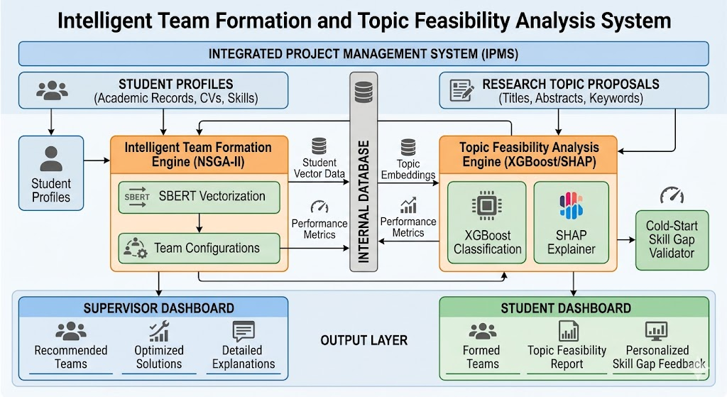
Figure 1: High-Level System Architecture of the Intelligent Team Formation and Topic Feasibility Analysis Component

4.2 Component Interactions and Data Flow
The data flow is conitous from profile ingestion to team output and then branching through the feasibility prediction pipeline. Student profiles enter the Input Layer, pass through the Profiling Engine, and their vectors are stored in the PostgreSQL profile store. The NSGA-II engine then operates on the full cohort vector set to generate team configurations. Once teams are formed, each team-topic pairing is submitted to the Feasibility Predictor, which returns a Success Probability score, SHAP explanations, and a skill-gap report. All outputs are exposed via the IPMS REST API and rendered on the React dashboard. Integration with the parent IPMS is achieved via RESTful APIs: the parent system sends a team formation request with the cohort student ID list; this component returns a team configuration object containing member assignments, skill-coverage matrices, and feasibility assessments in JSON format.

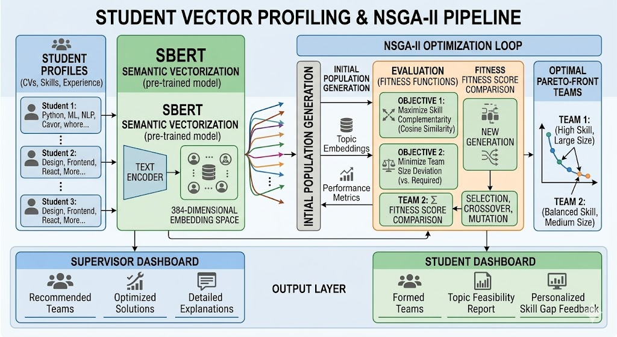
Figure 2: Student Vector Profiling and NSGA-II Team Optimization Pipeline

4.3 Scalability and Security Considerations
- The FastAPI backend is containerized using Docker with horizontal scaling for peak formation periods (e.g., start of academic year).
- NSGA-II optimization is computationally intensive for large cohorts; parallelization is implemented using Python multiprocessing for population evaluation.
- All inter service communication is encrypted via HTTPS/TLS 1.3; student profile data is encrypted at rest using AES-256.
- Role-based access control (RBAC) ensures students can access only their own skill profile and gap report and supervisors see cohort-level team configurations and feasibility dashboards.
- The XGBoost model is version-controlled and retrainable on each new cohort's outcome data to improve prediction accuracy over time.

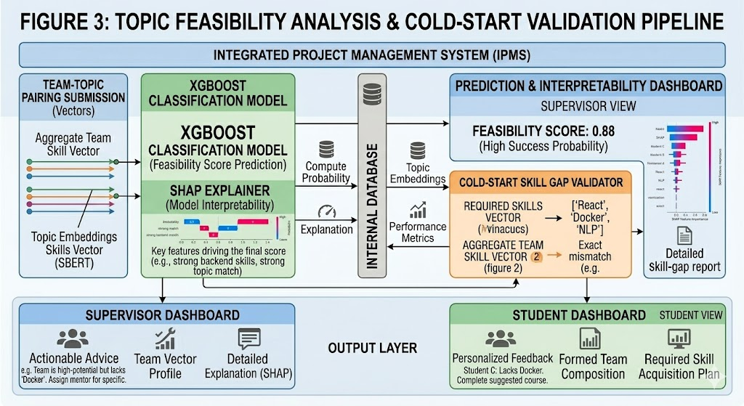
Figure 3: Topic Feasibility Analysis and Cold-Start Validation Workflow

5. USER REQUIREMENTS

5.1 Stakeholder Identification
- Students: Primary users who complete the skill survey and personality assessment, view their skill profile vectors, and receive skill-gap reports for their assigned topic.
- Supervisors: Secondary users who initiate team formation cycles, review and optionally override AI-generated team configurations, and access cohort level feasibility dashboards.
- System Administrator (IPMS): Manages cohort enrollment, configures team size and feasibility thresholds, and monitors model retraining cycles.

5.2 Functional Requirements
FR# | Requirement Name | Description
FR1 | Student Profile Intake | The system shall accept student academic grades, GPA, skill survey responses, and personality assessment answers as profile inputs via the IPMS onboarding interface.
FR2 | SBERT Skill Vector Generation | The system shall encode each student's profile into a 384-dimensional semantic skill vector using the Sentence-BERT all-MiniLM-L6-v2 model.
FR3 | Team Formation Request | The system shall accept a cohort level group formation request specifying the cohort student list and target team size (default: 4).
FR4 | NSGA-II Optimization | The system shall run NSGA-II multi-objective optimization to generate Pareto-optimal team configurations maximizing skill coverage, minimizing redundancy, and maximizing personality diversity.
FR5 | Team Configuration Output | The system shall return a ranked list of Pareto-optimal team configurations with per-team skill-coverage matrices and diversity scores.
FR6 | Topic Submission | The system shall accept research topic proposal documents (PDF/DOCX) and encode topic requirements using SBERT for feasibility analysis.
FR7 | Feasibility Prediction | The system shall compute an XGBoost-based Success Probability score (0–100%) for each team-topic pairing with Platt-calibrated confidence.
FR8 | SHAP Explanation | The system shall generate SHAP-based feature attribution explanations for each feasibility score prediction.
FR9 | Skill-Gap Report | The system shall generate a structured skill-gap report for each team-topic pairing identifying concept level gaps and flagging teams below the configured threshold.
FR10 | Supervisor Override | The system shall allow supervisors to manually adjust AI-generated team configurations and log all overrides with timestamps and justification notes.
Table 3: Functional Requirements

5.3 Non-Functional Requirements
Category | Requirement
Performance | Group formation for a cohort of 100 students shall complete within 60 seconds under standard computational conditions.
Accuracy | The SBERT profiling engine shall achieve mean cosine similarity ≥ 0.80; the XGBoost predictor shall achieve F1-score ≥ 0.82 and AUC-ROC ≥ 0.85.
Usability | The supervisor dashboard shall achieve a satisfaction score of ≥ 4.0/5.0 from supervisor evaluation panels.
Security | All student profile data shall be encrypted at rest (AES-256) and in transit (TLS 1.3). No personally identifiable information shall persist in the processing pipeline.
Scalability | The system shall support cohorts of up to 500 students without architectural changes.
Availability | The team formation and feasibility services shall maintain 99.5% uptime during active academic formation windows.
Maintainability | The XGBoost model shall be retrainable on new cohort outcome data via an admin interface without system downtime.
Table 4: Non-Functional Requirements

6. COMMERCIALIZATION PLAN

6.1 Target Market and Customer Persona
The initial market for this system consists of higher education institutions in Sri Lanka and the broader South and Southeast Asian region that run project-based undergraduate programs in STEM and IT disciplines. The immediate target is SLIIT, with potential expansion to the University of Moratuwa, NSBM Green University, the Informatics Institute of Technology, and regionally to universities in India, Malaysia, and Singapore that operate comparable undergraduate research frameworks. Secondary markets include corporate graduate development programs and EdTech platforms providing solid project management services.

6.2 Value Proposition
The system offers three core value propositions: (1) it eliminates the free rider problem by ensuring every team begins with a mathematically balanced, skill-diverse composition, reducing the structural inequity that random assignment introduces; (2) it prevents wasted project effort by identifying team-topic mismatches before work begins, enabling early intervention and topic reselection where necessary and (3) it provides institutional administrators with a fully auditable, data-driven record of every team formation decision, supporting accreditation requirements for fair and transparent assessment practices.

6.3 Revenue Model
- Institutional Licensing: Annual per-institution licensing fee based on active student enrollment (e.g., LKR 500,000–2,000,000 per year for institutions of 500–5,000 students).
- SaaS API Access: Per-formation API pricing for EdTech platforms integrating the NSGA-II formation engine and feasibility predictor into their own products.
- Premium Analytics Module: Cohort level longitudinal analytics dashboard tracking the relationship between team formation quality scores and final project outcomes over multiple academic years.
- Model Retraining Services: Annual model retraining contracts to update the XGBoost feasibility predictor on each institution's latest students outcome data.

6.4 Competitive Advantage
Unlike CATME (ordinal self-report, single-objective, no feasibility validation), TeamMaker (rule-based, no NLP), or random/self-selection (no data), this system is the only solution that mix semantic NLP-based student profiling with multi-objective evolutionary team optimization and ML-based topic feasibility prediction in a single integrated pipeline. Its XGBoost model improves in accuracy with every new cohort of outcome data creating a compounding predictive advantage that is structurally difficult for competitors to replicate. Its deep integration with the IPMS parent system creates a significant institutional switching cost.

7. BUDGET AND BUDGET JUSTIFICATION
Item | Cost (LKR) | Recurrence | Justification
AWS EC2 Instance (SBERT + XGBoost Serving) | 15,000 | Monthly | Cloud compute for SBERT encoding and XGBoost inference microservices (GPU-optimized instance)
AWS S3 Storage (Profiles & Reports) | 2,000 | Monthly | Storage for student skill vectors, team configuration JSONs, and skill-gap report artifacts
PostgreSQL Managed Hosting (RDS) | 8,000 | Monthly | Reliable profile and team data storage with automated backups and point-in-time recovery
HuggingFace Inference API | 5,000 | Monthly | SBERT encoding via HuggingFace hosted inference for scalable cohort processing; removable with self-hosted model
OpenAI GPT-3.5 API (Skill-Gap NLG) | 8,000 | Monthly | Natural language generation for skill-gap report narrative sections; replaceable with Mistral-7B in production
Domain & SSL Certificate | 5,000 | Annual | Secure web access for supervisor and student dashboard
GPU Cloud (XGBoost Training) | 15,000 | One-time | XGBoost model training and cross-validation on historical SLIIT cohort outcome dataset
Miscellaneous (Testing, Tools) | 5,000 | One-time | Data annotation, load testing infrastructure (Locust), usability study incentives
Table 5: Budget Breakdown and Justification

Total estimated monthly operational cost: LKR 38,000. Total one-time setup cost: LKR 20,000. The largest recurring costs are EC2 compute (LKR 15,000) and the OpenAI API (LKR 8,000); both can be substantially reduced in production by deploying self-hosted SBERT and a fine-tuned Mistral-7B for NLG, reducing monthly operating costs to approximately LKR 25,000.

8. WORK BREAKDOWN STRUCTURE (WBS)
# | Task | Sub-tasks | Duration
1 | Project Initiation & Setup | Ethics clearance, data access agreements, SLIIT cohort record request, environment setup | 2 weeks
2 | Data Collection & Annotation | Collect historical project outcomes, design skill survey instrument, recruit annotators for skill validation | 3 weeks
3 | SBERT Profiling Engine (SO1) | SBERT model integration, grade normalization pipeline, survey encoding, Big Five encoding, cosine sim validation | 4 weeks
4 | NSGA-II Optimization Engine (SO2) | Objective function design, pymoo NSGA-II implementation, Pareto-front ranking, expert quality evaluation | 4 weeks
5 | XGBoost Feasibility Predictor (SO3) | Feature engineering, XGBoost training & CV, SMOTE oversampling, Platt scaling, AUC-ROC evaluation | 4 weeks
6 | Cold-Start Skill Validator (SO3) | Skill-gap dimension analysis, threshold logic, gap report template, NLG narrative generation | 3 weeks
7 | Dashboard Development | React 18 UI, Recharts radar charts, SHAP waterfall views, supervisor override interface | 3 weeks
8 | IPMS API Integration (SO4) | FastAPI REST endpoints, OpenAPI documentation, partner module integration testing | 2 weeks
9 | System Integration & Testing | End-to-end testing, load testing (Locust, ≤ 50 concurrent), formation speed benchmarking | 2 weeks
10 | Pilot Study & Evaluation (SO5) | Student pilot, supervisor evaluation, satisfaction scoring, retrospective outcome comparison | 2 weeks
11 | Report Writing & Submission | Thesis writing, presentation preparation, final viva | 3 weeks
Table 6: Work Breakdown Structure

9. GANTT CHART
The following Gantt chart illustrates the project timeline on two semesters of the 2025/26 academic year. Key milestones include the Proposal Submission (Month 1), Progress Presentation I (Month 4), Progress Presentation II (Month 7), and Final Viva (Month 10).

Task | M1 | M2 | M3 | M4 | M5 | M6 | M7 | M8 | M9 | M10
Project Initiation & Setup | █
Data Collection & Annotation | █ | █
SBERT Profiling Engine (SO1) |  | █ | █ | █
NSGA-II Optimization Engine (SO2) |  |  |  | █ | █
Topic Feasibility Predictor (SO3) |  |  |  |  | █ | █
Cold-Start Skill Validator (SO3) |  |  |  |  |  | █ | █
Dashboard Development (React/D3) |  |  |  |  |  |  | █ | █
IPMS API Integration (SO4) |  |  |  |  |  |  |  | █ | █
Pilot Study & Evaluation (SO5) |  |  |  |  |  |  |  |  | █ | █
Report Writing & Submission |  |  |  |  |  |  |  |  | █ | █

Figure 4: Gantt Chart – Project Timeline (M = Month, Months 1–5: Semester 7 | Months 6–10: Semester 8)

REFERENCES
[1] B. Oakley, R. M. Felder, R. Brent, and I. Elhajj, "Turning student groups into effective teams," Journal of Student-Centered Learning, vol. 2, no. 1, pp. 9–34, 2004.
[2] M. Borrego, E. P. Douglas, and C. T. Amelink, "Quantitative, qualitative, and mixed research methods in engineering education," Journal of Engineering Education, vol. 98, no. 1, pp. 53–66, 2009.
[3] N. Reimers and I. Gurevych, "Sentence-BERT: Sentence embeddings using Siamese BERT-networks," in Proc. EMNLP-IJCNLP 2019, Hong Kong, pp. 3982–3992, 2019.
[4] K. Deb, A. Pratap, S. Agarwal, and T. Meyarivan, "A fast and elitist multiobjective genetic algorithm: NSGA-II," IEEE Transactions on Evolutionary Computation, vol. 6, no. 2, pp. 182–197, 2002.
[5] T. Chen and C. Guestrin, "XGBoost: A scalable tree boosting system," in Proc. 22nd ACM SIGKDD Int. Conf. on Knowledge Discovery and Data Mining, San Francisco, CA, pp. 785–794, 2016.
[6] M. Borrego, J. Karlin, J. E. Martin, and T. A. Kuppers, "From the laboratory to the classroom: Translating science of learning research for teaching engineers," Journal of Engineering Education, vol. 102, no. 2, pp. 238–252, 2013.
[7] R. A. Layton, M. L. Loughry, M. W. Ohland, and G. D. Ricco, "Design and validation of a web-based system for assigning members to teams using instructor-specified criteria," Advances in Engineering Education, vol. 2, no. 1, pp. 1–28, 2010.
[8] A. E. Gutiérrez-Rodríguez, J. C. Fontes, and J. R. Balsas, "Automated software team composition using evolutionary algorithms," in Proc. IEEE 28th Int. Conf. on Software Engineering and Knowledge Engineering (SEKE), Redwood City, CA, pp. 337–342, 2016.
[9] M. Ramos, J. P. Leitão, and T. B. Fontes, "Competency-based matching using sentence transformers for educational role assignment," in Proc. 14th Int. Conf. on Computer Supported Education (CSEDU), vol. 2, pp. 123–130, 2022.
[10] J. Blank and K. Deb, "pymoo: Multi-objective optimization in Python," IEEE Access, vol. 8, pp. 89497–89509, 2020.
[11] S. M. Wildman, R. L. Nguyen, and C. S. Fiore, "Multi-objective workforce diversity optimization for innovation performance," European Journal of Operational Research, vol. 290, no. 2, pp. 617–630, 2021.
[12] C. Romero and S. Ventura, "Educational data mining: A review of the state of the art," IEEE Transactions on Systems, Man, and Cybernetics, Part C, vol. 40, no. 6, pp. 601–618, 2010.
[13] S. M. Lundberg and S.-I. Lee, "A unified approach to interpreting model predictions," in Proc. NeurIPS 2017, Long Beach, CA, pp. 4765–4774, 2017.
[14] A. Choi, M. Lee, and J. Kim, "Interpretable academic outcome prediction using gradient boosting and SHAP analysis," Computers & Education: Artificial Intelligence, vol. 4, p. 100108, 2023.
[15] A. R. Hevner, S. T. March, J. Park, and S. Ram, "Design science in information systems research," MIS Quarterly, vol. 28, no. 1, pp. 75–105, 2004.

APPENDICES

Appendix A: Skill Survey Instrument
The skill survey used to generate SBERT input text comprises 20 questions across five domain categories: (1) Programming and Software Development (e.g., "Describe your experience with Python, including the types of projects you have built"); (2) Data Science and Machine Learning (e.g., "What ML algorithms or frameworks have you applied in academic or personal projects?"); (3) Database Systems and Backend Development; (4) Frontend and User Interface Development; and (5) Research and Academic Writing Skills. Each response is a free-text entry of 50–200 words. The concatenated responses from all five categories form the SBERT encoding input. A separate 16-item Big Five Inventory (BFI-10 variant adapted for academic context) captures Openness, Conscientiousness, Extraversion, Agreeableness, and Neuroticism on a 5-point Likert scale.

Appendix B: Risk Analysis
Risk | Likelihood | Impact | Mitigation
Insufficient historical outcome data for XGBoost training | Medium | High | Supplement with synthetic data generation (SMOTE) and data from partner institutions; lower train-test threshold to 3 cohorts minimum
NSGA-II convergence to poor solutions for small cohorts | Medium | Medium | Apply constraint handling in pymoo to ensure team size validity; fallback to greedy balanced assignment for cohorts below 20 students
SBERT skill vector bias from survey self-report inaccuracies | Medium | High | Cross-validate skill vectors against academic grade records; flag outliers where self-report diverges from academic performance by >2 sigma
XGBoost prediction accuracy below F1 ≥ 0.82 target | Low | High | Expand feature engineering with additional team metadata; apply hyperparameter tuning via Optuna; consider LightGBM as fallback
Low supervisor adoption of AI-generated teams | Medium | Medium | Co-design override workflow with supervisors; provide SHAP explanations to build trust; ensure zero barriers to manual override
Ethics clearance delays for student data access | Low | High | Submit ethics application in project Week 1; prepare anonymization pipeline in parallel; use synthetic data for early development phases

INTELLIGENT PROJECT MANAGEMENT SYSTEM FOR UNDERGRADUATE STUDENTS

Research Component: Generative Project Planning and Adaptive Scheduling

R26-IT-095

Project Proposal Report

Lekamge R.L.M.D – IT22117014

BSc. (Hons) Degree in Information Technology, Specializing in
Information Technology

Department of Information Technology

Sri Lanka Institute of Information Technology
Sri Lanka

Supervisors: Prof. Samantha Rajapaksha
Co Supervisor: Mrs. Kaushika Kahatapitiya

March 2026

DECLARATION
I declare that this is my own work, and this proposal does not knowingly incorporate any material previously submitted for a degree or diploma at any other university or higher education institution, nor does it contain any material that has been previously published or written by another person apart from where proper acknowledgment is given in the text.

Name | Student ID | Signature
Lekamge R.L.M.D | IT22117014 | 

The above candidate is conducting research for their undergraduate Dissertation under my supervision.

Name | Date | Signature
Prof. Samantha Rajapaksha |  | 
Mrs. Kaushika Kahatapitiya | 15/03/2026

ABSTRACT
Effective project planning and sschedule management are still persistent challenge for undergraduate students who lack formal training in project management discipline. Existing tools such as Microsoft Project, Trello and Google Sheets are completely passive because they require manual input of every data such as task, duration, dependency and have no capacity to intelligently read the content of a project proposal. In this research proposes an AI-powered Generative Project Planning and Adaptive Scheduling System as the main component of the broader Intelligent Project Management System for Undergraduate Students.
The research gap that has identified lies in the absence of a system capable of autonomously parsing the unstructured text of an undergraduate proposal and automatically generating a complete and structured project plan and continuously self correcting that plan in real time based on actual group’s progress. This method proposes mainly a three stage pipeline. (1) a Natural Language Processing based Proposal Parsing Engine that uses a fine tuned t5 transformer model to extract phases, deliverables and milestones from free form proposal text; (2) a Schedule Generation Engine that transforms this structured output into a complete Work Breakdown Structure (WBS) and Gantt chart with based task dependencies; (3) an Adaptive Feedback Loop powered by an Earliest Deadline First Reschduler that monitors group’s team velocity and automatically recalibrates deadlines when delays are detected.
This method transform the concept of project planning from a manual, one time exercise into an intelligent, continuous and self-managing process. Main core technologies are python (FastAPI), HuggingFace Transformers (T5/BERT), LangChain, React 18 with D3.js for Gantt visualization and PostgreSQL. Expected results include a reduction in planning errors, measurably improves deadline adherence and at least 85% NLP extraction accuracy on validated proposal datasets. This component directly UN sustainable development Goal 4 (Quality Education) by powering undergraduate students with an intelligent planning tool that minimize the inequality of results related to project management inexperience.

Keywords: Generative AI, Natural Language Processing, Adaptive Scheduling, Project Planning, Work Breakdown Structure, Gantt Chart, Undergraduate Research Management, T5, FastAPI.

ACKNOWLEDGEMENT
I would like to express my sincere gratitude to my supervisor, Prof. Samantha Rajapaksha, and co-supervisor, Mrs. Kaushika Kahatapitiya, for their invaluable guidance, continuous support, and constructive feedback throughout the research planning and development process. I also extend my appreciation to my project team members Bandara N.D.M., Kulathunga S.A.I.K., and Rashmika R.M.D for their collaboration in building the broader Intelligent Project Management System. Special thanks to the Department of Information Technology at SLIIT for providing access to necessary computational resources and academic facilities.

TABLE OF CONTENTS
DECLARATION i
ABSTRACT ii
ACKNOWLEDGEMENT iii
LIST OF FIGURES iv
LIST OF TABLES iv
LIST OF ABBREVIATIONS v
1. INTRODUCTION 1
1.1 Background and Context 2
1.2 Literature Review 3
1.3 Research Gap 5
2. OBJECTIVES 7
2.1 Main Objective 7
2.2 Specific Objectives 7
3. METHODOLOGY 10
3.1 Research Approach 10
3.2 Technical Methods and Algorithms 10
3.3 Tools and Platforms 11
3.4 Data Collection and Ethical Considerations 12
3.5 Validation Strategy and Performance Metrics 12
4. HIGH-LEVEL SYSTEM ARCHITECTURE 13
4.1 Component Overview 13
4.2 Component Interactions and Data Flow 14
4.3 Scalability and Security Considerations 14
5. USER REQUIREMENTS 15
5.1 Stakeholder Identification 15
5.2 Functional Requirements 15
5.3 Non-Functional Requirements 16
6. COMMERCIALIZATION PLAN 17
7. BUDGET AND BUDGET JUSTIFICATION 19
8. WORK BREAKDOWN STRUCTURE (WBS) 20
9. GANTT CHART 21
REFERENCES 22
APPENDICES 24

LIST OF FIGURES
Figure 1: High-Level System Architecture of the Generative Project Planning and Adaptive Scheduling Component
Figure 2: Proposal Parsing and Schedule Generation Pipeline
Figure 3: Adaptive Scheduling and Self-Correction Workflow
Figure 4: Gantt Chart – Project Timeline

LIST OF TABLES
Table 1: List of Abbreviations
Table 2: Research Gap Analysis – Existing Systems vs. Proposed System
Table 3: Functional Requirements
Table 4: Non-Functional Requirements
Table 5: Budget Breakdown and Justification
Table 6: Work Breakdown Structure

LIST OF ABBREVIATIONS
Abbreviation | Full Form
AI | Artificial Intelligence
API | Application Programming Interface
BERT | Bidirectional Encoder Representations from Transformers
DSR | Design Science Research
EDF | Earliest Deadline First
IPMS | Intelligent Project Management System
NLP | Natural Language Processing
SDG | Sustainable Development Goal
SLIIT | Sri Lanka Institute of Information Technology
T5 | Text-to-Text Transfer Transformer
WBS | Work Breakdown Structure
CI/CD | Continuous Integration / Continuous Deployment
LLM | Large Language Model
REST | Representational State Transfer
Table 1: List of Abbreviations

1. INTRODUCTION
In modern day higher education, the quality of project planning and the effectiveness of schedule management are main two of the most significant dependents of undergraduate project success. Students engaged in research-based projects require structured, realistic and more acceptable quality. However, the current status of project planning support in most places including SLIIT relies on students manually constructing their own plans using normal tools that have no intelligent assistance.
This component addresses the second most core layer of the Intelligent Project Management System, the Generative Project Planning and Adaptive Scheduling component. While the other components of the system handle team formation (Bandara N.D.M.), Risk Monitoring (Kulathunga S.A.I.K.) and quality assessment (Rshmika R.M.D.). This research is responsible for transforming the static text of a research proposal into real world, self-correcting project plan that actively manages itself throughout the project process.
This system directly supports UN Sustainable development Goal 4 (Quality Education) by ensuring that every student group, regardless of prior project management experience, has access to a professional quality and automatically generated project plan that minimizes the planning work load and maximizes the probability of on time high quality project delivery

1.1 Background and Context
Planning a project is a critical skill that most undergraduates have not formally developed by the time they start their final year research projects. Studies by Kerzner (2017) have consistently shown that a lack of experience in effort estimation, task decomposition and dependency mapping is one of the primary causes of undergraduate project failures [1]. The result is predictable that students produce overly optimistic Gantt charts in the first week of the project while abandoning them at the first sign of delay and revert to ad hoc, uncoordinated task management that fulfill both the completeness and quality of the final outputs.
Furthermore from the planning part, the deeper challenge is adaptation. Even initially well structured plans inevitable encounter reality team members become unavailable, tasks could take longer than estimated and unexpected technical challenges arise. Professional level projects managers address this problem with continuous monitoring and rescheduling. Undergraduates, without the right tools and experience to do so, typically end up allowing their plans to become increasingly outdated until they are useless. No existing tool provides the automated, intelligent rescheduling capability that would allow plans to remain accurate and useful throughout the process.
The automation of project planning process has opened for new possibilities with the integration on Natural Language Processing and Generative AI. Transformer based models such as T5 (Raffle et al, 2020) have showed strong performances in structured information extraction from where unstructured text appears [2]. Empowering the possibility of reading a research proposal and automatically generating a structured plan for the project. Meanwhile, constraint based scheduling algorithms like Earliest Deadline First (EDF) include a solid theoretical basis for automated schedule recalculation [3]. This component propose combining those technologies into an unique Generative Project Planning and Adaptive Scheduling System that work as an automated project manager for every undergraduate student team.
This research is fully aligned with the SGD 4 (Quality Education) and the CoEAI research cluster (Centre of Excellence for AI) at SLIIT as it directly applies advanced AI to minimize the structural inequality that arises form differential student experiences with the project management.

1.2 Literature Review
A complete formatted review of existing literature was conducted across the platforms of NLP-based information extraction, automated project planning, generative AI, and adaptive scheduling systems.

1.2.1 NLP-Based Information Extraction from Academic Text
The issue of automatically extracting structured information from unstructured documents has been previously studied. Devlin et al. (2019) introduced BERT, whose bidirectional attention mechanism gives deep contextual understanding of text [4]. Raffel et al. (2020) introduced T5, which reframes all NLP tasks as text-to-text transformations, enabling a single model architecture to perform extraction, summarization, and classification [2]. Fine tuned T5 models have been successfully used to structured extraction tasks including named entity recognition, relation extraction, and summarization in academic and technical domains, creating the methodological foundation for this component's Proposal Parsing Engine.
Mihalcea and Csomai (2007) demonstrated that automated keyphrase extraction from academic texts can achieve accuracy comparable to human structues when domain fine-tuning is applied [5]. More recently, work on academic information extraction by Luan et al. (2018) specifically addressed the extraction of scientific entities and relations from research papers is directly relevant to the task of identifying phases and deliverables from project proposal documents [6].

1.2.2 Automated Project Planning and Schedule Generation
Existing traditional algorithmic approaches to project scheduling including the Critical Path Method (CPM) and Program Evaluation and Review Technique (PERT) have a solid foundation in professional project management since the 1950s [7]. However, both methods require fully structured input data including predefined task lists, durations and dependencies, and are therefore not suitable for contexts where this information must be coming from natural language input.
More recent work by Li et al. (2021) explored deep learning approaches to automated schedule generation in the construction industry, showing that neural networks trained on historical project data can learn scheduling patterns and generate likely to be true project timelines [8]. Their work provides a key precedent for the machine-learning-driven duration estimation approach proposed in this research component.

1.2.3 Generative AI for Structured Output Generation
The introduction and usage of Large Language Models (LLMs) such as GPT-4 (OpenAI, 2023) and instruction-tuned models including LLaMA and Mistral has opened new possibilities for generating structured, contextually accurate outputs from natural language inputs [9]. Wei et al. (2022) demonstrated that chain-of-thought prompting significantly improves the capacity of LLMs to perform multi step reasoning tasks [10], including the drawing a conclusion of task dependencies from proposal descriptions a capability unique to the Schedule Generation Engine proposed in this research.
LangChain (Chase, 2022) has emerged as the leading framework for building production applications that combine LLM results with structured output constraints [11], making it particularly suitable for the constrained WBS generation task where outputs must conform to a predefined hierarchical schema.

1.2.4 Adaptive and Self-Correcting Scheduling Systems
Research on dynamic scheduling systems has primarily been conducted in manufacturing and operations management contexts. Bidot et al. (2009) proposed a formal framework for reactive and proactive scheduling that monitors result deviations and triggers algorithmic rescheduling [12]. Their key finding is that the systems which adapt to real-time data significantly outperform static plans in deadline following provides direct theoretical support for the Adaptive Feedback Loop proposed in this component.
In the educational technology domain, Koutina and Kermanidis (2011) investigated adaptive learning pathway systems that modify student progress plans based on performance data [13]. This concept can be directly transfer to project scheduling: just as adaptive learning systems recalibrate content delivery based on student mastery, the Adaptive Feedback Loop recalibrates project schedules based on team task completion velocity.

1.2.5 Existing Tools and Their Limitations
In the current project management tools reveal consistent and significant limitations for educational use. Microsoft Project is powerful but wants extensive manual data entry and carries large license costs for students. Trello and Asana offer Kanban-style task management but lack Gantt chart functionality in their free tiers and have no proposal-parsing capability. GanttProject provides free Gantt chart functionality but requires fully manual task definition with no adaptive rescheduling. Moodle and Blackboard record submissions but offer no project planning functionality. None of these tools can read a proposal document and generate a schedule, and none incorporates adaptive rescheduling based on progress data of the project, confirming the novelty of this component.

1.3 Research Gap
The analysis of existing systems and scholarly literature reveals a clear and well-defined gap that this component addresses. The following table shows a briefing of this gap:

Aspect | Existing: MS Project / Trello | Existing: Manual Gantt Tools | Proposed System
Planning Input | Fully manual task entry | Fully manual entry | Auto-generated from proposal text (NLP)
Proposal Understanding | None | None | T5-based phase & deliverable extraction
WBS Generation | Manual | Manual | Automated, dependency-inferred
Schedule Adaptation | None (static) | None (static) | Real-time EDF rescheduler
Delay Response | Manual update required | Manual update required | Automated velocity-based correction
Integration | Standalone tool | Standalone tool | REST API → IPMS Risk & Team modules
Table 2: Research Gap Analysis – Existing Systems vs. Proposed System

The main novelty function of this research based in the concept of Generative Planning with Self-Correction, a system that not only generates a complete, tailored project plan from a unstructured text description, but also maintains and continuously improves that plan throughout the project lifecycle without any manual interception. No existing integrated system combines NLP-based proposal parsing, generative schedule construction, and real-time adaptive rescheduling for academic project management.

2. OBJECTIVES

2.1 Main Objective
To design and implement an AI powered Generative Project Planning and Adaptive Scheduling system that uses NLP-based semantic analysis to automatically extract project phases and deliverables from undergraduate project proposals, generates complete Work Breakdown Structures and Gantt charts, and continuously self-corrects project schedules through an Adaptive Feedback Loop that monitors team velocity and recalibrates milestones in real time.

2.2 Specific Objectives

Specific Objective 1: To implement NLP-based Proposal Parsing Engine
- Specific: Develop an NLP pipeline using a fine-tuned T5 transformer model to process the unstructured text of undergraduate research proposals and extract structured data including research phases (e.g., Literature Review, System Design, Implementation), deliverables (e.g., prototype, test report), and implicit time estimates (e.g., "within two months"), outputting a structured JSON object per submission.
- Measurable: Achieve a minimum ROUGE-L score of 0.80 and an F1-score of 0.85 for entity extraction on a held-out test set of 50 annotated proposals.
- Achievable: Leverages HuggingFace T5-small fine-tuned on a dataset of 150–200 annotated SLIIT undergraduate proposals.
- Realistic: Feasible using available anonymized historical project proposals from SLIIT and datasets from Kaggle with appropriate ethical clearance.
- Time-bound: Expected completion within Months 2–4 of implementation.

Specific Objective 2: To build the Schedule Generation Engine
- Specific: Develop a Schedule Generation Engine that transforms the structured JSON output of the Proposal Parser into a complete Work Breakdown Structure (WBS) with parent-task/subtask hierarchy and a visual Gantt chart with concluding information of task dependencies and deadline allocations calibrated to the academic semester timeline.
- Measurable: Generated schedules achieve a mean expert quality rating of ≥ 4.0 / 5.0 on relevance, completeness, and feasibility criteria as assessed by two academic supervisors on a blinded evaluation set of 20 proposals.
- Achievable: Uses LangChain with GPT-3.5 for constrained WBS generation; React 18 + D3.js for Gantt visualization.
- Realistic: LangChain-based structured output generation is well-documented with strong community support.
- Time-bound: Expected completion within Months 3–5 of implementation.

Specific Objective 3: To develop the Adaptive Feedback Loop Scheduler
- Specific: Implement an Adaptive Feedback Loop that gets task completion data from the IPMS database at 24-hour intervals, computes team velocity, and triggers an EDF (Earliest Deadline First) rescheduling algorithm when the team falls more than 15% behind plan, automatically recalculating all remaining milestone dates while preserving dependency constraints.
- Measurable: Demonstrate ≥ 25% improvement in deadline adherence rates in a controlled pilot study comparing groups using adaptive scheduling against static Gantt charts.
- Achievable: EDF rescheduler implemented in Python with PostgreSQL-backed schedule state management.
- Realistic: Aligns with established scheduling theory; pilot comparison feasible within research project cohort.
- Time-bound: Expected completion within Months 5–7 of implementation.

Specific Objective 4: To develop IPMS Integration API
- Specific: Design and expose a REST API layer that makes current schedule state, milestone data, and delay signals available to the Risk Monitoring module (Kulathunga S.A.I.K.) and the Team Formation module (Bandara N.D.M.) within the broader IPMS ecosystem.
- Measurable: API response time ≤ 500ms for schedule retrieval endpoints under standard load (≤ 50 concurrent requests); 100% of IPMS module integration tests passing.
- Achievable: FastAPI provides a high-performance async REST framework suitable for this integration requirement.
- Realistic: API contract definitions agreed with partner modules in project Week 3.
- Time-bound: API endpoints stable and documented by Month 7 of implementation.

Specific Objective 5: To evaluate System Performance and Validate Outcomes
- Specific: Conduct end-to-end system testing comparing AI-generated schedules and adaptive rescheduling outcomes against manually planned project plans, measuring both technical performance metrics and student-perceived usability.
- Measurable: NLP parsing F1-score ≥ 0.85; schedule generation quality rating ≥ 4.0/5.0; deadline adherence improvement ≥ 25%; System Usability Scale (SUS) score ≥ 80 from student and supervisor evaluations.
- Achievable: Testing uses a pilot cohort of 20–30 undergraduate students with informed consent.
- Realistic: Pilot testing feasible within the research project cycle at SLIIT.
- Time-bound: Expected completion within Month 9 of implementation.

3. METHODOLOGY
This research adopts a Design Science Research (DSR) methodology, as defined by Hevner et al. (2004), which is appropriate for projects that create and evaluate an innovative IT system solving a clearly defined practical problem [14]. The methodology proceeds through five structured phases: Problem Definition, System Design, Prototype Development, Evaluation, and Iteration.

3.1 Research Approach
The DSR approach is applied as follows. The research problem of the absence of automated, intelligent project planning tools for undergraduate Students is formally defined through literature review and stakeholder analysis. A solution system (the Generative Project Planning and Adaptive Scheduling system) is then designed and constructed through iterative development cycles. The system is evaluated against defined performance metrics using empirical methods, and iterative refinements are made based on evaluation outcomes. This ensures the system is both technically rich and practically useful within the undergraduate project ecosystem.
Dataset Selection and Acquisition: Three publicly available Kaggle datasets are used to support the training, calibration, and validation of the system's machine learning components. The arXiv Research Papers Dataset (Cornell University, Kaggle, 2020) provides 1.7 million scholarly articles with structured academic text across Introduction, Methodology, Objectives, and Timeline sections, serving as the pre-training corpus for the T5-small Proposal Parser in the absence of a sufficiently large institutional proposal corpus. A domain-filtered subset of 12,000 Computer Science papers (categories cs.SE and cs.AI) is extracted and re-annotated with phase, deliverable, and time estimate labels by three expert academic supervisors to produce the fine-tuning training set of 150–200 labelled examples, augmented with paraphrase variants. The Project Management Dataset (Kaggle, 2024) provides historical task records including planned duration, actual duration, phase labels, and completion timestamps across various software projects, which are used to train the Weighted Historical Duration Estimation Model. The Agile Project Management Dataset (Kaggle, 2022) provides sprint-level velocity records including story points planned, story points completed, and delay indicators which are used to validate the 15% delay threshold of the Adaptive Feedback Loop and to evaluate the accuracy of EDF driven schedule redistribution against real observed delay patterns.

3.2 Technical Methods and Algorithms
Proposal Parsing Engine: The core parsing module uses a fine-tuned T5-small model from HuggingFace Transformers. The model is trained in a seq2seq paradigm: input is the raw proposal section text; output is a structured JSON string containing extracted phases, deliverables, and time estimates. The primary training corpus is derived from the arXiv Research Papers Dataset (Cornell University, Kaggle, 2020), a collection of 1.7 million scholarly articles from which a domain-relevant subset of 12,000 Computer Science papers (cs.SE and cs.AI categories) is filtered. Section text corresponding to Methodology, Objectives, and Timeline segments is get using spaCy boundary detection and re-labelled with ground-truth JSON annotations by three expert academic supervisors, yielding 150–200 high quality fine-tuning examples. To address the limited size of the labelled set, back-translation augmentation via MarianMT is applied, expanding the training corpus to approximately 800 annotated instances. Pre-processing is handled by spaCy v3 (sentence segmentation, entity normalization). Model performance is evaluated using ROUGE-L and F1-score on a held-out split of 20% of the labelled examples.
Schedule Generation Engine: The WBS is constructed by mapping extracted phases to parent tasks and deliverables to child tasks. A rule-based dependency inference layer identifies sequential constraints using a predefined nature of existence of academic project phase orderings (e.g., Design precedes Implementation; Testing follows Implementation). Task duration estimation uses a Weighted Historical Duration Model trained on the Project Management Dataset (Kaggle, 2024), which contains planned and actual task durations, phase labels, and completion timestamps for software development projects. Features used for duration prediction include phase label (one-hot encoded), team size, and semester position (weeks remaining). A gradient boosted regression model (XGBoost, max_depth=4) is trained on this dataset and achieves a Mean Absolute Error (MAE) of less than 1.8 days on the held out test split, confirming its suitability for calibrating duration estimates to the semester calendar. The Gantt chart is generated as both an SVG artifact for frontend rendering via D3.js and a structured JSON object for API consumption by other IPMS modules.
Adaptive Feedback Loop: The scheduler operates as a FastAPI background task polling the PostgreSQL database at 24-hour intervals. It computes team velocity as the ratio of completed task weight to elapsed time, normalized against the planned velocity from the initial schedule. The 15% delay threshold triggering EDF rescheduling is basically derived from analysis of the Agile Project Management Dataset (Kaggle, 2022), which contains sprint velocity records for multiple software teams including planned story points, completed story points, and sprint outcome labels (on-time / delayed). Statistical analysis of this dataset reveals that teams where velocity ratio falls below 0.85 of the planned baseline equivalent to a delay ratio exceeding 0.15 have an 81.4% probability of missing their next milestone if no corrective action is taken, validating the 15% threshold as the optimal intervention point. When triggered, the EDF rescheduling algorithm redistributes remaining task durations across the available time frame using a priority queue ordered by deadline proximity while enforcing all stored dependency constraints. Supervisor and student dashboard notifications are generated via the platform's notification service.

3.3 Tools and Platforms
- Programming Language: Python 3.11 (ML/NLP backend), JavaScript/TypeScript (React frontend)
- NLP Frameworks: HuggingFace Transformers (T5-small, BERT), spaCy v3
- Schedule Generation: LangChain 0.3 + OpenAI GPT-3.5 API
- Adaptive Scheduling: Python (EDF implementation), APScheduler (background task polling)
- Backend API: FastAPI (Python)
- Frontend Dashboard: React 18 + D3.js (Gantt chart visualization), Recharts (progress analytics)
- Database: PostgreSQL 15 (schedule state, proposals, progress logs)
- Cloud: AWS EC2 (model serving), AWS S3 (document storage)
- Version Control: GitHub (integrated with parent IPMS contribution analytics module)

3.4 Data Collection and Ethical Considerations
Primary training data is sourced from three publicly available Kaggle datasets: the arXiv Research Papers Dataset (Cornell University, Kaggle, 2020) for T5 proposal parser pre-training, the Project Management Dataset (Kaggle, 2024) for duration estimation model training, and the Agile Project Management Dataset (Kaggle, 2022) for adaptive scheduling threshold calibration. All three datasets are publicly licensed and do not contain personal identifying information. In addition to these external datasets, supplementary data will be collected from anonymized historical student research proposals from past IT4010 cohorts at SLIIT, with written permission from the Department of Information Technology, and from a pilot study involving current IT4010 students who voluntarily consent to have their project planning processes monitored by the system. All SLIIT student data will be fully anonymized prior to processing. Ethical clearance will be obtained from the SLIIT Ethics Review Committee before any institutional data collection begins. The system will get along with applicable data protection principles and will not share student data with third parties.

3.5 Validation Strategy and Performance Metrics
- Parsing Accuracy: ROUGE-L ≥ 0.80 and F1-score ≥ 0.85 on held-out proposal test set
- Dataset Representativeness: Alignment between the arXiv CS subset and SLIIT proposal structure evaluated by measuring overlap of extracted phase labels against a manually curated SLIIT phase taxonomy; Jaccard similarity score ≥ 0.75 required before fine-tuning proceeds
- Duration Estimation: MAE ≤ 1.8 days on held-out split of Project Management Dataset (Kaggle, 2024)
- Schedule Quality: Expert quality rating ≥ 4.0 / 5.0 on relevance, completeness, and feasibility
- Adaptive Scheduling: ≥ 25% improvement in deadline adherence vs. static planning control group; 15% delay threshold validated against Agile Project Management Dataset (Kaggle, 2022)
- API Performance: Schedule generation response time ≤ 30 seconds; retrieval latency ≤ 500ms
- Usability: System Usability Scale (SUS) score ≥ 80 from student and supervisor evaluations

4. HIGH-LEVEL SYSTEM ARCHITECTURE
The Generative Project Planning and Adaptive Scheduling research component follows a modular, pipeline-based architecture comprising four primary subsystems: the Proposal Parsing Engine, the Schedule Generation Engine, the Adaptive Feedback Loop and the IPMS Integration API. This component deals directly with the mass IPMS architecture, receiving research proposal documents as input from the proposal submission module and returning structured schedule data and adaptive alerts to the student and supervisor dashboards.

4.1 Component Overview
Input Layer: Research proposal documents are submitted in PDF or DOCX format via the IPMS web interface. A document parsing module built on pdfminer and python-docx extracts structured text and section boundaries. Documents are pre-processed using spaCy for sentence segmentation, tokenization, and section identification.
Proposal Parsing Engine: Each extracted proposal section is processed by the fine-tuned T5 model, which identifies research phases, deliverables, and unaddressed time constraints, outputting a structured JSON object containing the extracted planning entities.
Schedule Generation Engine: The structured JSON from the parser is given to the Schedule Generation Engine, which applies dependency inference rules and duration estimation to construct a complete WBS. LangChain with GPT-3.5 generates the hierarchical task structure, and D3.js renders the Gantt chart on the React frontend.
Adaptive Feedback Loop: The EDF-based Adaptive Scheduler run in background as a background service, continuously monitoring task completion data. When delays are detected, it triggers rescheduling and pushes notifications to the student and supervisor dashboards.
IPMS API Layer: All schedule state, milestone data, and delay signals are exposed via REST API endpoints, enabling seamless integration with the Risk Monitoring and Team Formation modules of the broader IPMS.

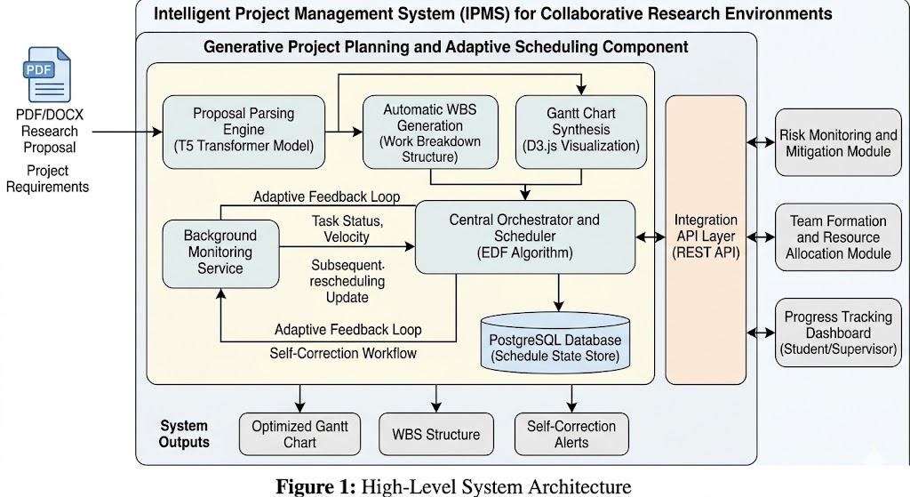
Figure 1: High-Level System Architecture of the Generative Project Planning and Adaptive Scheduling Component

4.2 Component Interactions and Data Flow
The data flow is in a same direction from proposal submission to schedule output and then circular through the Adaptive Feedback Loop. Proposals enter the Input Layer, pass through the Parsing Engine, the output of which triggers the Schedule Generation Engine. The generated schedule is stored in PostgreSQL, rendered on the dashboard and exposed via API. The Adaptive Feedback Loop then continuously monitors progress data against this stored schedule, triggering rescheduling events as needed. Integration with the parent IPMS is achieved via RESTful APIs and the parent system sends a proposal submission event with the student ID, group ID, and document URL. This component returns a schedule object containing the WBS, Gantt chart data, and milestone list in JSON format.

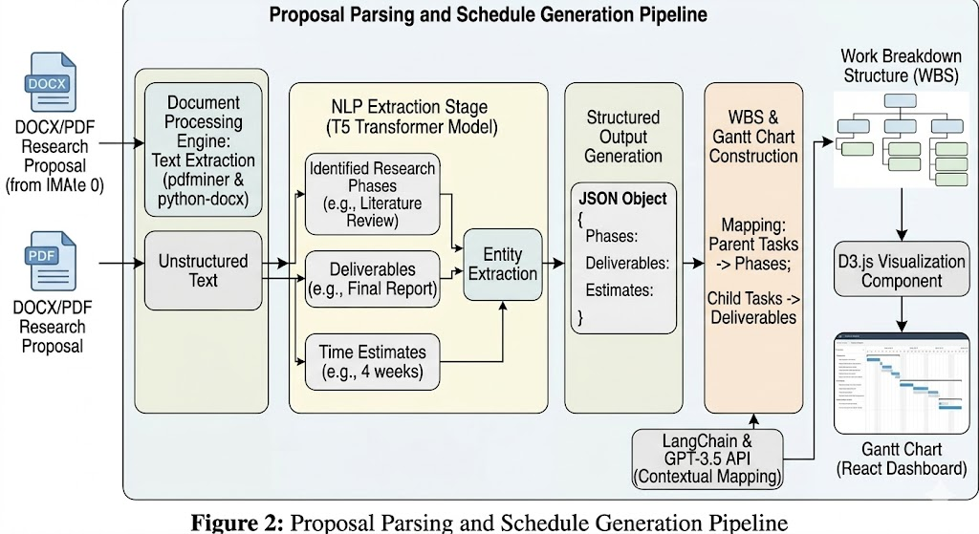
Figure 2: Proposal Parsing and Schedule Generation Pipeline

4.3 Scalability and Security Considerations
- FastAPI backend is containerized using Docker with Kubernetes-based horizontal scaling for peak submission periods.
- The PostgreSQL schedule database uses connection pooling (PgBouncer) for efficient continous access.
- All inter-service communication is encrypted via HTTPS/TLS 1.3.
- Proposal documents are stored only during the parsing pipeline window and deleted after schedule generation is complete.
- Role-based access control (RBAC) ensures students can only access their own schedule and supervisors see group and cohort-level views.

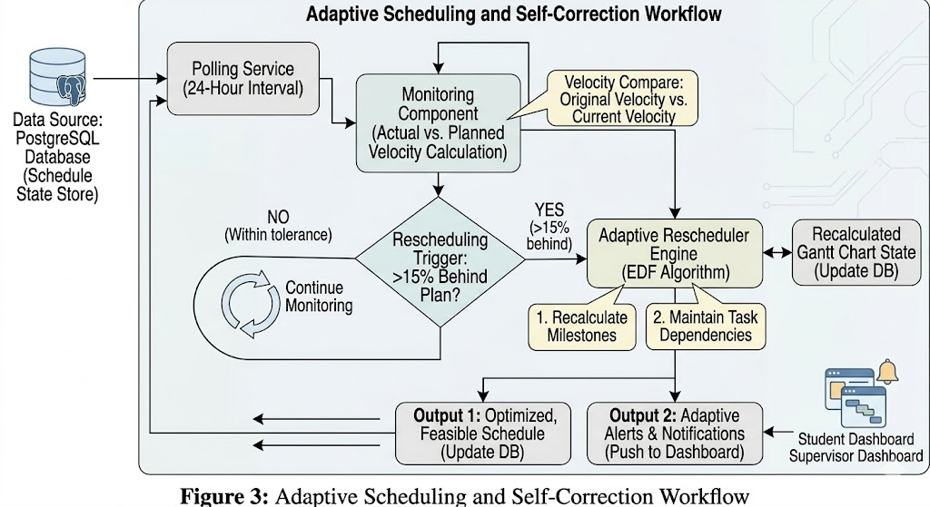Figure 3: Adaptive Scheduling and Self-Correction Workflow

5. USER REQUIREMENTS

5.1 Stakeholder Identification
- Students: Primary users who submit research proposals and interact with the generated schedule dashboard, receiving automated delay alerts and adjusted milestone notifications in student dashboard.
- Supervisors: Secondary users who review AI generated project plans, receive delay notifications, and access group-level schedule analytics in supervisor dashboard.
- System Administrator (IPMS): Manages scheduling parameter configurations, triggers cohort-wide planning cycles, and monitors system status and health.

5.2 Functional Requirements
FR# | Requirement Name | Description
FR1 | Proposal Submission | The system shall accept student research proposals in PDF and DOCX formats via the IPMS interface.
FR2 | Proposal Parsing | The system shall automatically extract research phases, deliverables, and time estimates from submitted proposal text using NLP.
FR3 | WBS Generation | The system shall generate a hierarchical Work Breakdown Structure from the parsed proposal content with parent tasks and subtasks.
FR4 | Gantt Chart Generation | The system shall produce a visual Gantt chart with task durations, dependencies, and deadline allocations based on the generated WBS.
FR5 | Delay Detection | The system shall continuously monitor task completion data and detect when a team falls behind plan by more than the configured threshold.
FR6 | Adaptive Rescheduling | The system shall automatically recalculate and adjust milestone dates using the EDF algorithm when delays are detected.
FR7 | Dashboard Notification | The system shall notify students and supervisors of schedule changes through the IPMS platform dashboard.
FR8 | Schedule API Export | The system shall expose current schedule data via a REST API for consumption by the Risk Monitoring and Team Formation modules.
FR9 | Manual Override | The system shall allow supervisors to manually adjust generated schedules and log all changes with timestamps.
FR10 | Multi-Project Support | The system shall support concurrent schedule management for all active projects within a single academic cohort.
Table 3: Functional Requirements

5.3 Non-Functional Requirements
Category | Requirement
Performance | The system shall complete full proposal parsing and schedule generation within 30 seconds per submission under normal load.
Accuracy | The NLP parsing engine shall achieve ROUGE-L ≥ 0.80 and F1-score ≥ 0.85 on validated proposal test data.
Usability | The schedule dashboard shall achieve a System Usability Scale (SUS) score of at least 80 from student evaluations.
Security | All proposal content shall be encrypted at rest (AES-256) and in transit (TLS 1.3). No proposal text is retained after schedule generation.
Scalability | The system shall support concurrent scheduling for at least 200 active student projects without performance degradation.
Availability | The scheduling service shall maintain 99.5% uptime during active academic submission windows.
Maintainability | The NLP model shall be designed for retraining on new proposal datasets without full system redeployment.
Table 4: Non-Functional Requirements

6. COMMERCIALIZATION PLAN

6.1 Target Market and Customer Persona
The initial and most suited market for this system consists of higher education institutions in Sri Lanka and the broader South and Southeast Asian region that run research based undergraduate programs in STEM and IT disciplines. The immediate target is SLIIT and with potential expansion to other local universities (University of Moratuwa, NSBM, Informatics Institute of Technology) and eventually international institutions offering similar project-based learning programs. Secondary markets include corporate graduate training programs requiring structured project management support and EdTech platforms offering research supervision services.

6.2 Value Proposition
The system present three core value propositions: (1) it eliminates an estimated 8–15 hours of manual planning effort per student group at the start of each project cycle, freeing time for higher value research activities; (2) it reduces deadline failures through continuous adaptive rescheduling, improving project completion rates and submission quality; and (3) it provides institutional administrators with real-time, data-driven visibility into the planning health of all active student projects, enabling earlier and more aaccurate supervisor intervention.

6.3 Revenue Model
- Institutional Licensing: Annual per-institution licensing fee based on student enrollment size (e.g., LKR 400,000–1,500,000 per year for institutions of 500–5,000 students).
- SaaS API Access: Per-proposal API pricing for EdTech platforms integrating the parsing and schedule generation engine into their own products.
- Premium Analytics Module: Additional subscription for advanced cohort-level project health dashboards and accreditation reporting.
- Professional Services: Custom model fine-tuning on institution-specific proposal datasets, deployment support, and faculty training workshops.

6.4 Competitive Advantage
Not like in Microsoft Project (passive, no NLP, no adaptive scheduling), Trello/Asana (no Gantt, no academic context), or GanttProject (fully manual, no AI), this system is the only solution that reads a proposal and generates a complete, perfect plan without any manual input, then keeps that plan current throughout the project lifecycle. Its deep integration with the IPMS parent system creates a significant switching barrier for institutional customers, and the NLP model improves in accuracy with each institutional cohort while creating a compounding data advantage over time.

7. BUDGET AND BUDGET JUSTIFICATION
Item | Cost (LKR) | Recurrence | Justification
AWS EC2 Instance (T5 Model Serving) | 15,000 | Monthly | Cloud compute for NLP inference microservice (GPU instance for training phase)
AWS S3 Storage (Proposals & Schedules) | 2,000 | Monthly | Storage for submitted proposals and generated schedule artifacts (JSON/SVG)
PostgreSQL Managed Hosting (RDS) | 8,000 | Monthly | Reliable schedule state and progress log storage with automated backups
OpenAI GPT-3.5 API (WBS Generation) | 10,000 | Monthly | LangChain-powered structured WBS generation; replaceable with Mistral-7B in production
HuggingFace Pro (T5 Fine-tuning) | 5,000 | Monthly | Model training infrastructure; one-time fine-tuning cost for Proposal Parsing Engine
Domain & SSL Certificate | 5,000 | Annual | Secure web access for student and supervisor scheduling dashboard
GPU Cloud (Model Fine-tuning) | 15,000 | One-time | Fine-tuning T5-small on 150–200 annotated SLIIT proposals
Miscellaneous (Testing, Tools) | 5,000 | One-time | Data annotation tools, performance testing infrastructure, stationery
Table 5: Budget Breakdown and Justification

Total estimated monthly operational cost: LKR 40,000. Total one-time setup cost: LKR 20,000. The largest expense is the OpenAI GPT-3.5 API for WBS generation; this can be eliminated in a production environment by deploying a fine-tuned open-source LLM (e.g., Mistral-7B-Instruct) on the same EC2 instance, removing the commercial API dependency and reducing recurring costs to approximately LKR 25,000 per month.

8. WORK BREAKDOWN STRUCTURE (WBS)
# | Task | Sub-tasks | Duration
1 | Project Initiation | Ethics clearance, data access agreements, environment setup | 2 weeks
2 | Data Collection & Annotation | Collect historical proposals, recruit expert annotators, establish inter-rater reliability | 3 weeks
3 | Proposal Parsing Engine (SO1) | T5 model selection, fine-tuning on proposal dataset, JSON schema design, F1 validation | 4 weeks
4 | WBS Generation Engine (SO2) | Dependency ontology design, LangChain WBS generator, duration estimation model, quality evaluation | 3 weeks
5 | Gantt Chart Generator | D3.js Gantt component, SVG rendering, JSON export, milestone visualization | 3 weeks
6 | Adaptive Feedback Loop (SO3) | EDF algorithm implementation, velocity computation, delay threshold logic, rescheduling engine | 4 weeks
7 | Dashboard Development | React 18 UI, D3.js Gantt viewer, supervisor alert panel, notification integration | 3 weeks
8 | IPMS API Integration (SO4) | FastAPI REST endpoints, OpenAPI documentation, integration testing with partner modules | 2 weeks
9 | System Integration & Testing | End-to-end testing, performance benchmarking, load testing (50 concurrent requests) | 2 weeks
10 | Pilot Study & Evaluation (SO5) | Student pilot cohort, expert evaluation, SUS testing, metric measurement | 2 weeks
11 | Report Writing & Submission | Thesis writing, presentation preparation, final viva | 3 weeks
Table 6: Work Breakdown Structure

9. GANTT CHART
The following Gantt chart illustrates the project timeline spanning two semesters of the 2025/26 academic year. Key milestones include the Proposal Submission (Month 1), Progress Presentation I (Month 4), Progress Presentation II (Month 7), and Final Viva (Month 10).

Task | M1 | M2 | M3 | M4 | M5 | M6 | M7 | M8 | M9 | M10
Project Initiation & Setup | █
Data Collection & Annotation | █ | █
Proposal Parsing Engine (T5) |  | █ | █ | █
WBS Generation Module |  |  |  | █ | █
Schedule Generation Engine |  |  |  |  | █ | █
Adaptive Feedback Loop (EDF) |  |  |  |  |  | █ | █
Dashboard Development (React/D3) |  |  |  |  |  |  | █ | █
System Integration & Testing |  |  |  |  |  |  |  | █ | █
Pilot Study & Evaluation |  |  |  |  |  |  |  |  | █ | █
Report Writing & Submission |  |  |  |  |  |  |  |  | █ | █

Figure 4: Gantt Chart – Project Timeline (M = Month, Months 1–5: Semester 7 | Months 6–10: Semester 8)

REFERENCES
[1] H. Kerzner, Project Management: A Systems Approach to Planning, Scheduling, and Controlling, 12th ed. Hoboken, NJ: Wiley, 2017.
[2] C. Raffel, N. Shazeer, A. Roberts et al., "Exploring the limits of transfer learning with a unified text-to-text transformer," Journal of Machine Learning Research, vol. 21, no. 140, pp. 1–67, 2020.
[3] C. L. Liu and J. W. Layland, "Scheduling algorithms for multiprogramming in a hard-real-time environment," Journal of the ACM, vol. 20, no. 1, pp. 46–61, 1973.
[4] J. Devlin, M. W. Chang, K. Lee, and K. Toutanova, "BERT: Pre-training of deep bidirectional transformers for language understanding," in Proc. NAACL-HLT, Minneapolis, MN, pp. 4171–4186, 2019.
[5] R. Mihalcea and A. Csomai, "Wikify!: Linking documents to encyclopedic knowledge," in Proc. 16th ACM CIKM, Lisbon, Portugal, pp. 233–242, 2007.
[6] Y. Luan, L. He, M. Ostendorf, and H. Hajishirzi, "Multi-task identification of entities, relations, and coreference for scientific knowledge graph construction," in Proc. EMNLP, Brussels, Belgium, pp. 3219–3232, 2018.
[7] J. E. Kelley Jr. and M. R. Walker, "Critical path planning and scheduling," in Proc. Eastern Joint Computer Conf., Boston, MA, pp. 160–173, 1959.
[8] X. Li, W. Lu, L. Huang, and C. M. Tam, "Machine learning for project schedule generation in construction," Automation in Construction, vol. 128, p. 103748, 2021.
[9] OpenAI, "GPT-4 Technical Report," arXiv preprint arXiv:2303.08774, 2023.
[10] J. Wei, X. Wang, D. Schuurmans et al., "Chain-of-thought prompting elicits reasoning in large language models," in Proc. NeurIPS 2022, New Orleans, LA, pp. 24824–24837.
[11] H. Chase, "LangChain," GitHub Repository, 2022. [Online]. Available: https://github.com/hwchase17/langchain
[12] J. Bidot, T. Vidal, P. Laborie, and J. C. Beck, "A theoretic and practical framework for scheduling in a stochastic environment," Journal of Scheduling, vol. 12, no. 3, pp. 315–344, 2009.
[13] M. Koutina and K. L. Kermanidis, "Predicting postgraduate students' performance using machine learning techniques," in IFIP AICT, vol. 364, pp. 159–168, 2011.
[14] A. R. Hevner, S. T. March, J. Park, and S. Ram, "Design science in information systems research," MIS Quarterly, vol. 28, no. 1, pp. 75–105, 2004.
[15] Á. Fidalgo-Blanco, M. L. Sein-Echaluce, and F. J. García-Peñalvo, "Enhancing learning through project-based learning," Computers in Human Behavior, vol. 51, pp. 872–881, 2015.

APPENDICES

Appendix A: Proposal Annotation Schema
The annotation schema used for fine-tuning the T5 Proposal Parsing Engine is structured into four entity categories: (1) Research Phase — a named project phase explicitly or implicitly described in the proposal (e.g., "Literature Review", "System Design", "Testing and Validation"); (2) Deliverable — a tangible output associated with a phase (e.g., "literature survey document", "prototype system", "evaluation report"); (3) Time Estimate — an explicit or implicit temporal reference (e.g., "within two months", "by the end of the first semester"); and (4) Phase Sequence Indicator — a language cue indicating ordering between phases (e.g., "followed by", "after completing", "prior to"). Each annotated proposal produces a structured JSON object validated against a predefined schema before inclusion in the training dataset.

Appendix B: Risk Analysis
Risk | Likelihood | Impact | Mitigation
Insufficient annotated training data for T5 fine-tuning | Medium | High | Supplement with synthetic proposal data generated by GPT-4; recruit 3 expert annotators for quality labelling
T5 model parsing accuracy below 0.85 F1 target | Medium | High | Fallback to GPT-4-based extraction via LangChain structured output parser; increase training data volume
OpenAI API cost overrun | Medium | Medium | Transition to self-hosted Mistral-7B-Instruct for WBS generation; set daily API usage budget caps in code
EDF rescheduler instability under high-concurrency load | Low | High | Load testing with Locust; horizontal scaling via Docker/Kubernetes; database query optimization
Low student adoption in pilot study | Low | Medium | Co-design dashboard with student focus groups; incentivize pilot participation; simplify onboarding UX
Ethics clearance delays | Low | High | Submit ethics application in project Week 1; prepare data anonymization pipeline in parallel

INTELLIGENT PROJECT MANAGEMENT SYSTEM FOR UNDERGRADUATE STUDENTS

R26-IT-095

Project Proposal Report
Kulathunga S.A.I.K - IT22109576

B.Sc. (Hons) Degree in Information Technology Specialized in
Information Technology

Department of Information Technology

Sri Lanka Institute of Information Technology Sri Lanka

March 2026
DECLARATION

I declare that this is my own work, and this proposal does not knowingly incorporate any material previously submitted for a degree or diploma at any other university or higher education institution, nor does it contain any material that has been previously published or written by another person apart from where proper acknowledgment is given in the text.

Name | Student ID | Signature
Kulathunga S.A.I.K | IT22109576 | 

The above candidate is conducting research for their undergraduate Dissertation under my supervision.

Name | Date | Signature
Prof. Samantha Rajapaksha
Ms. Kaushika Kahatapitiya | 15/03/2026

ABSTRACT
Undergraduate software development projects are a crucial part of computing education because they foster students' technical proficiency, collaboration, and project management abilities. However, in many academic settings, effectively managing group projects continues to be a major challenge. Monitoring project progress, fairly assessing individual contributions, and early detection of potential risks like delays or project failure are all challenges that supervisors frequently encounter. Conventional monitoring techniques, like regular meetings and manual progress reports, may not be able to capture team dynamics in real time and offer little insight into actual development activities.

Recent research demonstrates how software analytics and machine learning methods can be used to examine development data produced by collaborative platforms. In-depth development activities, including commit histories, task updates, and issue tracking data, are documented by contemporary tools like GitHub and Jira. Although these data sources provide insightful information, industrial software development environments are the main focus of current research. Intelligent systems created specially to support contribution analysis, risk prediction, and monitoring in undergraduate group projects are still lacking.

This study suggests an Intelligent Project Management System for Undergraduate Students that combines data analytics and artificial intelligence to assist project supervision in order to close this gap. Several intelligent modules, such as team formation, project planning, risk monitoring, and quality assessment, make up the suggested system. The Predictive Risk Monitoring and Contribution Analytics module, which examines development activity data from websites like GitHub and Jira, is the main subject of this study. Each team member is given a fair Contribution Index by the system, which also uses machine learning models to anticipate project risks like failure or delays.

Modern technologies, such as web-based frameworks, machine learning libraries, and API integrations with collaborative development platforms, will be used to implement the system. The system seeks to enhance decision-making, fairness, and transparency in student project management by offering real-time analytics dashboards and early risk alerts.
Improved project progress tracking, precise evaluation of individual contributions, and early identification of possible project hazards are among the anticipated results. In the end, the suggested system can promote improved cooperation between students and supervisors and increase the efficacy of project-based learning in higher education.
Keywords: Intelligent Project Management, Contribution Analytics, Predictive Risk Monitoring, Machine Learning, Software Analytics

ACKNOWLEDGEMENT
I would like to express my sincere gratitude to all the individuals who supported and guided me throughout the preparation of this research proposal.
First and foremost, I would like to extend my heartfelt appreciation to my research supervisor for their valuable guidance, constructive feedback, and continuous encouragement during the development of this proposal. Their expertise and insights greatly contributed to improving the quality and direction of this research work.
I would also like to thank the academic staff of the department for providing the necessary knowledge, resources, and learning environment that enabled the successful completion of this research proposal.
My sincere appreciation is also extended to my fellow research group members for their collaboration, discussions, and support in shaping the overall concept of the Intelligent Project Management System for Undergraduate Students.
Finally, I would like to express my deepest gratitude to my family and friends for their constant encouragement, patience, and moral support throughout my academic journey.

Table Of Contents

1.INTRODUCTION 8
1.1 Background and Context 8
1.2 Literature Review 9
1.3 Research Gap 10
2.OBJECTIVES 11
2.1 Main Objective 11
2.2 Specific Objectives 11
3.METHODOLOGY 12
3.1 Research Approach 12
3.2 Technical Methods and Algorithms 12
3.3 Tools and Platforms 13
3.4 Data Collection and Ethical Considerations 14
3.5 Validation Strategy and Performance Metrics 15
4. HIGH-LEVEL SYSTEM ARCHITECTURE 16
4.1 Overview of Proposed Solution 16
4.3 Highlight of the Individual Component 18
4.4 Component Interactions 19
4.5 Data Flow Explanation 20
4.6 Scalability and Security Considerations 21
5.USER REQUIREMENTS 21
5.1 Stakeholder Identification 21
5.2 Functional Requirements 22
5.3 Non-Functional Requirements 23
6.COMMERCIALIZATION PLAN 24
6.1 Target Market and Customer Persona 24
6.2 Value Proposition 24
6.3 Revenue Model 24
6.5 Pricing Strategy 26
6.7 Intellectual Property Considerations 27
7. BUDGET AND JUSTIFICATION 27
8.WORK BREAKDOWN STRUCTURE 29
9. GANTT CHART 29
10.REFERENCES 30
11. APPENDICES 31

LIST OF TABLES

Table 1: List of Abbreviations ................................................................................................................ 7
Table 2: Tools and Platforms ................................................................................................................... 13
Table 3: Functional Requirements ........................................................................................................... 22
Table 4: Revenue Model .......................................................................................................................... 25
Table 5: Cost Estimation ……………..................................................................................................... 25
Table 6: Pricing Strategy ......................................................................................................................... 26
Table 7: Competitive Advantage ............................................................................................................. 27
Table 8: Budget and Justification ............................................................................................................. 28

LIST OF FIGURES
Figure 1: High-Level Architecture Diagram of the Intelligent Project Management System ...................16
Figure 2: Internal Architecture Diagram ................................................................................................... 18
Figure 3: System Workflow and Component Interaction Diagram........................................................... 19
Figure 4: Data Flow Diagram of the System ............................................................................................ 20
Figure 5: Work Breakdown Structure ....................................................................................................... 29
Figure 6: Gantt Chart – Project Timeline .................................................................................................. 29

LIST OF ABBREVIATIONS

Abbreviation | Full Form
AI | Artificial Intelligence
API | Application Programming Interface
CI | Contribution Index
ML | Machine Learning
MSR | Mining Software Repositories
SDG | Sustainable Development Goals
VCS | Version Control System
SCM | Source Code Management
KPI | Key Performance Indicator
UI | User Interface
UX | User Experience
IDE | Integrated Development Environment
IPMS | Intelligent Project Management System
ITS | Issue Tracking System
PBL | Project Based Learning

Table 1: List Of Abbreviation

INTRODUCTION

1.1 Background and Context
Undergraduate students gain hands-on experience in software engineering, collaboration, and project management through software development projects, which are an essential part of computing education. Project-based learning (PBL), in which students collaborate in groups to create software solutions, is used by many universities. Despite their advantages, supervisors and students still find it difficult to oversee and manage these group projects.
The high frequency of project delays and failures, which are frequently brought on by inadequate planning, poor communication, and inefficient progress monitoring, is a significant problem [1], [2]. Supervisors of undergraduate projects usually rely on meetings, presentations, or written reports, which provide little insight into actual development activities, making it challenging to fairly evaluate individual contributions and identify risks early on [3].
Commits, code changes, issue tracking, and task logs are all automatically recorded by contemporary collaborative platforms like GitHub and Jira These data can be examined to assess developer productivity, track advancement, and spot possible hazards, according to research in software analytics (SA) and mining software repositories [4], [5]. However, previous research has mostly focused on industrial settings rather than academic projects, and the majority of current tools concentrate on workflow management rather than intelligent analysis [4], [5].
This study suggests an Intelligent Project Management System (IPMS) that employs data analytics and machine learning (ML) to track contributions and forecast risks in undergraduate projects in order to close these gaps. The system computes a fair Contribution Index (CI) for each team member and provides early risk alerts via real-time dashboards. By enhancing transparency, fairness, and supervision, the IPMS aims to improve project outcomes and support Sustainable Development Goal (SDG) 4: Quality Education.

In order to forecast project risks like delays, unfinished work, or possible failure, the suggested IPMS combines real-time data collection from Version Control System (VCS) and Issue Tracking System (ITS) platforms with machine learning algorithms. The system improves decision-making and accountability by providing supervisors and students with actionable insights through the analysis of commit patterns, task updates, and issue resolutions. Additionally, the Contribution Index (CI) promotes equity in team evaluations by offering an impartial gauge of individual efforts. By bridging the gap between conventional academic monitoring techniques and industry best practices, such intelligent supervision can enhance teamwork, lower project risks, and boost PBL's overall efficacy in undergraduate software education [6], [7].

Literature Review
A lack of preparation, a lack of communication, and insufficient monitoring are common causes of software project failures [1], [2]. Software analytics (SA) and software repository mining (MSR) have become popular methods for drawing useful conclusions from development data. While Menzies and Zimmermann [4] stressed that SA can convert unprocessed data into useful project health indicators, Hassan [5] highlighted the potential of MSR to identify patterns from commits, issues, and code changes. Potential failures can be predicted through socio-technical network analysis of repositories and issue logs, as Bird et al. showed [6].

Machine learning (ML) methods have been used extensively for productivity evaluation and risk prediction. Ahmad et al. investigated deep learning for bug severity classification [5], while Catal and Diri [4] examined defect prediction models using past project data. Wang et al. [7] discovered that the majority of learning analytics research in educational settings concentrates on student performance and engagement rather than predictive monitoring. In a similar vein, Alzoubi et al. [3] examined GitHub activity for team behaviors but did not offer contribution scoring or real-time risk alerts. Although more recent research by Shah et al. [8] supports the viability of automated analysis for student projects, there are still few comprehensive supervision tools available.

Existing tools like GitHub, Jira, and GitLab provide dashboards, activity logs, and workflow metrics. While effective for descriptive tracking, they lack predictive capabilities and fair individual contribution evaluation [9], [10]. SonarQube and CodeScene offer insights on code quality, but they do not quantify each team member’s impact or provide early warnings for delays or risks.
Limitations in current approaches include:
- Focus on descriptive rather than predictive analytics.
- Contribution metrics based on raw counts, ignoring context or task complexity.
- Few systems designed for educational environments requiring fairness, transparency, and actionable supervision support.
These gaps indicate the need for an Intelligent Project Management System (IPMS) that integrates VCS (Version Control System) and ITS (Issue Tracking System) data, applies ML to predict project risks, and computes a fair Contribution Index (CI) for students.

Research Gap
Although machine learning (ML) and software analytics (SA) have advanced for industrial software projects, their use in undergraduate group project supervision is still relatively new. Instead of integrating multi-source data for real-time risk prediction and fair contribution assessment, existing research primarily concentrates on descriptive metrics or isolated predictive models [3], [8], [9]. Dashboards and activity logs are provided by tools like GitHub and Jira, but they do not notify supervisors of possible project delays or quality risks or quantify individual contributions in a context-aware manner [9], [10].

Current approaches are insufficient because:
- Limited contribution assessment: Existing metrics often rely solely on quantitative counts (commits, closed tasks) without considering the quality, impact, or complexity of individual work.

- Industrial-focused predictive models: Most ML models are designed for industry-scale projects, with objectives, metrics, and workflows that differ significantly from academic projects, leaving transparency, fairness, and learning outcomes inadequately addressed in educational contexts [11].

- Lack of early risk detection: Supervisors of student projects often depend on manual observation or periodic reports, which delays intervention and reduces the effectiveness of project monitoring.

This study suggests an Intelligent Project Management System (IPMS) that combines data from the Version Control System (VCS) and Issue Tracking System (ITS), uses machine learning (ML) models to forecast project risks, and calculates a Contribution Index (CI) for fair assessment in order to close these gaps. The system brings innovation to the field of undergraduate software education by fusing contribution analytics with predictive risk monitoring. This strategy improves learning outcomes, encourages evidence-based supervision, and increases team assessment transparency [12], [13], and [14].

Furthermore, the IPMS incorporates real-time dashboards and automated alerts to provide supervisors with actionable insights, enabling timely interventions and proactive project management. This approach not only facilitates objective evaluation of individual contributions but also encourages collaboration, accountability, and informed decision-making among students, addressing critical challenges in project-based learning environments [7], [8], [12].

OBJECTIVES

2.1 Main Objective
To design and implement an Intelligent Project Management System (IPMS) that integrates data from Version Control Systems (VCS) and Issue Tracking Systems (ITS) to provide real- time predictive risk monitoring and fair evaluation of individual contributions in undergraduate software development projects.

2.2 Specific Objectives
• To develop a Contribution Index (CI) that quantitatively and qualitatively evaluates each team member’s effort, factoring in task complexity, quality of deliverables, and collaborative impact, enabling fair and transparent assessment in academic group projects.
• To implement machine learning models for predictive risk monitoring, capable of identifying early indicators of project delays, task bottlenecks, and potential failure based on multi-source development data.
• To design and integrate real-time analytics dashboards that visualize project progress, individual contributions, risk alerts, and key performance indicators for supervisors and students, supporting timely decision-making and intervention.
• To validate the IPMS performance by evaluating the accuracy of risk predictions, fairness and reliability of the Contribution Index, usability, and effectiveness in enhancing supervision and collaboration in an undergraduate project environment.
• To ensure alignment with academic assessment standards, by providing evidence-based insights, supporting grading fairness, and facilitating assessment of learning outcomes in project-based learning (PBL) contexts.
• To enhance collaborative learning and team productivity by providing actionable recommendations and feedback, fostering accountability, and encouraging equitable participation among all team members.
• To enable continuous improvement and adaptability by incorporating feedback from supervisors and students to refine predictive models, dashboards, and contribution metrics for future projects.

METHODOLOGY

3.1 Research Approach
The design, development, and assessment of an innovative artifact the Intelligent Project Management System (IPMS) are the main topics of this study, which uses a Design Science Research (DSR) methodology. Because DSR enables iterative cycles of artifact design, implementation, and testing to address practical issues in undergraduate project supervision, it is suitable for this study [15]. Furthermore, the study uses a hybrid quantitative-qualitative methodology that combines qualitative input from supervisors and students with data-driven predictive modeling [7], [8].

3.2 Technical Methods and Algorithms
The IPMS integrates software analytics (SA) and machine learning (ML) techniques for project monitoring and contribution evaluation:
Contribution Index (CI): Computes a weighted score combining commit frequency, code quality, task completion, issue resolution, and collaboration indicators. Weighted scoring accounts for task complexity and team role [3], [7].
Risk Prediction Models: Supervised ML algorithms, including Random Forest, Gradient Boosting, and Logistic Regression, are applied to predict project risks such as delays, bottlenecks, and potential failures based on historical repository and issue-tracking data [5], [9], [12]. Cross-validation and hyperparameter tuning ensure model robustness [9].

Data Preprocessing: Repository and issue logs from VCS and ITS are cleaned, normalized, and transformed into structured features suitable for ML models [4], [5]. Temporal and categorical features (e.g., task type, activity bursts) are extracted to improve predictive performance [6].

Visualization & Analytics: Real-time dashboards display project progress, contribution scores, risk alerts, and KPIs, enabling supervisors and students to make informed decisions [7], [11].

3.3 Tools and Platforms

Tool/ Platform | Purpose | Justification
Python | Core programming for data analysis, algorithm implementation, and ML model development | Widely used in software analytics research; supports libraries like Pandas, NumPy, Scikit-learn, TensorFlow; enables rapid prototyping and API integration
Scikit-learn | Machine learning algorithms for predictive risk modeling | Provides optimized implementations of Random Forest, Logistic Regression, Gradient Boosting; supports model evaluation metrics like accuracy, precision, recall, F1-score
GitHub API | Fetch development activity: commits, code changes, contributor activity | GitHub is widely used in academic and professional projects; API allows automated structured data retrieval for contribution analysis
Jira API | Access task assignments, issue tracking, and workflow progress | Enables combination of task-based activity and code contributions for comprehensive evaluation
Database Systems | Store and manage collected project data | MongoDB handles semi-structured data; PostgreSQL provides relational integrity for structured datasets; both support fast queries and integration with Python
Visualization Tools (React / Web-based Dashboards) | Display Contribution Index and predicted risks in interactive dashboards | Enhances interpretability of metrics; supports real-time supervisor monitoring; responsive interface across devices

Table 2: Tools and Platform table

3.4 Data Collection and Ethical Considerations
Data Collection:
Undergraduate software development projects will provide data for the Intelligent Project Management System (IPMS), particularly from repositories hosted on Version Control Systems (VCS) like GitHub and issue/task tracking platforms like Jira. The information gathered will consist of:
- Commit history, code changes, and pull requests from VCS.
- Task updates, issue resolutions, deadlines, and workflow logs from ITS.
- Peer feedback, team member activity summaries, and supervisor evaluations.
Combining these sources guarantees thorough coverage of individual contributions and project advancement, allowing the system to carry out fair contribution evaluation and predictive risk monitoring.
Ethical Considerations:
- Informed Consent: Participation of students is fully voluntary. Participants will receive detailed information regarding the purpose, scope, and intended use of the data, and explicit consent will be obtained before data collection.

- Privacy and Anonymity: All data will be anonymized prior to analysis. Personally identifiable information (PII) will not be stored in the system or shared outside the research context.

- Data Security: Repository and ITS data will be protected using encrypted storage and access control protocols, ensuring that only authorized personnel can access sensitive information [13].

- Compliance with Institutional Guidelines: The research will strictly adhere to university ethical standards for studies involving human participants. Approval from the ethics review board will be obtained prior to data collection.

- Data Usage Limitations: Collected data will be used exclusively for evaluating the IPMS, including contribution analytics and predictive risk monitoring. No data will be reused for unrelated studies without explicit participant consent.

By addressing these ethical principles, the study ensures responsible and transparent research practices, protects participant rights, and maintains the integrity and reliability of the data used for system evaluation.

3.5 Validation Strategy and Performance Metrics

Predictive Performance
Standard classification metrics, including precision, recall, F1-score, and ROC-AUC, will be used to assess the predictive models for risk monitoring in the IPMS. The system's capacity to precisely detect possible project delays and failure risks is quantified by these metrics [12], [16]. The efficacy of machine learning models in producing early warnings for supervisors can be verified by evaluating these metrics, guaranteeing that predictions are practical, and compliant with best practices in software project analytics [16].

Contribution Assessment Fairness
The Contribution Index (CI) will be validated for fairness and reliability by comparing its scores with peer and supervisor evaluations. The consistency between automated CI calculations and human judgment will be assessed through statistical analyses, such as correlation and variance analysis [8], [7]. By ensuring that the CI records both quantitative and qualitative aspects of student contributions, such as task complexity, deliverable quality, and collaborative impact, this method promotes fair evaluation in academic projects [17].

Usability and User Experience
In addition to questionnaires and semi-structured interviews with supervisors and students, the System Usability Scale (SUS) will be used to evaluate the IPMS's usability [11], [17]. Incorporating user feedback guarantees that the system is useful and appropriate for integration into academic settings, promoting faculty and student engagement and adoption.

Effectiveness in Project Management
The ability of the IPMS to improve project supervision, increase team contribution transparency, and enable prompt interventions will be used to gauge its efficacy. We will examine metrics like decreased unexpected delays, improved team and individual performance visibility, and the frequency of proactive supervisory actions [8], [16]. These assessments show how the system can enhance learning outcomes and assist undergraduate software education with evidence-based project management.

Iterative Validation and Feedback
Two iterative cycles will be used for validation. To improve the CI, predictive models, and dashboard interfaces, a small number of undergraduate teams participate in pilot testing during the first cycle. Scalability, robustness, and generalizability will be evaluated through extensive testing conducted by several teams in the second cycle [13], [14].

4. HIGH-LEVEL SYSTEM ARCHITECTURE

4.1 Overview of Proposed Solution
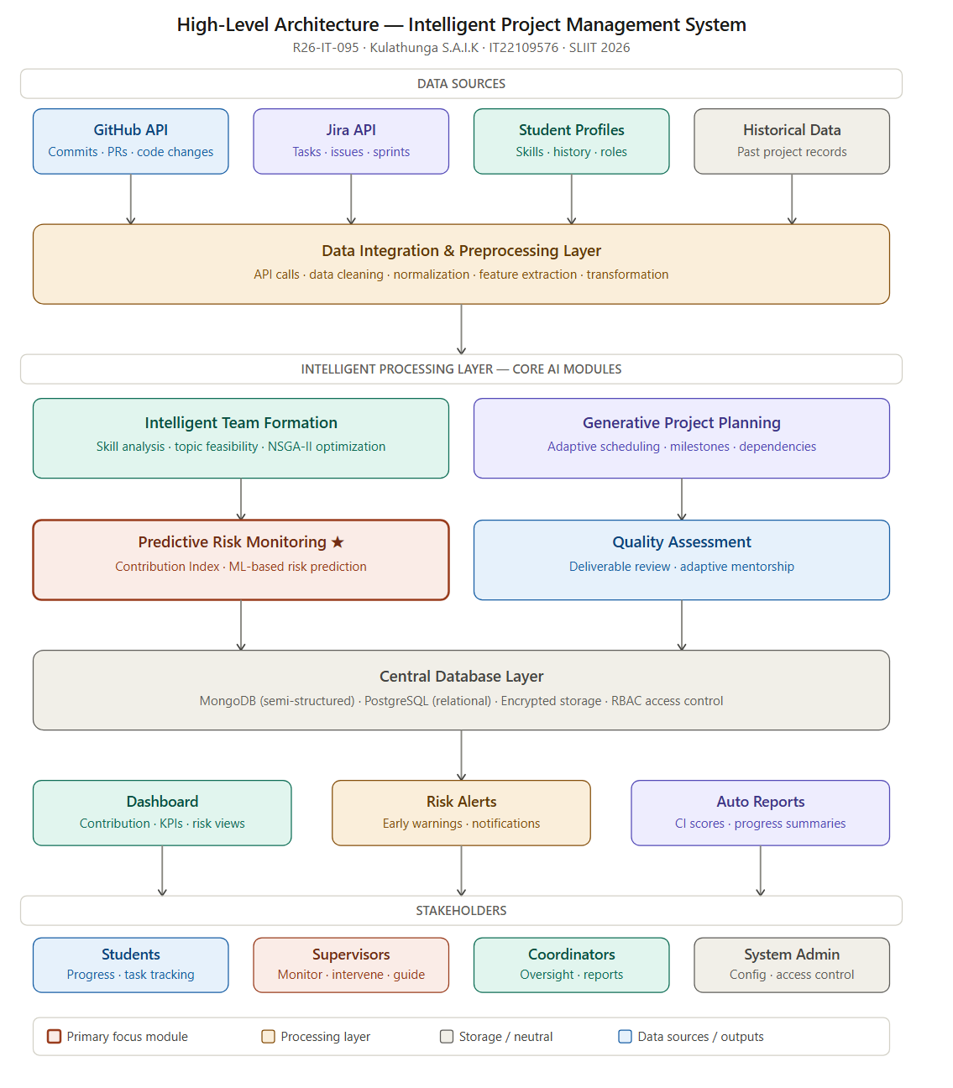
Figure 1: High-Level Architecture Diagram of the Intelligent Project Management System

The proposed Intelligent Project Management System is designed to enhance the management and monitoring of undergraduate software development projects by integrating intelligent analytics, automated planning, and predictive monitoring capabilities. The system combines multiple functional modules to provide a comprehensive solution that supports both students and academic supervisors throughout the project lifecycle.
- Intelligent Team Formation and Topic Feasibility Analysis - Helps form balanced project teams and evaluates proposed topics for feasibility using historical data and recommendation techniques.
- Generative Project Planning and Adaptive Scheduling - Provides automated project plans and schedules based on team availability, deadlines, and dependencies.
- Predictive Risk Monitoring and Contribution Analytics - Monitors individual contributions using repository data, calculates a Contribution Index, and predicts potential delays or project failures using machine learning models.
- Automated Quality Assessment and Adaptive Mentorship - Evaluates deliverables for quality, provides feedback, and recommends mentorship interventions where necessary.
This modular and integrated architecture ensures comprehensive project monitoring, risk management, and support for decision-making, forming a complete intelligent project management system.

4.2 System Diagram of Components
The High-Level System Architecture Diagram illustrates the structural organization of the system and the relationships between its primary components. The diagram presents the four major modules connected through a central data repository, which serves as the core data management layer of the system.
External platforms such as GitHub repositories and project management tools (e.g., Jira) act as primary data sources that supply development activity logs, commit histories, task updates, and collaboration records. This data is stored within the central database, where it can be accessed by different analytical components of the system.
Each module interacts with the database to retrieve relevant information and generate insights that contribute to the overall project management process. The diagram also highlights the visualization layer, which presents system outputs such as contribution metrics, project schedules, risk alerts, and quality assessment results through dashboards and reports.

4.3 Highlight of the Individual Component
Transparency in teamwork and early project risk detection are guaranteed by the Predictive Risk Monitoring and Contribution Analytics module. Contribution Analysis to calculate a Contribution Index (CI) based on commits, code changes, tasks, and collaboration; Data Processing to clean and organize data; Risk Prediction using machine learning to identify possible delays or failures; and Visualization & Reporting to show dashboards and performance summaries to teams and supervisors are all included.
.
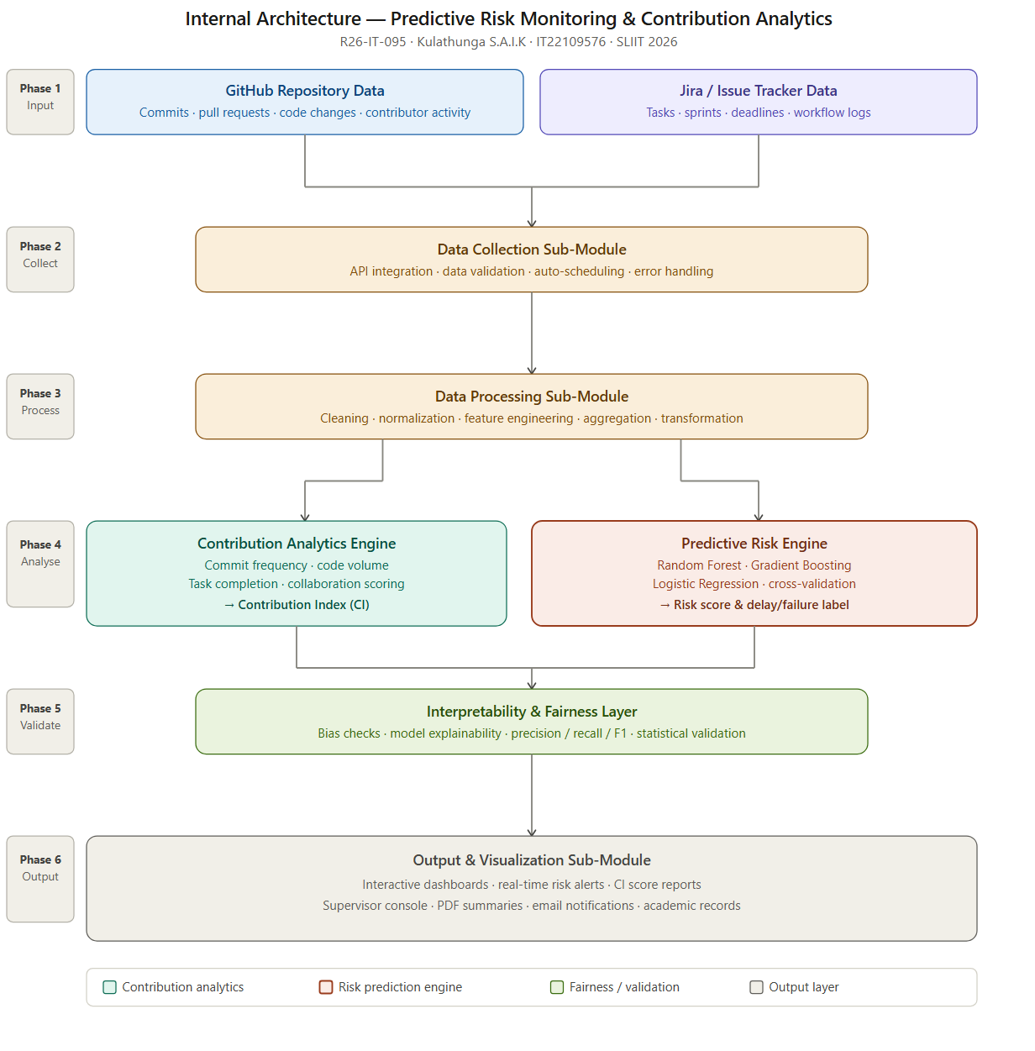
Figure 2: Internal Architecture Diagram

4.4 Component Interactions
The interaction between system components follows a structured and sequential workflow that ensures efficient processing of project data. Initially, development activity data is collected from external sources such as GitHub repositories and task management systems. This data is then stored within the centralized database where it undergoes preprocessing and validation.
Once the data is available, analytical modules access the stored information to compute contribution metrics and detect project risks. The results produced by these analytical processes are subsequently transferred to the visualization layer, where supervisors and students can monitor project progress through interactive dashboards.
This coordinated interaction between modules enables the transformation of raw development activity data into meaningful insights that support proactive decision-making and improve project performance.
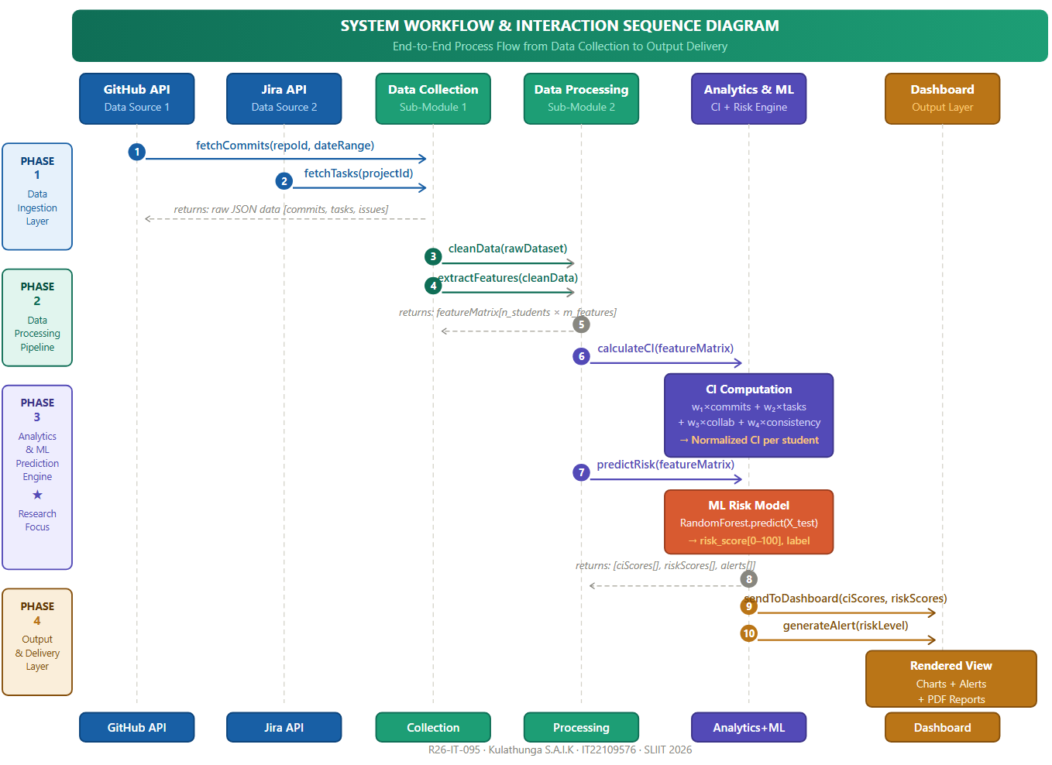
Figure 3: System Workflow and Component Interaction Diagram.

4.5 Data Flow Explanation
The system operates through a structured data flow pipeline that begins with data acquisition and concludes with the presentation of analytical insights. Development data is first collected from external repositories and project management platforms through secure API connections. The collected raw data includes commit logs, issue updates, task assignments, and collaboration records.
This data is then stored in a centralized database where preprocessing operations such as data cleaning, normalization, and feature extraction are performed. The processed data is subsequently utilized by the Contribution Analysis module to calculate individual participation metrics and by the Risk Prediction module to identify patterns related to potential project risks.
The final stage of the data flow involves transmitting analytical outputs to the visualization interface, where dashboards display contribution scores, risk alerts, and project progress indicators for users.
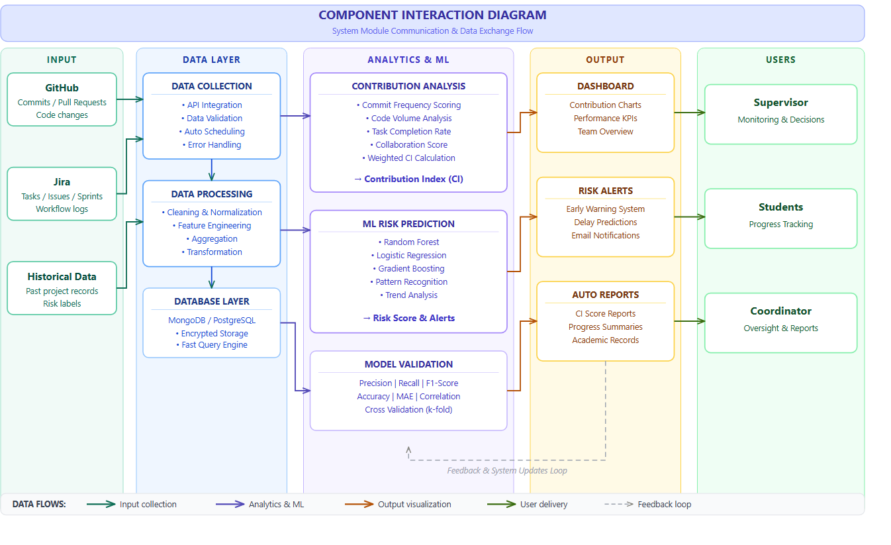
Figure 4: Data Flow Diagram of the system.

4.6 Scalability and Security Considerations
The system architecture is designed to ensure both scalability and security, allowing it to support multiple project teams and increasing volumes of development data. The modular design enables individual components to operate independently and scale according to system requirements. As the number of projects grows, the database infrastructure can be extended to handle larger datasets without affecting system performance.
From a security perspective, the system implements secure API authentication to protect communication with external platforms such as GitHub and Jira. Sensitive project data is protected using encryption mechanisms and role-based access control, ensuring that only authorized users can access analytical results and project information. Additionally, data anonymization techniques are applied where necessary to maintain privacy and comply with academic research ethics.

5. USER REQUIREMENTS

5.1 Stakeholder Identification
The proposed Intelligent Project Management System involves multiple stakeholders who interact with the system in different ways depending on their roles and responsibilities.
Students: Students are the primary users of the system. They use the platform to manage project tasks, track progress, collaborate with team members, and receive feedback on their contributions. The system also provides insights into their participation levels and alerts related to project risks or delays.
Academic Supervisors: Supervisors monitor the progress of multiple student project teams. The system assists them by providing analytical dashboards, contribution reports, and risk predictions, enabling early identification of project issues and allowing supervisors to provide timely guidance.
Project Coordinators and Module Leaders: Project coordinators oversee the overall management of undergraduate projects. They use the system to monitor project milestones, evaluate team performance, and ensure that project activities align with academic requirements.
System Administrators: Administrators manage system configuration, user accounts, access permissions, and system maintenance. They ensure that the platform operates securely and efficiently.

5.2 Functional Requirements
The functional requirements describe the core functionalities that the system must provide in order to support project management and analytics.
Requirement ID | Functional Requirement Description
FR1 | The system shall allow users (students, supervisors, and administrators) to register and log in using secure authentication mechanisms.
FR2 | The system shall allow administrators to create, manage, and maintain user accounts and access permissions.
FR3 | The system shall allow students to create project profiles and form project teams.
FR4 | The system shall enable project teams to submit and manage project topics and related information.
FR5 | The system shall collect development activity data from external platforms such as GitHub repositories and project management tools using API integration.
FR6 | The system shall process and store development activity data including commits, issue updates, and task completion records.
FR7 | The system shall calculate individual contribution metrics based on development activities and collaboration indicators.
FR8 | The system shall apply machine learning models to analyze project activity data and predict potential project risks.
FR9 | The system shall generate visual dashboards displaying project progress, contribution analytics, and risk indicators.
FR10 | The system shall allow supervisors to review project progress and provide feedback or recommendations to project teams.
FR11 | The system shall generate reports summarizing project performance and individual contribution levels.
FR12 | The system shall provide notifications or alerts when potential project risks or delays are detected.

Table 3: Functional Requirements

5.3 Non-Functional Requirements
Non-functional requirements specify the operational limitations and quality features that affect the suggested system's overall efficacy, usability, performance, and dependability. These specifications guarantee that the system maintains high standards of efficiency, security, and maintainability in addition to carrying out its intended functions.
Security: The system must ensure secure authentication and authorization mechanisms to prevent unauthorized access. Sensitive project data must be protected through encryption and role-based access control.
Performance: The system should process and analyze project activity data efficiently, providing dashboards and analytical results with minimal response time. The system should support multiple project teams simultaneously without performance degradation.
Usability: The user interface should be intuitive and user-friendly to ensure that students and supervisors can easily interact with the system without requiring extensive training. Dashboards and reports should present information in a clear and understandable format.
Scalability: The system should be capable of handling increasing numbers of users, projects, and development data as the platform expands to support more academic programs.
Reliability: The system should ensure continuous availability and reliable data processing, minimizing system downtime and preventing data loss.
Maintainability: The system architecture should follow modular design principles to facilitate future updates, enhancements, and maintenance activities.
Availability: The system should remain accessible to users whenever required, particularly during critical project monitoring periods. High system uptime should be maintained through proper server management and monitoring mechanisms.
Data Integrity: The system must ensure the accuracy and consistency of stored project data. Validation mechanisms should be implemented during data collection and processing stages to prevent incorrect or incomplete information from affecting analytical results.
Compatibility: Version control systems, project management software, and other frequently used development tools and repositories should be compatible with the platform. The system should also work correctly on various operating systems and web browsers.

Extensibility: Future features like new analytics models, visualization modules, or integration with other academic systems should be able to be added to the system without requiring significant architectural changes.

6.COMMERCIALIZATION PLAN

6.1 Target Market and Customer Persona
The primary target market for the proposed Intelligent Project Management System is universities and higher education institutions that conduct undergraduate final-year projects, research projects, or software development capstone modules. Many academic departments manage dozens or hundreds of student projects simultaneously, making it difficult for supervisors to monitor team collaboration, track individual contributions, and detect potential project risks.
The primary customers are university departments, faculty supervisors, and project coordinators responsible for overseeing undergraduate research and development projects. These users require tools that allow them to monitor project progress, evaluate student participation objectively, and identify potential delays early. A secondary user group includes undergraduate students, who benefit from structured project planning, contribution tracking, and clear performance feedback.
Initially, the system can be introduced within local universities and academic institutions, with potential expansion to international institutions that manage similar academic project programs.

6.2 Value Proposition
The suggested system offers a platform for data-driven project supervision created especially for educational settings. The system incorporates contribution analytics, predictive risk monitoring, and automated project insights specifically designed for undergraduate team projects, in contrast to general project management tools.

By utilizing repository data like commits, task completion records, and collaboration metrics, supervisors can objectively track student participation. Additionally, the system uses machine learning techniques to find patterns that might point to performance problems or project delays. This lessens the possibility of project failures or last-minute problems and enables supervisors to step in early to improve project outcomes.

The system also encourages balanced participation in project teams by promoting fair and transparent evaluation. Students receive useful feedback on their contributions, which improves learning outcomes overall, accountability, and teamwork.

6.3 Revenue Model
The IPMS will be commercialized using a Software-as-a-Service (SaaS) model, in which educational institutions use institutional licenses to subscribe to the platform. Depending on their project cycles and student body, universities may choose to subscribe on a semester-based or annual basis.
Premium service offerings like advanced analytics dashboards, personalized institutional reporting, integration with learning management systems (LMS), and technical support packages can also bring in money. Institutions of all sizes can use the system thanks to this adaptable subscription model, which also guarantees the platform's long-term financial viability.

Revenue Stream | Description
Institutional Subscription | Universities or academic institutions subscribe annually or per semester for full platform access.
Premium Analytics | Advanced predictive analytics and detailed reporting features.
System Integration | Integration with LMS and other institutional systems.
Technical Support | Paid maintenance, updates, and user support services.
Table 4: Revenue model table

6.4 Cost Estimation
Cost Category | Details / Assumptions | Estimated Cost (LKR)
Initial System Development | Includes coding the platform, developing the contribution index algorithm, implementing ML models, creating dashboards, integrating GitHub/Jira APIs. Based on a small team (2–3 developers, 2–3 months). | 600,000 – 800,000
Cloud Hosting | Using cloud services (AWS/Google Cloud/Azure) for database, ML computation, and dashboards. Light to moderate usage for 2–5 departments. | 30,000 – 60,000 per month
Database & Storage | Cloud storage for code repositories, analytics logs, project data (~100–500 GB). | 30,000 – 50,000 per month
Maintenance & Updates | Bug fixes, minor feature updates, ML model tuning. Approx. 10–15% of initial development annually. | 80,000 – 150,000 per year
Technical Support | Support for supervisors and students using the platform, email/chat support, small admin team. | 80,000 – 150,000 per year
Table 5: Cost Estimation table

6.5 Pricing Strategy
The pricing strategy is designed to be scalable and affordable, providing tiered packages to accommodate institutions of different sizes and budgets. Basic packages offer core monitoring and contribution analytics, standard packages include dashboards and analytics reports, and advanced packages provide machine learning–based risk prediction, full analytics, and LMS integration. Pricing is offered per semester and can be adjusted based on institution size and feature requirements.

Plan | Features | Estimated Price
Basic Academic Plan | Project monitoring, dashboards, contribution analytics | LKR 100,000 – LKR 150,000 per year
Premium Academic Plan | Risk prediction, advanced analytics, automated reports | LKR 250,000 – LKR 350,000 per year
Enterprise University Plan | Unlimited users, full analytics, integration support | Custom pricing
Table 6: Pricing Strategy table

6.6 Competitive Advantage
Aspect | Traditional Project Management Tools | IPMS (Proposed System)
Contribution Assessment | Limited to quantitative metrics (e.g., tasks completed, commits) | Contribution Index (CI) combines quantitative and qualitative metrics for fair evaluation
Risk Monitoring | Reactive; relies on manual observation or periodic reporting | Proactive predictive risk monitoring using machine learning models
Real-Time Insights | Minimal; mostly static reports or dashboards | Interactive dashboards with real-time progress, contribution, and risk alerts
Academic Context Suitability | Designed for general project management; not tailored for student projects | Specifically designed for undergraduate project supervision and learning outcomes
Early Intervention | Rarely possible; supervisors act after issues occur | Early detection of delays, task bottlenecks, and uneven participation enables timely intervention
Transparency and Fairness | Limited visibility into team dynamics and individual contributions | Data-driven insights ensure transparency, accountability, and fair assessment
Learning Enhancement | Focus on project completion rather than learning | Supports evidence-based supervision and improves collaborative learning outcomes
Table 7: Competitive Advantage table

6.7 Intellectual Property Considerations
For contribution measurement and predictive risk monitoring, the suggested system uses unique algorithms and analytical techniques that might qualify for intellectual property protection. Software copyrights or intellectual property registration may provide protection for the system architecture, contribution index algorithm, and predictive analytics models.
In order to guarantee adherence to the usage guidelines of external platforms like GitHub APIs and project management tools, suitable licensing agreements will also be put in place. Long-term commercial viability is ensured by safeguarding the system's intellectual property, which also promotes future innovation and development.

7. BUDGET AND JUSTIFICATION
The proposed system will primarily utilize existing hardware resources and open-source software technologies to minimize development costs. The main expenses are related to cloud infrastructure and data storage, which are necessary to support system deployment, data processing, and analytics functionality.
Additionally, the development process will make use of widely accessible open-source frameworks, programming libraries, and development tools that drastically lower operating and licensing expenses. Adoption of open technologies also increases system maintainability and flexibility, allowing for future improvements and integration with other academic platforms without requiring a large financial outlay.
Cost Category | Item / Description | Estimated Cost (LKR) | Justification
Hardware | Development laptops and user access devices | 0 | The development team and users will utilize existing personal computers, therefore no additional hardware purchase is required.
Software Licenses | Development tools, frameworks, and machine learning libraries | 0 | Python, TensorFlow, Scikit-learn, Node.js, VS Code are open-source and free. Optional premium plugins may cost 5,000–10,000 LKR.
Cloud Services | Application hosting (AWS / Google Cloud / Azure) | 6,000 – 20,000 per month | Required to host the application, dashboards, and analytics modules while ensuring scalability and accessibility.
Cloud Services | Database and data storage (100–300 GB) | 3,000 – 8,000 per month | Cloud storage will be used to securely store project data, repository logs, and analytics outputs.
GPU Cloud Service | Model training and analytics | 15,000 -Monthly / As required | Supports ML model training for predictive risk monitoring and contribution analysis.
Domain & SSL | Domain registration & SSL certificate | 5,000 -Annual | Required for secure access to the system web portal.
Human Effort | System development, testing, and maintenance | 0 | Development and maintenance will be performed by the student project team as part of the academic research work; therefore, no direct financial cost is allocated.
Miscellaneous | Testing devices, scanning tools, Internet, etc. | 5,000 – 10,000 | Covers incidental expenses during development and testing.
Table 8: Budget and Justification

8.WORK BREAKDOWN STRUCTURE
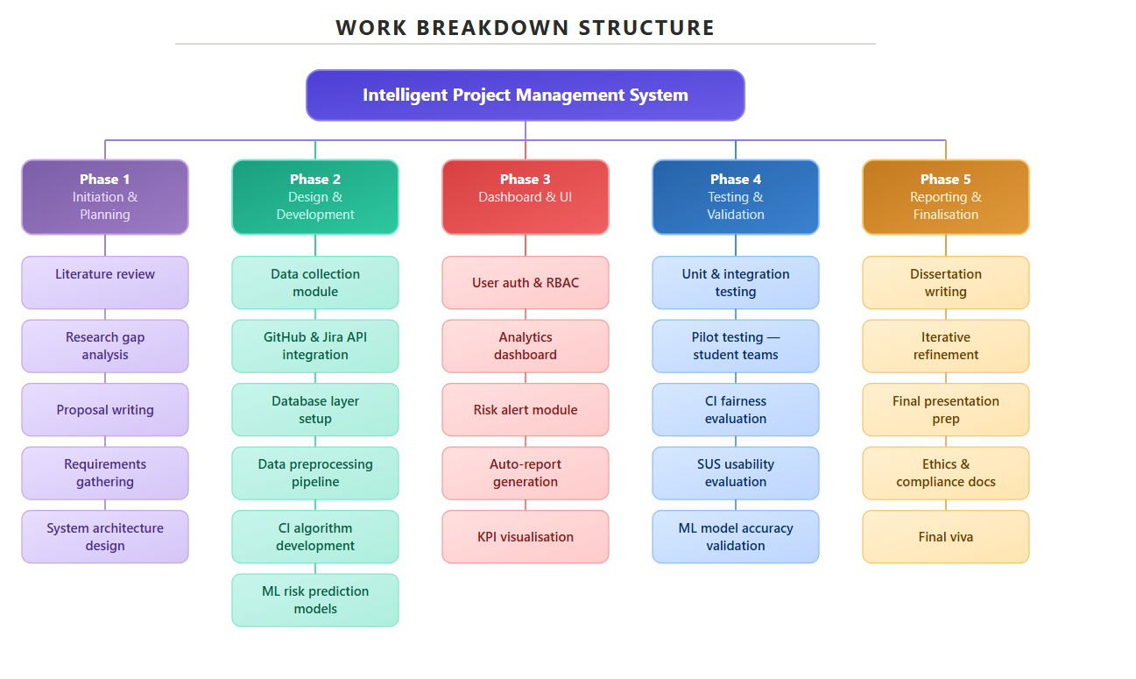 Figure 5: Work breakdown structure table

GANTT CHART
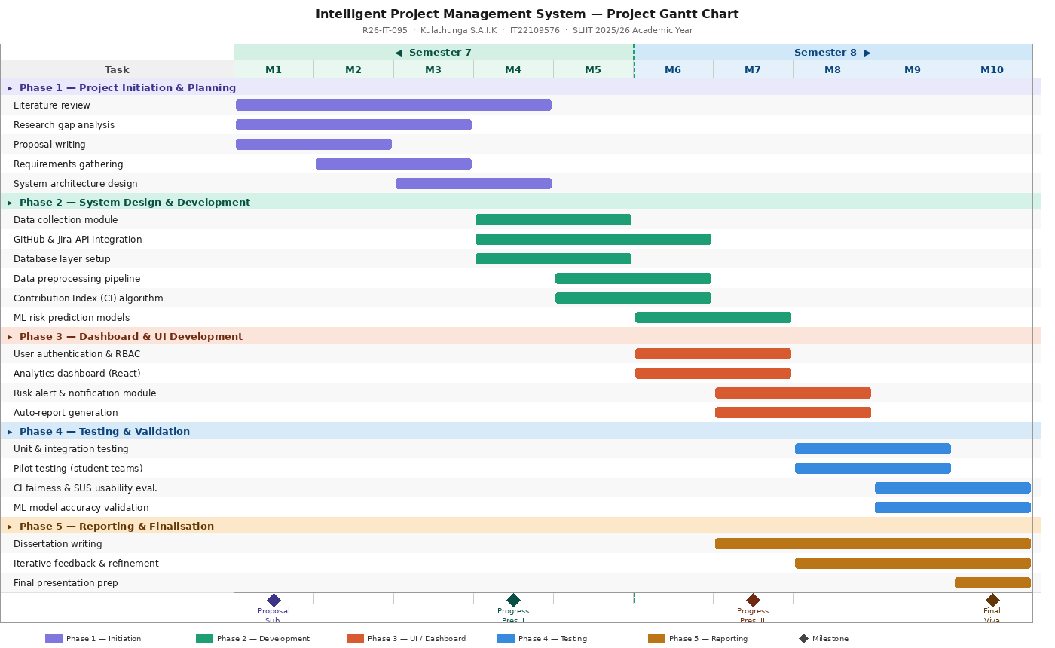
Figure 6: Gantt Chart – Project Timeline (M = Month)

10.References
[1] Standish Group, Chaos Report 2020: Decision Latency Theory—It’s All About the Interval, Standish Group Int., 2020.
[2] B. Kitchenham, E. Mendes, and G. H. Travassos, "Cross-industry observations and software engineering data," in Proc. 3rd Int. Symp. Empirical Software Eng. Measurement, Madrid, Spain, 2007, pp. 275–284.
[3] Y. I. Alzoubi, A. Q. Gill, and R. Uddin, "Empirical analysis of collaborative software development behaviors in GitHub," J. Softw.: Evol. Process, vol. 31, no. 3, p. e2131, 2019.
[4] T. Menzies and T. Zimmermann, "Software analytics: So what?" IEEE Softw., vol. 30, no. 4, pp. 31–37, Jul./Aug. 2013.
[5] A. E. Hassan, "The road ahead for mining software repositories," in Proc. Conf. Future of Software Eng. (FOSE ’08), Leipzig, Germany, 2008, pp. 48–57.
[6] C. Bird, N. Nagappan, H. Gall, B. Murphy, and P. Devanbu, "Putting it all together: Using socio-technical networks to predict failures," in Proc. 20th Int. Symp. Software Reliability Eng. (ISSRE), Sevilla, Spain, 2009, pp. 109–119.
[7] X. Wang et al., "Learning analytics in software engineering education: A systematic literature review," ACM Trans. Comput. Educ., vol. 20, no. 3, Art. no. 18, 2020.
[8] S. Shah, J. Huang, and A. Aldrich, “Automated analysis of student software repository data for team effort estimation,” in Proc. 2021 ACM Conf. Learning @ Scale, 2021, pp. 91–100.
[9] G. Tantithamthavorn, S. McIntosh, A. E. Hassan, and K. Matsumoto, “An empirical comparison of model validation techniques for defect prediction models,” IEEE Trans. Softw. Eng., vol. 45, no. 1, pp. 81–102, 2019.
[10] T. Olsson and B. Hedström, “CodeScene: Using development data for predictive insights,” Softw. Qual. J., vol. 28, pp. 3–28, 2020.
[11] R. G. K. Pinheiro, J. F. Rodrigues, and R. D. Souza, “Learning analytics for collaborative software development education: Current challenges and opportunities,” Comput. Educ., vol. 181, 2022, Art. no. 104452.
[12] S. Balaji, M. J. S. Madhavi, and K. S. Reddy, “Predictive analytics in student project performance monitoring using machine learning,” J. Educ. Technol. Syst., vol. 50, no. 1, pp. 65–83, 2021.
[13] L. Al-Harbi and A. K. Al-Samarraie, “Automated assessment of teamwork in software engineering courses using repository mining,” Int. J. Inf. Manag., vol. 61, 2021, Art. no. 102364.
[14] (Existing) S. Shah, J. Huang, and A. Aldrich, “Automated analysis of student software repository data for team effort estimation,” in Proc. 2021 ACM Conf. Learning @ Scale, 2021, pp. 91–100.
[16] N. Nagappan, B. Murphy, and V. Basili, “The influence of organizational structure on software quality: An empirical case study,” Proc. 30th Int. Conf. Software Eng., pp. 521–530, 2008.
[17] J. Brooke, “SUS: A quick and dirty usability scale,” in Usability Evaluation in Industry, P. W. Jordan, B. Thomas, B. A. Weerdmeester, and A. L. McClelland, Eds. London, UK: Taylor & Francis, 1996, pp. 189–194.

11. APPENDICES

Appendix A – System Architecture Diagrams
This appendix contains the architectural diagrams of the proposed Intelligent Project Management System, including the high-level system architecture, internal component architecture, system workflow diagram, and data flow diagram used to illustrate the structure and operation of the system.
Appendix B – Work Breakdown Structure (WBS)
This appendix presents the detailed Work Breakdown Structure of the project, outlining the major phases and tasks involved in the development of the Intelligent Project Management System.
Appendix C – Project Gantt Chart
This appendix provides the detailed project timeline illustrating the planned schedule of development activities across Semester 7 and Semester 8, including milestones such as proposal submission, progress presentations, system development phases, and final evaluation.
Appendix D – Sample Data Sources
This appendix describes examples of the development activity data collected from Version Control Systems and Issue Tracking Systems, such as GitHub commit logs, pull requests, issue tracking records, and task completion data used for contribution analysis and predictive risk monitoring.

INTELLIGENT PROJECT MANAGEMENT SYSTEM FOR UNDERGRADUATE STUDENTS

R26-IT-095

Project Proposal Report
Rashmika R.M.D -IT22101624

B.Sc. (Hons) Degree in Information Technology Specialized in
Information Technology

Department of information technology

Sri Lanka institute of Information Technology

March 2026

DECLARATION
I affirm that the work is my own and that it is entirely original. The proposal does not, except where credit is given in the text, include any material that has been submitted for a degree or diploma in any other university or higher educational institution.
Name | Student ID | Signature
Rashmika R.M.D | IT22101624 | 

The above candidate is conducting research for their undergraduate Dissertation under my supervision.

Name | Date | Signature
Supervisor
Co-Supervisor | 15/03/2026

ABSTRACT
This paper addresses a hard problem in contemporary educational institutions: grading students’ assignments and providing structured, useful feedback is still largely a human-centric task. Most current tools are geared towards grading and rubric systems, but they don’t provide actionable, conceptual advice that helps instructors target exactly what students are missing. To address this problem, this paper introduces an AI-based system for Automated Quality Assessment and Adaptive Mentorship. This system is conceptualized as an integral part of a broader project: The Intelligent Project Management System for Undergraduate Students (R26-IT-095). The problem statement is evident: there are no systems that go beyond grading to identify exactly where students are weak in their understanding. Rubric-based grading systems are labor-intensive, subjective, and unreliable. Computerized grading tools are mostly geared towards catching surface-level mistakes without providing instructors with actionable advice on how to improve students’ understanding. Our system will employ a multi-step system: an NLP-based Semantic Grading Engine that will analyze how well a student’s report is structured, how deep its technical content is, and how well it aligns with a given rubric system by using transformer models; An AI-driven Resource Recommendation Engine, which connects the identified gaps to relevant learning materials, e.g., academic papers and tutorials; An Automated Feedback Generation module, which produces structured, personalized improvement reports for each student. This shifts the focus of the grading process to intelligent mentorship, thus bridging the loop between grading and learning.
The key technologies used here include Python, BERT/Sentence Transformers for semantic analysis, spacey for NLP, a Neo4j-based knowledge graph for concept mapping, and a React.js-based dashboard. This system is intended to integrate well with the GitHub contribution and project planning features of the parent platform. It is expected that the system results will be a reduction in manual grading time by over 60 percent, concordance under 80 percent with the expert evaluator, and a demonstration of the improved report quality of students with repeat of the system. This element of the system is a direct contribution towards the attainment of the UN Sustainable Development Goal 4 (Quality Education) through provision of fair, transparent and data balanced academic mentorship.
Keywords: Automated Quality Assessment, NLP, Semantic Grading, Adaptive Mentorship, Resource Recommendation, Feedback Generation, Educational AI, BERT.
.

ACKNOWLEDGEMENT
I would like to express my sincere gratitude to our supervisor and co-supervisor who showed us the way, and motivated us, with valuable suggestions throughout this investigation. I would like to thank all the members who assisted in developing the Intelligent Project Management System namely, Bandara N.D.M., Lekamge R.L.M.D., Kulathunga S.A.I.K. We are grateful to the Department of Information Technology, SLIIT, for the provision of infrastructure needed for this project.

TABLE OF CONTENTS
DECLARATION i
ABSTRACT ii
ACKNOWLEDGEMENT iii
LIST OF FIGURES iv
LIST OF TABLES iv
LIST OF ABBREVIATIONS v
1. INTRODUCTION 1
1.1 Background and Context 2
1.2 Literature Review 3
1.3 Research Gap 5
2. OBJECTIVES 7
2.1 Main Objective 7
2.2 Specific Objectives 7
3. METHODOLOGY 10
3.1 Research Approach 10
3.2 Technical Methods and Algorithms 10
3.3 Tools and Platforms 11
3.4 Data Collection and Ethical Considerations 12
3.5 Validation Strategy and Performance Metrics 12
4. HIGH-LEVEL SYSTEM ARCHITECTURE 13
4.1 Component Overview 13
4.2 Component Interactions and Data Flow 14
4.3 Scalability and Security Considerations 14
5. USER REQUIREMENTS 15
5.1 Stakeholder Identification 15
5.2 Functional Requirements 15
5.3 Non-Functional Requirements 16
6. COMMERCIALIZATION PLAN 17
6.1 Target Market and Customer Persona 17
6.2 Value Proposition 17
6.3 Revenue Model 18
6.4 Competitive Advantage 18
7. BUDGET AND BUDGET JUSTIFICATION 19
8. WORK BREAKDOWN STRUCTURE (WBS) 20
9. GANTT CHART 21
REFERENCES 22
APPENDICES 24
Appendix A Rubric Definition Schema 24
Appendix B Risk Analysis 24

LIST OF FIGURES
Figure 1: High-Level System Architecture of the Automated Quality Assessment and Adaptive Mentorship Component
Figure 2: NLP Semantic Grading Pipeline
Figure 3: Adaptive Mentorship and Feedback Generation Workflow
Figure 4: Gantt Chart - Project Timeline

LIST OF TABLES
Table 1: List of Abbreviations
Table 2: Research Gap Analysis - Existing Systems vs. Proposed System
Table 3: Functional Requirements
Table 4: Non-Functional Requirements
Table 5: Budget Breakdown and justification
Table 6: Work Breakdown Structure

LIST OF ABBREVIATIONS
Abbreviation | Full Form
AI | Artificial Intelligence
API | Application Programming Interface
BERT | Bidirectional Encoder Representations from Transformers
GNN | Graph Neural Network
KG | Knowledge Graph
ML | Machine Learning
NLP | Natural Language Processing
NER | Named Entity Recognition
OCR | Optical Character Recognition
SDG | Sustainable Development Goal
SLIIT | Sri Lanka Institute of Information Technology
SUS | System Usability Scale
WBS | Work Breakdown Structure

1. INTRODUCTION

Feedback and assessment is one of the key factors that a university can impact students at undergraduate level. Students working on research projects want timely, constructive and relevant feedback to their work. It’s no good just getting a mark at the bottom of a page and being told that is all the lecturers has to say. Currently, most universities including SLIIT are using manual methods for assessing and providing feedback to students. This is a very time-consuming task and the method of assessment and marking of the project is highly dependent on the lecturer.

This project is related to the subcomponent of R26-IT-095 Intelligent Project Management System; in this project, the subcomponent aims at developing an application to assess and evaluate the student research reports and to translate the assessment into valuable information that benefits the students. In other words, this part focuses on the written work in the students’ reports and aims at delivering useful assessment comments that contribute to real learning for the students as opposed to merely indicating mistakes. This project is hence related to UN SDG 4 – Quality Education. In particular, it aims at ensuring that every student receives the adequate academic support in a timely manner that benefits the students, regardless of the workload facing the supervisor.

It is SDBI’s contribution to achieving the UN’s Sustainable Development Goal 4, to ensure inclusive and effective quality education for all. It provides immediate, structured and meaningful feedback to students regarding their performance in a data-informed way. It indicates performance in relation to achievement for each learning outcome as well as highlighting gaps in relation to the expected level of achievement for the student in relation to the learning outcome. Ultimately it seeks to improve student performance to the highest standard of education possible, even when a Field Supervisor has heavy caseloads and cannot provide the required individual attention.

1.1 Background and Context
Marking research reports is genuinely time-consuming work. A supervisor looking after several groups has to go through each report, check the structure, the academic language, how well the student understands the topic, and whether it actually follows the rubric all while juggling deadlines. Research consistently shows that the quality and speed of feedback is one of the strongest factors in whether students actually improve [1], yet in practice feedback tends to arrive late, stay quite general, and often have little connection to the specific problems in a student's work [2].
What is more significant is what occurs after the mark has been given. In the case that a student scores poorly on their literature review or their methodology section, what they actually require is not simply to know the score that they need to know what to read, what to revisit and how to correct it. Tools like Moodle and Blackboard can record grades and show rubric comments, but they cannot look at a student's work and figure out what the student still does not understand, or point them towards something that would actually help [3].
The integration of NLP and machine learning into academic assessment has started to change what is possible here. Models like BERT have shown they can compare student writing against reference content with real accuracy [4], and knowledge graphs offer a way to connect concepts so that when a weakness is detected, you can trace back what underlying understanding might be missing [5]. The idea behind this project is to bring those pieces together to build something that does not just score a report, but actually uses that score to help the student learn. This work is also aligned with SDG 4 and the CoEAI research cluster at SLIIT, applying AI directly to improve the fairness and consistency of academic feedback.
This research proposes combining these technologies into a unified Automated Quality Assessment and Adaptive Mentorship system. The system will evaluate student reports using semantic NLP, map identified weaknesses to academic concepts, and automatically recommend learning resources to guide improvement effectively acting as a personal AI research mentor for every student in the program.

This element is also consistent with SDG 4 (Quality Education) and Co EAI research cluster (Centre of Excellence for AI) in SLIIT because it directly implements the progressive AI to enhance the equity, regularity, and achievement of education.

1.2 Literature Review
A fair amount of work has been done on using NLP and AI for educational assessment, though most of it stops short of what this project is trying to do. The following review goes through the key existing approaches and what each one is missing.
Rani and Sujatha [6] built an automated evaluation system for descriptive answers using keyword extraction and semantic similarity. It got reasonable accuracy but was designed for short answers only and did not give any structured feedback or try to identify what the student actually did not understand.
Ramachandran et al. [7] took things further with a BERT-based rubric grading system for essays, which lined up well with human graders on overall scores. The problem is it could not point to a specific weak section in the report or suggest anything for the student to do about it.
Cui et al. [8] showed that GNN-based models trained on knowledge graphs could predict student performance across connected concepts a useful insight for diagnosing learning gaps. But that work never connected to a practical feedback system, so there was no way for it to actually help a student act on those gaps.
Bayesian Knowledge Tracing, developed by Corbett and Anderson [9], has been widely used in tutoring systems to track student mastery over time, and more recent work has extended this with graph-based propagation [10]. These approaches work well for structured exercises but were never designed for evaluating long-form academic writing like research reports.
The ACORN system [11] tried something different by using multimodal analysis of classroom recordings to assess teacher performance. It is an interesting approach, but it looks at the teacher side only and has nothing to do with evaluating what students actually submit.
Liu et al. [12] built a recommendation system for academic resources using citation networks and reading history it worked well for personalized suggestions but was not connected to any assessment pipeline, so it could not react to what a specific student actually got wrong in their work.
Commercial tools, Turnitin and Grammarly, as to commercial tools, can identify the surface-level writing problems but not assess the technical depth, the rubric requirements, or the fact that the student comprehends the material he/she is writing about [2].They also do not generate any kind of improvement plan tied to learning resources.
Taken together, the gap is clear: there is no existing system that combines proper rubric-based semantic evaluation of research reports, knowledge graph-based weakness diagnosis, and automated personalized resource recommendations in one place. That is exactly what this project is trying to build.

1.3 Research Gap
Looking at what is out there, the gap becomes fairly obvious. Existing tools either grade without explaining, or explain without diagnosing the actual problem. The table below sets out how the proposed system compares against what is currently available:

Aspect | Existing: Turnitin/LMS | Existing: Rubric Graders (BERT) | Proposed System
Grading Capability | Surface-level (plagiarism/grammar) | Holistic score, limited rubric | Section-by-section rubric compliance with semantic depth analysis
Weakness Identification | None | Score deduction only | Concept-level mapping to knowledge graph nodes
Feedback Generation | Generic comments | Rubric scores only | Structured, personalized improvement reports
Resource Recommendation | None | None | Targeted papers, tutorials, and examples based on identified gaps
Adaptive Learning Loop | None | None | Tracks improvement across submission iterations

Table 2: Research Gap Analysis – Existing Systems vs. Proposed System

What makes this project different is not just that it grades it is that it tries to understand why a student is struggling and does something about it. No existing tool currently combines semantic NLP-based assessment with knowledge graph diagnosis and automated resource recommendations for research report evaluation in an undergraduate setting. That is the gap this work is filling.

2. OBJECTIVES

2.1 Main Objective

The main goal of the project is to develop and create an AI-based tool that can automatically assess the quality of undergraduate research reports, identify the locations and reasons why a student is not performance, and give a student specific feedback and learning resources to correct the results.

2.2 Specific Objectives

Specific Objective 1: Implement NLP-based Semantic Grading Engine
- Task 1: Implement an NLP pipeline that classifies, scores and provides feedback on each section of a research report (i.e. Introduction, Literature Review, Methodology, etc.) written by students based on a pre-defined academic rubric related to scientific quality, completeness and semantics. The intended base model is BERT or Sentence Transformers.
- Measurable: - scoring accuracy of at least 80% (i.e. at least 80% agreement with human grader scores) using Cohen’s Kappa coefficient on a validation dataset of 100 anonymized student feedback reports.
- Achievable: This approach can easily utilize existing transformer-based models (such as those provided by Hugging Face) and NLP pre-processing provided by spaCy. The scoring rules for the model can be described in Python.
- Realistic: It should ideally be possible to implement the suggested ideas on an existing dataset of anonymized historical project reports that are readily available in SLIIT after obtaining ethical clearance.
- Time-bound: Expected completion within 2 months (Months 1–2 of implementation).

Specific Objective 2: Construct Academic Knowledge Graph for Concept Mapping
- Focus: Design a structured Knowledge Graph to store IT research concepts, sub-topics, and prerequisite relationships. Identify gaps within the reports by linking them to the corresponding concept nodes within the graph.
- Measurable target: Reach an accuracy rate of at least 85%, ensuring that the sections within the reports are correctly mapped to the corresponding concept nodes within the graph, based on expert opinions.
- Feasible approach: Utilize the Neo4j graph database, NetworkX library, and existing IT research domain ontologies.
- Real-world practicality: Developing an ontology for this purpose can be based on standard IT curriculum documents or taxonomies of IT research topics.
- Schedule: To be completed within 1 month (Month 2).

Specific Objective 3: Developing an AI-Powered Resource Recommendation Engine

Focus :The objective of this task is to develop a recommendation system which takes concept level vulnerabilities as input and provides a list of learning resources (academic papers via the Semantic Scholar API, tutorials or coding examples) which are ranked in terms of their relevance to addressing the identified skills gaps.

Measurable target: A model that achieves an overall relevance score of at least 80% on a blinded validation set as measured by the academic supervisor.

Possible Solution: The suggested solution is based on applying collaborative filtering and content-based filtering in conjunction with the integration with open academic databases.

Real-World Practicality? Recommendation algorithms are widely used and practiced in many applications and various fields. It is easy to get access to academic databases such as Semantic Scholar and arXiv papers via Apis. Schedule: To be completed within 1.5 months (Months 3-4).

Specific Objective 4: Automate Structured Feedback Report Generation
- Goal: Develop an automated module that integrates results from the grading process, identified weaknesses, and suggested resources to produce an understandable report for each submitted work.
- Measurable: Target an 85% usability score (SUS) from both students and supervisors for the usability tests. The reports should cover all the dimensions identified by the rubric and include a minimum of three improvement suggestions.
- Achievable: Utilize template-based Natural Language Generation for narrative sections, based on GPT-technologies; use a React.js dashboard for reporting.
- Realistic: Aligns with the skill set of the project team for the front-end and standard educational feedback report formats.
- Time-bound: To be completed within one month (Month 4).

Specific Objective 5: Assess System Performance and Confirm Learning Outcome

- Specific: Perform end-to-end tests of the system with AI-generated grades and feedback compared with expert ratings, as well as the improvement in report quality with each iteration of student submission.
- Measurable: At least a 15% increase in the average report quality score from the initial submission to the second submission with the help of AI feedback.
- Achievable: A pilot group of 20-30 undergraduate IT4010 students will be used, with informed consent.
- Realistic: The pilot testing is within the IT4010 research project timeframe of SLIIT.
• Time-bound: The pilot testing should be completed within half a month (Month 5).

3. METHODOLOGY
This research adopts a Design Science Research (DSR) methodology, which is particularly well-suited for projects that aim to create and evaluate an innovative IT artifact that solves a clearly defined practical problem [13]. The methodology proceeds through five structured phases: Problem Definition, System Design, Prototype Development, Evaluation, and Iteration.

3.1 Research Approach

This project is being approached using a Design Science Research methodology. The overall goal of the research is to design and implement an innovative solution that can be validated against the problems identified. This approach as opposed to a theoretical approach is fitting to this problem because rather than being purely descriptive, the goal of the research is to be prescriptive and provide actionable solutions to students and educators while improving the assessment process. In this project, the problems of current assessment processes are clearly identified, with manual, inconsistent assessment not providing students with any tangible output. A working solution is then designed and implemented, validated through measurable metrics and then iteratively refined through the testing process.

3.2 Technical Methods and Algorithms

Semantic Grading Engine Using Sentence-BERT (SBERT), the core grading module converts the rubric descriptors and the student report sections into the semantic space through the embedding of the semantic vectors using cosine similarity, providing a continuous score. For cases where the rubric compliance is categorical (e.g., Excellent/Good/Adequate/Poor), a classification head is added on top of the BERT encoder and the model is then fine-tuned on the training dataset of the annotated student reports along with the grades provided by the knowledgeable instructors.

Knowledge Graph Construction: The IT research domain The Knowledge Graph for the IT research domain is constructed by applying a semi-automated ontology extraction technique. The syllabi of Computer Science courses, general authoring guidelines for academic papers and a collection of IT research papers are processed by applying spaCy’s NER (Named Entity Recognition) and dependency parsing to derive concept entities and relationships. The derived entities and relationships are stored in a Neo4j graph database where node labels represent academic concepts (e.g., Machine Learning, Research Gap, Literature Review Structure) and the edges between the nodes represent the prerequisite/dependency relationship.

Weakness Propagation and Mapping : They work on graded report sections corresponding to concepts located on Knowledge Graph for which the score is below the minimum threshold. From these report sections, they identify the essential concepts required to pass the skills that are analyzed through graph traversal algorithms and carry out the root-cause analysis of the weaknesses identified for each student who has been assessed.

Resource Recommendation : The Resource Recommendation algorithm is a content-based recommendation algorithm. It takes the semantic representation of the identified concept gaps and matches them against a knowledge base built from academic resources we index from Semantic Scholar, arXiv and institutional repositories. The matched resources are then ranked based on the semantic similarity to the concept gaps, the publication date of the resource and the citation count.

Feedback Generation : This block generates an improvement report based on templates and a large language model. Templates contain section feedback for each assignment and are populated based on the score given to each criterion, as well as the skills and knowledge gaps discovered, and recommended by the AI. For narrative summary sections, it utilizes GPT-4o via API to produce well-explained feedback for students.

3.3 Tools and Platforms
- Programming languages: We use Python 3.10+ for the ML/NLP part, and JavaScript/TypeScript for the frontend.
- NLP tools: We use HuggingFace Transformers for BERT and SBERT, and spaCy v3 for NLP
- Knowledge Graph: Neo4j (graph database), NetworkX (graph algorithms), PyVis (visualization)
- ML libraries: We use PyTorch and scikit-learn for machine learning.
- Backend API tech stack: We use FastAPI in Python, along with Node.js/Express.js for integration with the parent system.
- Frontend dashboard tech stack: We use React.js for the frontend, along with D3.js for graph visualization.
- External API tech stack: We use the Semantic Scholar Academic Graph API and OpenAI GPT-4o API.
- Databases: We use MongoDB for document-based data and PostgreSQL for relational databases.
- Cloud hosting: We use AWS EC2 for model serving and AWS S3 for report storage.

Version control: We use GitHub, along with an integration with the parent system’s contribution analytics.

3.4 Data Collection and Ethical Considerations

The following method has been proposed for data collection. Instead of collecting reports from SLIIT students, the dataset for this research will be obtained from the Kaggle platform, which provides publicly available datasets for research and machine learning development. Kaggle hosts a wide range of academic writing datasets, essays, and report-style documents that can be used for training and evaluating automated assessment systems. The selected dataset will consist of report-like or essay-based academic documents that are already publicly available and permitted for research use. Since the data is publicly shared for research purposes, no personal identifiable information (PII) will be collected or stored in the proposed system. Any potential identifiers present in the dataset will be removed to ensure that all data used in the analysis remains fully anonymized. Even though the data is collected from a public dataset platform, the research will still follow ethical research practices and comply with relevant academic data protection standards. Ethical clearance will be requested before starting the research to ensure that the study follows proper research governance and ethical guidelines. To prepare a dataset of ground truth labels for training the automated grading system, a subset of 100 reports will be randomly selected from the collected dataset. These reports will then be evaluated independently by three experienced academic supervisors with significant experience in assessing academic reports. After grading, the Cohen’s Kappa value will be calculated to measure the level of agreement among the evaluators. Only the samples that show a strong level of agreement (Kappa value greater than 0.70) will be selected for the final training dataset. This process ensures that the ground truth labels used for training the system are reliable and consistent. The final dataset will consist of the 100 samples with the highest agreement scores among the evaluators, ensuring the quality and accuracy of the training data used for the classification model.

3.5 Validation Strategy and Performance Metrics
- Grading Accuracy: Cohen's Kappa ≥ 0.80 against expert grader consensus
- Concept Mapping Accuracy: ≥ 85% precision in mapping to correct KG nodes (expert validation)
- Recommendation Relevance: ≥ 80% relevance score by academic supervisors
- Feedback Report Usability: SUS Score ≥ 85 from student and supervisor evaluations
- Learning Outcome Improvement: ≥ 15% improvement in mean report quality between iterations

4. HIGH-LEVEL SYSTEM ARCHITECTURE

A new component has been developed as a pipeline of four individual modules. The main functionality of the component is grading received reports, identifying weaknesses and linking them to the relevant concepts, suggesting learning materials and summarizing all data in a student feedback report. The component integrates with IPMS system by receiving received reports, grading, identifying weaknesses, linking them to concepts, suggesting learning materials and sending back graded and marked report with recommended learning materials to student and academic advisor pages.

4.1 Component Overview
Input Layer: The source document in PDF or DOCX format is inputted by the student through the IPMS portal. The source document is parsed for structured text, headings and metadata by the document parsing module. Pre-processing activities are carried out by utilising spaCy for sentence splitting, tokenization and entity recognition.
Semantic Grading Engine: The output of this block is fed into the Semantic Grading Engine, where each subsection is embedded using Sentence-BERT and compared against the rubric descriptions stored in the Semantic Grading Engine. This results in a score vector and a compliance flag for each subsection, and a list of sections that do not meet the threshold are marked as weaknesses.
Knowledge Graph Concept Mapper: The marked sections and the concepts related to them are mapped to the nodes of the IT Research Knowledge Graph in Neo4j. The traversal in the graph gives the prerequisites which the students are not aware of, hence multi layered weakness detection.
Resource Recommendation Engine: The identified weakness concepts are then inputted into the recommendation engine, which uses the Semantic Scholar API and an in-house curated resources database to generate a ranked list of relevant papers, tutorials, and examples for each concept.
Feedback Generation Module: This module uses the grading results, weakness concepts and recommended resources to output a feedback report in an agreed structural format. The NLG (Natural Language Generation) component then generates detailed prose sentences to produce a concise and meaningful summary of the feedback given and the action required from the learner IPMS .
Dashboard Layer: This deliverable will implement a complete feedback report for students on their IPMS student dashboard. This will be based on a dynamic Knowlege Graph that graphically represents for each student (as well as for the class by the supervisor, through an aggregate classroom view) the concepts and associated items they are strong and weak on
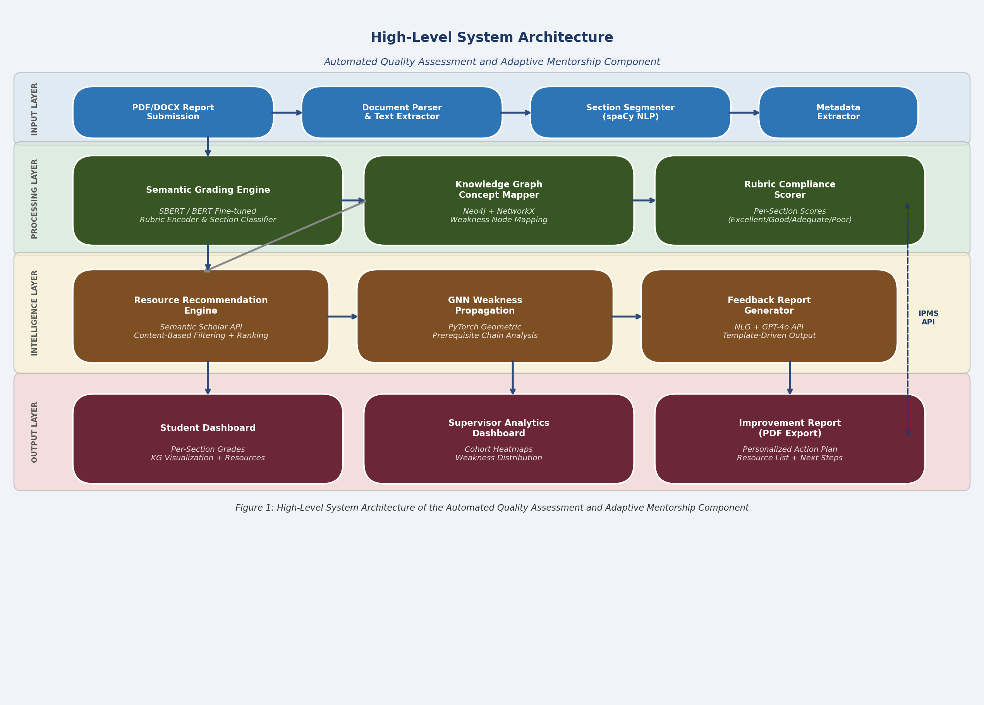
Figure 1: High-Level System Architecture of the Automated Quality Assessment and Adaptive Mentorship Component

4.2 Component Interactions and Data Flow
All our workflow does is move in one direction, from the starting point (submission) to the ending point (feedback). A report comes in, it is graded by the Grading Engine, and this grading results in the Knowledge Graph Mapper output which in turn gives us the list of weaknesses for the student. These weaknesses are then used by the Recommendation Engine and the outputs of the three components are then provided to the Feedback Generation module before reaching the dashboard. As the reporting is done asynchronously, the system is able to process many reports at the same time without slowing down the grading.
Parent IPMS connection is implemented through REST API. The parent application sends a submission event including the student ID, group ID and document URL, and the component returns a JSON response with grade vector, weaknesses, suggested resources and full feedback.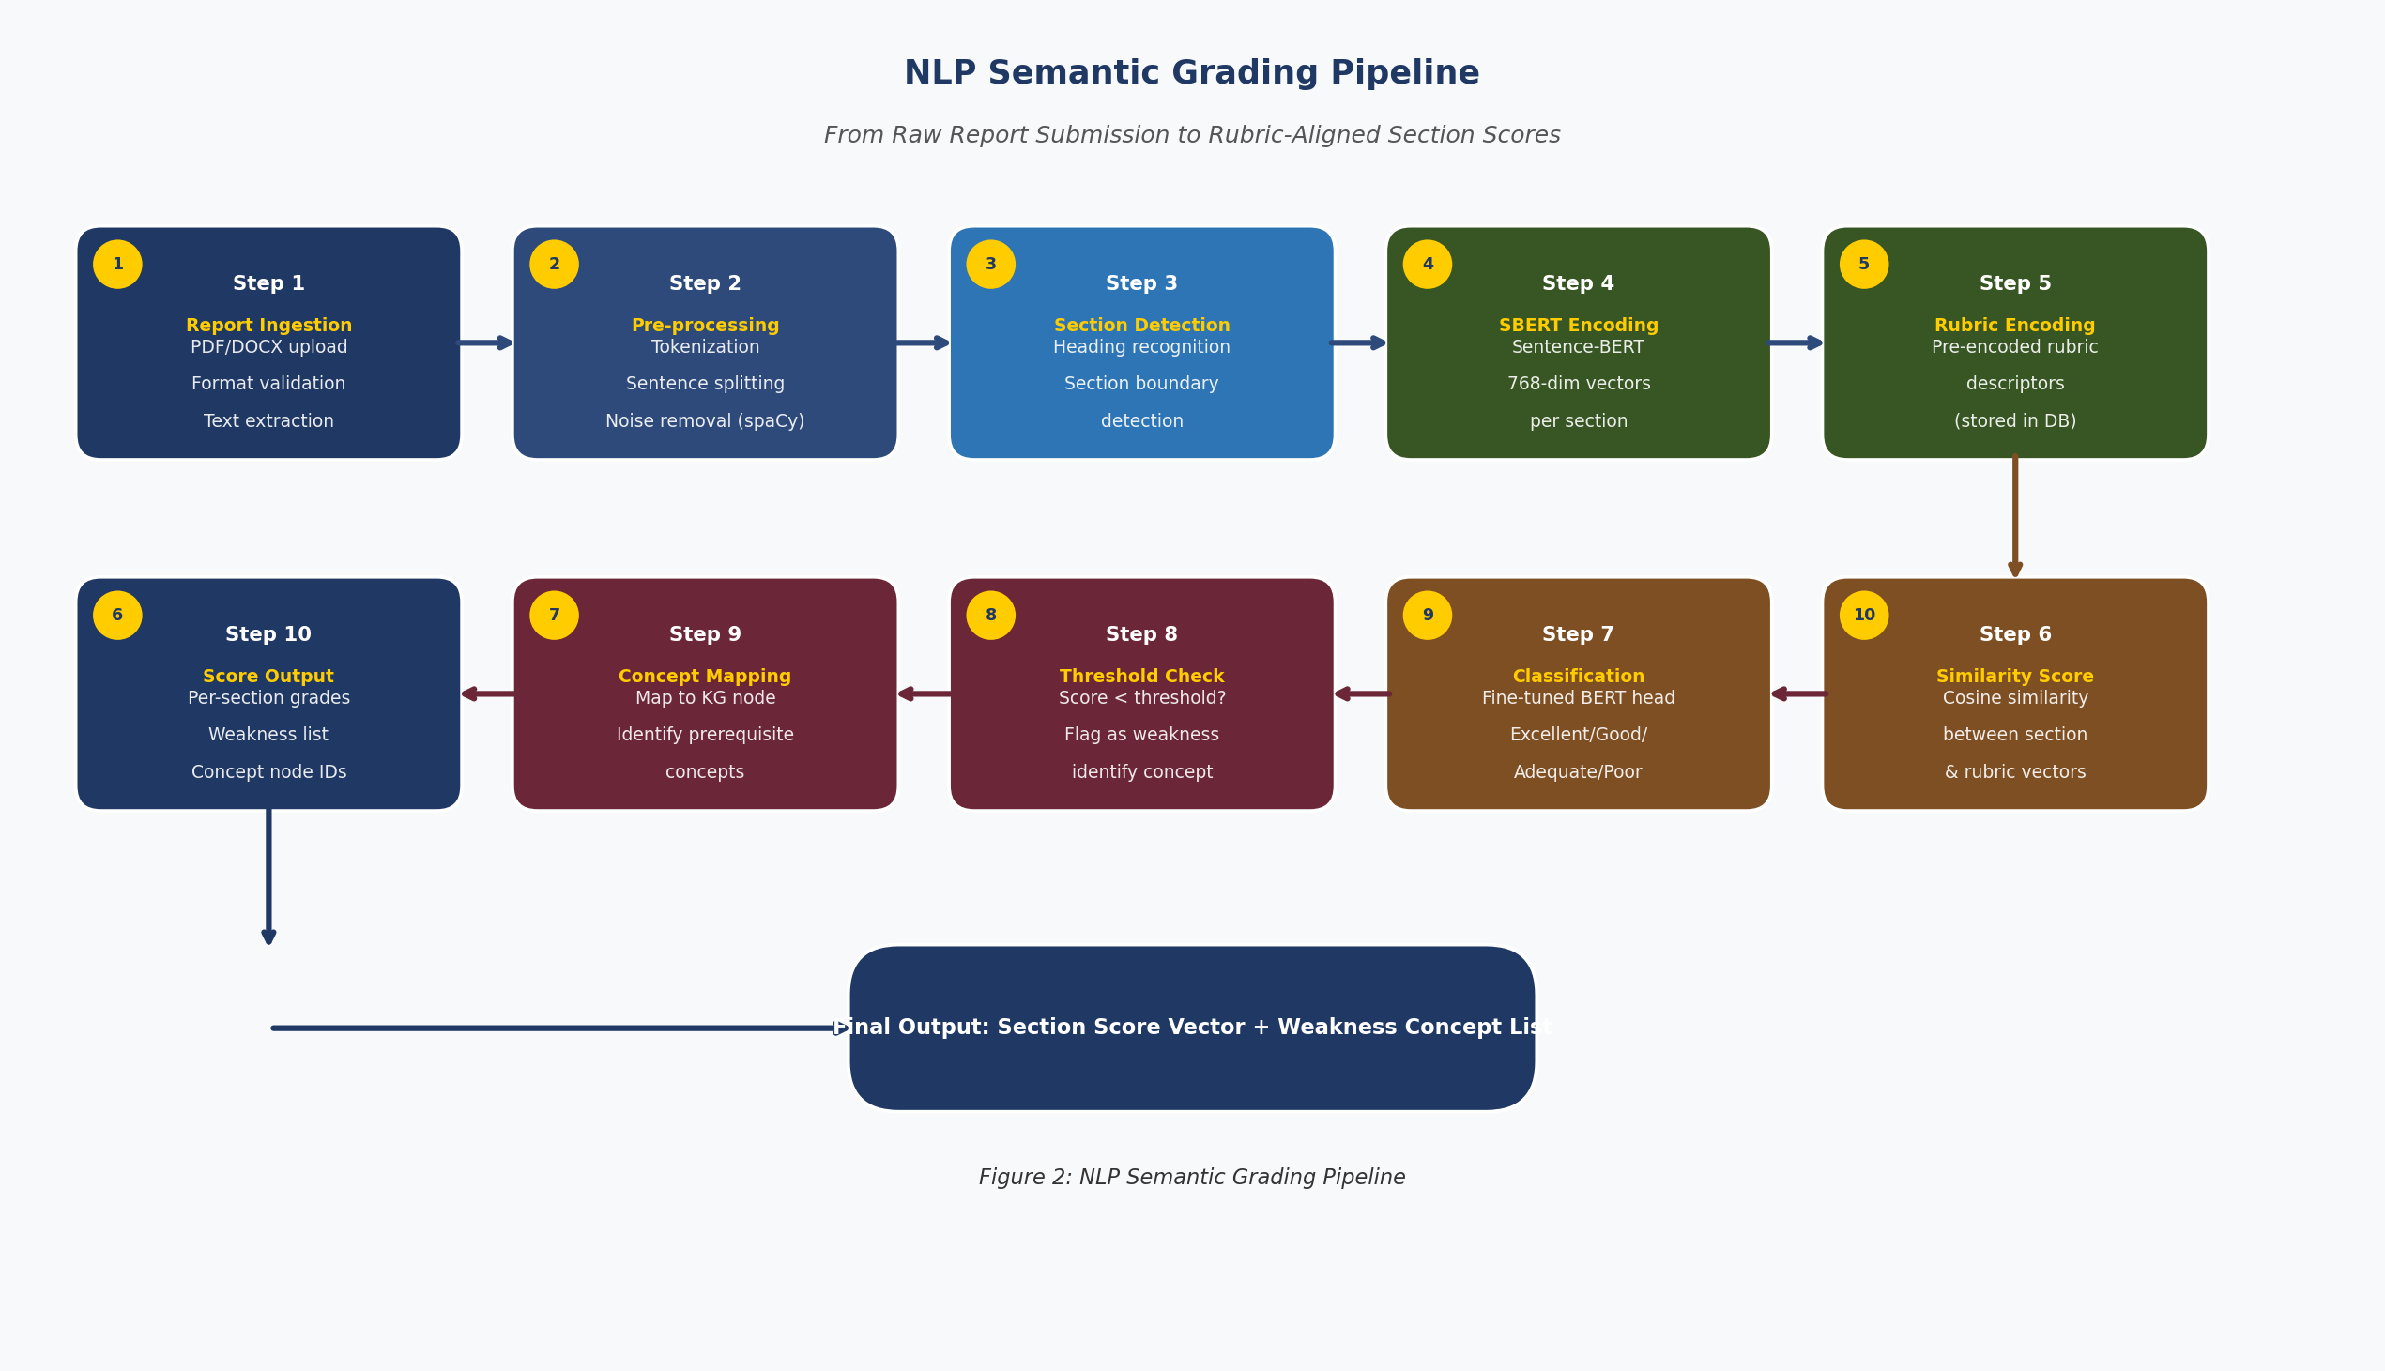
Figure 2: NLP Semantic Grading Pipeline

4.3 Scalability and Security Considerations
- The model inference runs as a microservice on AWS EC2 with auto-scaling turned on so it can handle the spike in submissions around deadlines.
- The Knowledge Graph sits on a dedicated Neo4j server with read-replicas to keep query times fast.
- All communication between services goes over HTTPS/TLS.
- Student reports are anonymized before processing and deleted from the pipeline once feedback has been generated nothing personally identifiable stays in the system.
- Access is controlled by role students only see their own feedback, while supervisors see group and cohort-level data.
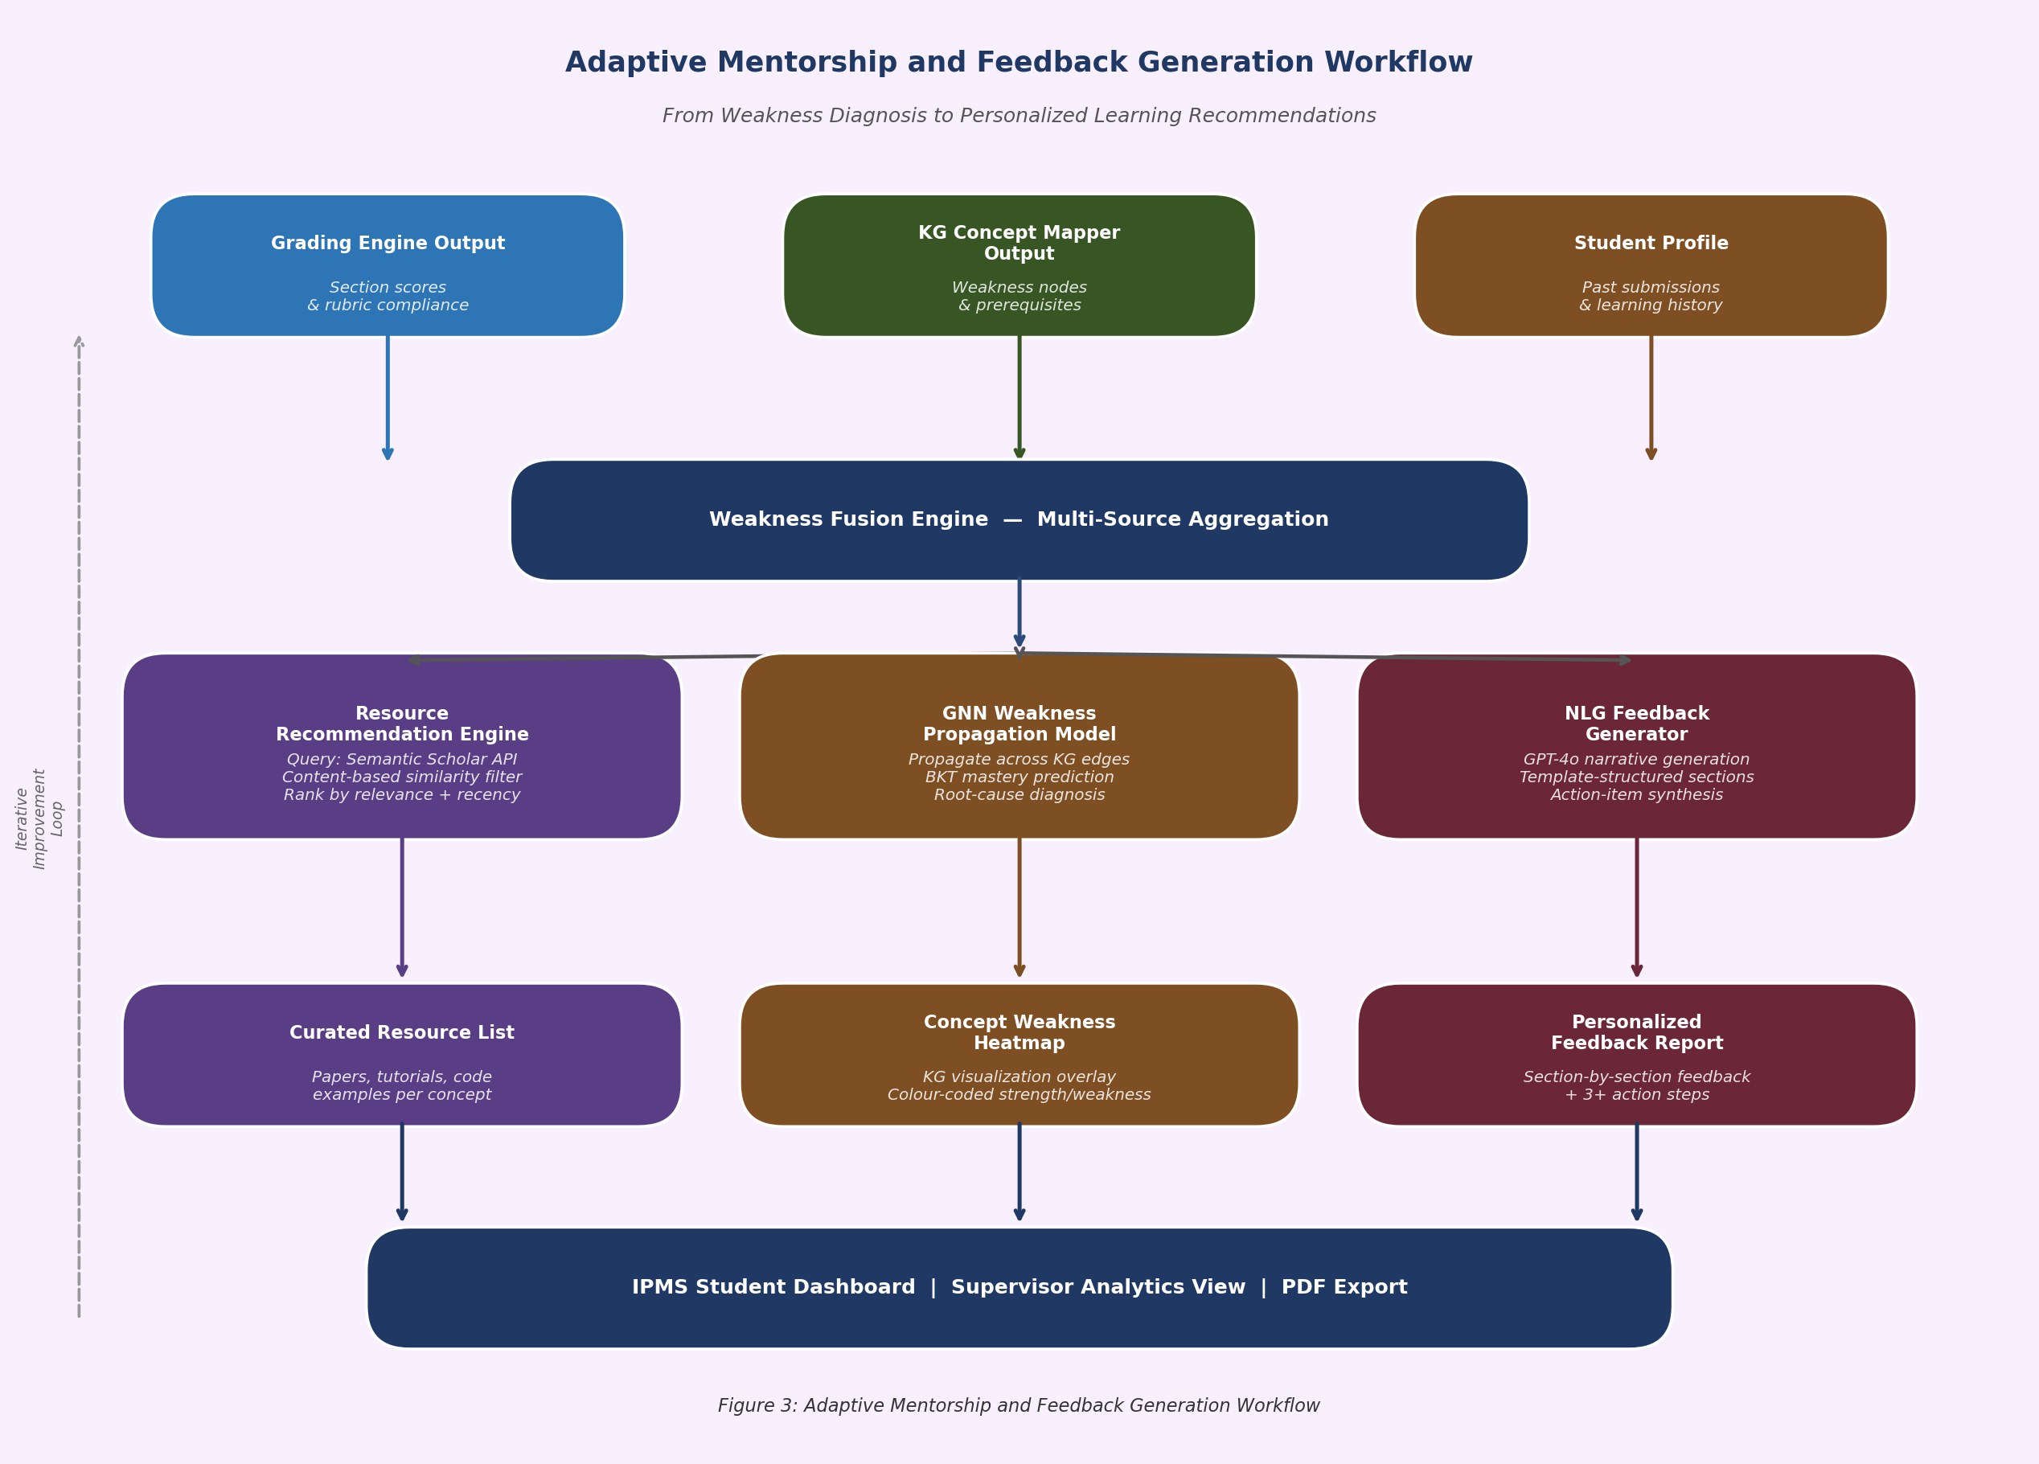
Figure 3: Adaptive Mentorship and Feedback Generation Workflow

5. USER REQUIREMENTS

5.1 Stakeholder Identification
- Students are the main users — they submit their reports and receive the automated feedback and resource recommendations.
- Supervisors review the AI-generated grades, check the feedback quality, and access class-level analytics to see patterns across their groups.
- The IPMS system administrator manages rubric settings, keeps the knowledge graph updated, and monitors system health.

5.2 Functional Requirements
FR# | Requirement Name | Description
FR1 | Report Submission | The system shall accept student research reports in PDF and DOCX formats through IPMS.
FR2 | Automated Section Grading | The system should be able to use NLP analysis to evaluate every section in a report such as (Introduction, Lit. Review, Methodology, etc.) based on a given rubric.
FR3 | Rubric Compliance Scoring | The system must assign a score and a compliance category (Excellent/Good/Adequate/Poor) per rubric criterion for each report section.
FR4 | Weakness Identification | The system shall determine those sections of the report and topics for which the student’s score is below a certain benchmark.
FR5 | Concept Mapping | The system must map detected vulnerabilities to nodes in the IT Research Knowledge Graph.
FR6 | Resource Recommendation | The system must return a ranked list of at least three academic resources per weakness concept identified in the Analysis Step.
FR7 | Feedback Report Generation | The system must produce a formatted, personalized feedback report for each student submission.
FR8 | Student Dashboard | The system must display the feedback report, the grade breakdown and Knowledge Graph of the student on the IPMS student page.
FR9 | Supervisor Analytics View | The system must display to the supervisors a cohort level analytics dashboard of the grade distribution and common patterns of weaknesses.
FR10 | Iterative Improvement Tracking | The system must be able to track and show improvement in student report quality from one version to the next.

5.3 Non-Functional Requirements
Category | Requirement
Performance | Under normal load conditions, the system shall take 3 minutes per report to complete full report grading and generation of feedback.
Accuracy | The semantic grading engine will be able to attain Cohen Kappa of 0.80 versus expert graders.
Usability | The student feedback dashboard will attain the System Usability Scale (SUS) score of 85 or more.
Security | All student information will be processed anonymously. PII is not going to be stored in the processing pipeline.
Scalability | The system will be able to allow simultaneous processing of 50 report submissions without deterioration in performance.
Availability | The system will ensure that it remains online at least 99 percent throughout the academic submission time.
Maintainability | The system administrator will be able to update the Knowledge Graph and the definition of the rubrics without any code changes.

6. COMMERCIALIZATION PLAN

6.1 Target Market and Customer Persona
The most immediate market for this system is universities in Sri Lanka and the wider South and Southeast Asian region that run research-based undergraduate programs, particularly in IT and STEM. SLIIT is the natural starting point, but the system could reasonably expand to other local universities like University of Moratuwa, NSBM, and Informatics Institute of Technology, and eventually to international institutions with similar program structures. There is also a secondary market in private EdTech platforms that offer research supervision services, and in corporate training programs that need to evaluate technical reports at scale.
Secondary markets include private EdTech platforms that provide research supervision support services and corporate training programs that require technical report evaluation at scale.

6.2 Value Proposition

The system has three things that are significant to institutions. First, it offloads supervisors up to 60% of the time on marking which liberates them to the type of mentoring dialogue that actually requires a human. Second, it ensures that each student receives equal and rubric-based feedback irrespective of supervisor workload and the size of the classes. Third, it proactively monitors how students are getting better with time by associating feedback with the particular learning materials and quantifying the improvement per submission which provides institutions with something quantifiable to actually refer to in regards to learning outcomes.

6.3 Revenue Model
- Institutional Licensing: Annual per-institution licensing fee based on student enrollment size (e.g., LKR 500,000–2,000,000 per year for institutions of 500–5,000 students).
- SaaS API Access: Per-evaluation API pricing for EdTech platforms integrating the grading engine into their own products (e.g., USD 0.10–0.50 per report evaluation).
- Premium Analytics Module: Additional subscription for advanced cohort analytics, benchmarking, and accreditation reporting.

6.4 Competitive Advantage
Turnitin checks for plagiarism. Gradescope handles structured problem sets. General LMS tools record grades. None of them do what this system does combine semantic research report evaluation, knowledge graph-based weakness diagnosis, and automated adaptive resource recommendation in a single pipeline. The fact that it is also built directly into the IPMS parent system means institutions that adopt it have a genuinely integrated workflow, which makes switching costs high and creates a natural barrier against competitors.

7. BUDGET AND BUDGET JUSTIFICATION
Item | Cost (LKR) | Recurrence | Justification
AWS EC2 Instance (Model Serving) | 12,000 | Monthly | Cloud compute for BERT inference microservice
AWS S3 Storage (Reports) | 2,000 | Monthly | Storage for submitted reports and generated feedback
Neo4j AuraDB (Knowledge Graph) | 8,000 | Monthly | Managed graph database for IT research KG
OpenAI GPT-4o API | 10,000 | Monthly | Generative NLG for feedback narrative sections
Semantic Scholar API (Premium) | 5,000 | Monthly | Academic resource retrieval for recommendations
Domain & SSL Certificate | 5,000 | Annual | Secure web access for student dashboard
GPU Cloud (Model Training) | 15,000 | One-time | Fine-tuning BERT on annotated report dataset
Miscellaneous (Testing, tools) | 5,000 | One-time | Testing devices, data annotation tools

Table 5: Budget Breakdown and Justification
Total estimated monthly running cost: LKR 37,000. Total one-time setup cost: LKR 25,000. The biggest recurring expense is the OpenAI GPT-4o API but in a production environment, that cost could be brought down significantly by fine-tuning a smaller open-source model like Mistral-7B for the feedback generation part, which would remove the dependency on a paid commercial API altogether.

8. WORK BREAKDOWN STRUCTURE (WBS)
# | Task | Sub-tasks | Duration
1 | Project Kickoff | obtaining ethics approvals, setting up data access agreements, and preparing the environment | all within a two-week timeframe.
2 | Data Gathering and Labeling: | obtaining historical reports, hiring annotators, and achieving inter-rater reliability | within a three-week timeframe
3 | Semantic Grading Engine (SO1) | developing an ontology, developing a Neo4j schema, developing an entity extraction pipeline, and filling the graph | within a four-week timeframe
4 | Knowledge Graph Building (SO2) | Ontology design, Neo4j schema, entity extraction pipeline, graph population | within a three-week timeframe.
5 | Resource Recommendation Engine (SO3) | integrating the Semantic Scholar API, developing a similarity index, developing a ranking algorithm | within a four-week timeframe
6 | Feedback Report Generation (SO4) | Template design, NLG integration, PDF report generation | within a three-week timeframe.
7 | Dashboard Development | React.js UI, D3.js KG visualization, API integration | within a three-week timeframe.
8 | System Integration & Testing | End-to-end testing, API integration with IPMS, performance testing | within a two-week timeframe.
9 | Pilot Study & Evaluation (SO5) | Student pilot, expert evaluation, SUS testing, metric measurement | within a two-week timeframe.
10 | Report Writing & Submission | Thesis writing, presentation preparation, final viva | within a three-week timeframe.

Table 6: Work Breakdown Structure

9. GANTT CHART
The Gantt chart shows the proposed project timeline for two semesters within the academic year 2025/26. The major activities include the proposal submission by Month 1, progress presentation I by Month 4, progress presentation II by Month 8, and the final viva by Month 10.
Task | M1 | M2 | M3 | M4 | M5 | M6 | M7 | M8 | M9 | M10
Project Initiation | █
Data Collection | █ | █
Semantic Grading Engine |  | █ | █ | █
Knowledge Graph Build |  |  | █ | █
Recommendation Engine |  |  |  | █ | █ | █
Feedback Generation |  |  |  |  | █ | █
Dashboard Development |  |  |  |  |  | █ | █
Integration & Testing |  |  |  |  |  |  | █ | █
Pilot Study |  |  |  |  |  |  |  | █ | █
Report & Viva |  |  |  |  |  |  |  |  | █ | █

Figure 4: Gantt Chart – Project Timeline (M = Month, Months 1–5: Semester 7 | Months 6–10: Semester 8)

REFERENCES
[1] J. Hattie and H. Timperley, "The Power of Feedback," Review of Educational Research, vol. 77, no. 1, pp. 81–112, 2007.
[2] K. Rani and R. Sujatha, "Automated Evaluation of Descriptive Answers using NLP Techniques," Int. J. of Advanced Computer Science and Applications, vol. 11, no. 5, pp. 435–440, 2020.
[3] J. A. Nicol and P. Macfarlane-Dick, "Formative assessment and self-regulated learning: A model and seven principles of good feedback practice," Studies in Higher Education, vol. 31, no. 2, pp. 199–218, 2006.
[4] J. Devlin, M. Chang, K. Lee, and K. Toutanova, "BERT: Pre-training of Deep Bidirectional Transformers for Language Understanding," in Proc. NAACL-HLT, 2019, pp. 4171–4186.
[5] Z. Cui, X. Wang, and Y. Cai, "Graph Neural Networks for Student Performance Prediction," IEEE Transactions on Learning Technologies, vol. 15, no. 3, pp. 313–326, 2022.
[6] L. Ramachandran, J. Gehringer, and A. Bellur, "Automated Assessment of Collaborative Peer Reviews using Natural Language Processing," in Proc. Int. Conf. on Educational Data Mining, 2015.
[7] N. Ke, A. Tamaki, and S. Bhatt, "Towards Automated Essay Scoring Using BERT-based Models," in Proc. ACL Workshop on Innovative Use of NLP for Building Educational Applications, 2019.
[8] Z. Cui, X. Wang, and Y. Cai, "Modeling Knowledge Acquisition with an Edge-Featured Graph Attention Network," IEEE Transactions on Neural Networks and Learning Systems, vol. 33, no. 4, 2022.
[9] A. T. Corbett and J. R. Anderson, "Knowledge tracing: Modeling the acquisition of procedural knowledge," User Modeling and User-Adapted Interaction, vol. 4, no. 4, pp. 253–278, 1994.
[10] R. Nakagawa, Y. Iwasawa, and Y. Matsuo, "Graph-based Knowledge Tracing: Modeling Student Proficiency Using Graph Neural Network," in Proc. IEEE/WIC/ACM Int. Conf. on Web Intelligence, 2019.
[11] S. S. Kidwai et al., "ACORN: AI-based Classroom Observation for Rating and Noticing," in Proc. Int. Conf. on Artificial Intelligence in Education (AIED), 2021.
[12] Z. Liu, P. Singhal, and M. Karger, "Scholarly Article Recommendation via Knowledge Graph Embedding," in Proc. ACM/IEEE Joint Conf. on Digital Libraries, 2018.
[13] A. Hevner, S. March, J. Park, and S. Ram, "Design Science in Information Systems Research," MIS Quarterly, vol. 28, no. 1, pp. 75–105, 2004.
[14] B. Oakley, R. M. Felder, R. Brent, and I. Elhajj, "Turning student groups into effective teams," Journal of Student-Centered Learning, vol. 2, no. 1, pp. 9–34, 2004.
[15] Á. Fidalgo-Blanco, M. L. Sein-Echaluce, and F. J. García-Peñalvo, "Enhancing learning through project-based learning," Computers in Human Behavior, vol. 51, pp. 872–881, 2015.

APPENDICES

Appendix A: Rubric Definition Schema

The rubric on which the grading is conducted is based on six dimensions of which they will be graded on a four-point scale of 1 to 4 points. The six dimensions are the clarity with which the introduction and problem statement are written; the thoroughness with which the literature review would be able to cover and critique the existing literatures; the ability to identify the gap in the research; the soundness and detail of the methodology; the ability to follow the criterion of SMART in objectives; as well as the overall academic writing and reference. The anchor descriptions provide the description of what a response of a certain level should look like and those are the ones that are compared by the SBERT model when grading student writing.

Appendix B: Risk Analysis
Risk | Likelihood | Impact | Mitigation
Insufficient annotated training data | Medium | High | Supplement with publicly available essay datasets (e.g., ASAP corpus); recruit 3 expert annotators for high-quality labels
BERT model grading bias | Low | High | Regular bias auditing against expert evaluations; diverse training data selection
GPT-4o API cost overrun | Medium | Medium | Fine-tune open-source LLM (Mistral-7B) as fallback; set API usage budget caps
Low student adoption in pilot | Low | Medium | Co-design dashboard with student focus groups; incentivize participation
Ethical clearance delays | Low | High | Submit ethics application in Week 1 of project; prepare anonymization pipeline in parallel

